|  |
| --- |
| Ralph Allen School |
| F454 Report |
| 3006 - 50723 |

|  |
| --- |
| AppletonN |

Contents

Definitions 4

Client 4

End user 4

Investigation and Analysis 4

Investigating the Problem 4

Focus Group 4

Questionnaire 6

Response 7

Analysis 8

Researching the Current System 8

Flow Diagram of Current System 9

Initial Idea 10

Futher Investigation 10

Questionnaire II 10

Requirement Specifications 11

User Requirements 11

Hardware and Software Requirements 11

Design 12

Design Specifcation 12

Design 12

How the Game Will Run 12

UI design 13

Quiz 15

Design Objecives 15

Algorithms 16

Test Strategy 21

Final Design 23

Sidescroller 27

Design Objecives 27

Algorithms 28

Development: 32

First Quiz 32

Making the First Quiz 32

Setup 32

Main Loop 37

Testing the First Quiz 42

Alpha Testing 42

Beta Testing 46

Engine Room Quiz 48

Plan 48

Making the Assets 48

Making the Enigne Room Quiz 50

Setup 50

Testing the Engine Room 58

Alpha Testing 58

Beta Testing 60

Final Program 61

Planning 61

Assets 61

Level 1 61

Level 2 61

Level 3 62

Level 4 62

Level 5 63

Airships 63

Feedback 63

Development 65

VAR.py 65

Airships.py 65

Sidescroller 67

Setup 67

Main Loop 73

Cockpit 78

Engine Room 84

Testing 89

Alpha Testing 89

Airships.py 89

Sisedscroller 89

Cockpit 96

Engine Room 98

Beta Testing 100

Design Specification 100

One on One 100

Evaluation 102

User requirements 102

Has it Achieved Them? 102

Reviewing the User Requirements 102

Encountered Problems 104

Limitations 104

End User Feedback 104

Desirable Extensions 105

Good Points 105

Bad Points 105

Possible Extensions 105

# Definitions

## Client

My client is Mr. Torofdar (Mr T), computing teacher and hardware specialist at Ralph Allen School, a mixed gender secondary school for people between the ages of 11 to 18 year olds, from year 7 to A-level, including GCSE, BTEC, etc. He approached me on June 17th telling me of the problem outlined below, and asking if I could make him a solution.

## End user

My users are going to be computing students at the school of Ralph Allen. They are between the ages of 11 and 18, both boys and girls. At Ralph Allen School, computer science was only available to the GCSE and above students as one of their course choices, but now the lower years also learn computer science alongside their current ICT lessons.

# Investigation and Analysis

## Investigating the Problem

I have asked Mr. T what the biggest problems in his teaching are, and he informed me that a lot of his computer science students often struggle grasping some of the fundamental aspects of the course, most notably the Binary Logic subsection (section 2.12 of the GCSE specification) which focuses both on the conversion of binary from denary as well as teaching and testing the use of AND, OR, and NOT logic gates within the processor of a device, as well as the effect of compound logic gates. He says that they struggle remembering the techniques for conversion and how to make complex logic gates using only AND, OR, and NOT gates. This is why he approached me to make him a learning aid that the kids that they will enjoy and that can also highlight to them the importance of computer science in modern design.

I am going to talk to a selection of GCSE students from a range of computer science classes to try to pinpoint the problem within the course. I will ask them a series of questions about their methods of revising these topics and how affective these methods are to help the students retain the information and become faster and more efficient at recalling it. Hopefully this will help me to find the exact problem in the course so that I can correctly cater to these flaws in the curriculum with my product, as well as looking forward to try and foresee the problems that might arise when the younger kids are doing the course.

### Focus Group

I went to investigate a focus group at a local school and looked at some games that they had made. The games were made by a group of mixed gender; mixed ability; and mixed age groups. This was interesting because I could see what games the children enjoy making and therefore probably the games that they enjoy playing. I found that a lot of the children had made maze and puzzle games, which shows me that they enjoy problem solving and having to work to the solution, not only because of the style games that they made, but also the quality of the games which they obviously spent a lot of time and effort on. The children had split up into pairs and each pair had produced a game in a 3D game design program called Kodu. The children’s games were of considerable complexity and I was asked to help judge them; this meant I had to look at the games in detail and really pick out some of the good mechanics and what it was that made the games fun, meaning that I have a deeper insight into what the specific details of a game that the clientele will enjoy in the final product.

I was judging them on several factors that I had to consider:

1 Intuition – how imaginative is the idea?

2 Graphics – how good it looks, and how well the graphics are integrated.

3 Gameplay – is it fun to play?

4 Replayability - can you only play it once, or can you keep coming back to it?

5 UI & UX – attractiveness and ease of use for the player.

6 Challenge level – how difficult is it?

7 Story design – what’s the pretence of the game?

8 Sound design – Have they made the sounds relevant to the context in which you hear them?

### Questionnaire

The purpose of this questionnaire is to help me find the details of the current system that is in place as well as what does and doesn’t work within this system. This will give me a better idea of how I can improve the learning of the kids. The questions I will ask will be about the type of revision they use and how effective they find this, I will also ask them how they could improve they’re revision techniques, and how I can help them with this. The questionnaire will be conducted as follows: I will ask 30 students across 2 GCSE computer science classes the questionnaire that I have written below, I will then compile and analyse the results.

1. How do you currently revise?
   1. Using a textbook
   2. Online resources
   3. Reading and writing notes
   4. Past papers
2. Do you find the binary coding and binary logic topics difficult? y/n
3. Do you think that with more practice converting from denary to binary will help you learn how to do it and retain that for the exam? y/n
4. What would make you more likely to practice these?
   1. A more interesting textbook
   2. interactive software to help teach you
   3. some form of interactive educational game
5. What type of game would you want to see on it?
   1. Reaction based
   2. Skill based.
   3. Knowledge based
6. Do you think that having multiple games on the one program would help with revision? y/n
7. What style would you want the game to be based on?
   1. Sci-fi
   2. Modern
   3. Streamlined movement/cyberpunk
   4. Victorian/Steampunk

### Response

## Analysis

I can tell from the questionnaire that I conducted that the main problem with teaching and revising lies more in the revision section, and the way the children are revising, and not in the teaching element. While the teachers are properly teaching student all the topics and details of the course that they need to know, the majority of the kids are only reading and/or writing notes and not doing any interactive activities (although a lot of people are using past papers). I want to fix this by creating an interactive game, as the GCSE students told me that that is what they wanted to help them revise. They told me that they wanted a knowledge based game, so it is based on them knowing what they’re doing rather than their skill at a simple game or their reaction time etc. Most of the people I asked said that they would want multiple games on the same program to add variation on the games rather than just playing the same game over and over again; this will help keep them interested for potentially long study periods. They also said that if the game were to have a theme, then they would want the theme to be steampunk, but a lot of them said that they liked a lot of the options for this section.

Currently, the teacher will tell people how to do the conversions from binary to deanery and vice versa. The resources they use are relatively limited, they use the course textbook to teach the main bulk of the methods of conversion, as well as using some interactive online resources. The teacher will talk them through how to convert correctly and will get the students to try to do some together as a class. Once the teacher is confident that most of the students understand the method they will get the class to practice some other examples on their own. They may spend a couple of lessons doing some examples and practicing the conversions, which the students told me were helpful, however, they also told me that they do not do enough of them to remember it, and they only usually get tested on it once after learning it, which they do not think is enough. So they are taught the conversions, then tested once by their teacher, often doing very well in this initial test while it’s still fresh in their mind. But after that it’s up to them to keep that knowledge up, and most of them don’t do much to do this. I feel that if I make a game then they will be more inclined to come back and revise this topic more in their own time. Hopefully this will mean that Mr. T will have less pressure on him to help when multiple people are stuck on this same topic if and when they come back to revise it.

## Researching the Current System

I have looked into how the school currently teach the students about binary and how this can be improved upon, the results are outlined below:

After researching how the current system is implemented, I discovered that at GCSE level, the curriculum no longer includes binary, as they have all done that at a lower level in school. Because they learn the basics of binary quite early on, all the students know how to do it, therefore it must be because of a lack of revision that they perform badly in tests. This has led me to feel that the students do not need a game to *teach* them binary, but a game to help them revise binary. This evidence reinforces what I found with the questionnaire and means that I should definitely base it on the revision aspect rather than teaching.

### Flow Diagram of Current System

I have put together a flow diagram of the current system of teaching binary that I gathered from interviewing the students as well as talking to the teacher.

Start

Previous topic preceding binary

Introduction to binary and recap of what the system is used for

The relationship between binary and denery numbers

How to convert from binary to denery and back

Test on binary conversions

Next topic following binary

Finish

Private revision

Poor test results

Good test results

Looking through this flow diagram, we can see that when the students are tested on their ability to compete binary to denery conversions, if the majority of the class do poorly, then the teacher will go back over how to do it and will help them, however when they do understand it they then move on to the next topic, and the class do not get to recap the topic. During the private revision time the students are expected to use the book and some online resources to help them prepare for the exam, however after talking to them it seemed to me as though they didn’t very much like these resources and found them boring.

### Existing Solutions

I have spent some time researching if there is an already existing solution out there to a similar problem, and if there is, what are the advantages and disadvantages of it as a solution. This will help inform me of some of the more specific points of how my solution should be done.

Looking at existing games, there are a few sources to find them. Bytesize, mymaths, and GCP books are all good sources of games to help kids at GCSE level get better at particular subjects that they’re taking. However, the only subjects they cater for is English, maths and the sciences (not including computer science). While this shows that there are games out there for kids to use, they are limited by what subjects you are taking.

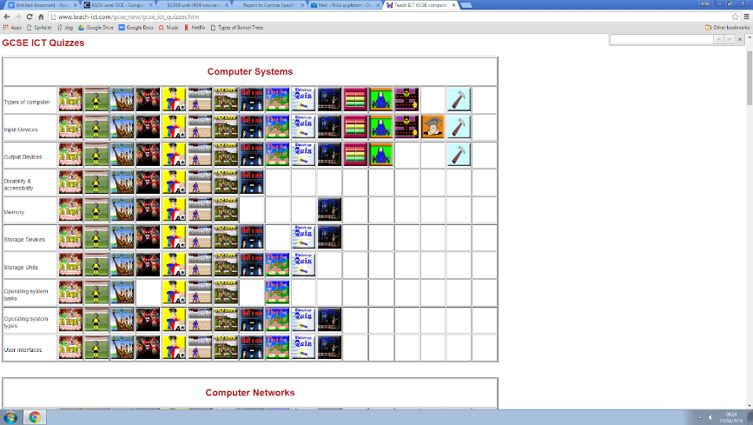After looking deeper into the situation, I found on the Teach ICT website there are a lot of games to help you revise ICT and computing. As you can see in the image [right], there are 17 games that can be played across most of the topics. I briefly asked some of the students if they enjoyed playing these games. The response I got was that while they are quite good for revision, and they are more fun than going through the topics in the book or doing past papers, they in themselves are not fun. I played through some the games myself, and found that they did get quite boring. I think this is probably due to the fact that the games are so focused on the learning aspect, I didn't find a single game that was focused on having fun over revision. They also all had very basic functions, like a simple whack-a-mole game, that was very repetitive and barely felt like a game.

These are some screenshots of the games available and the ones I tried out for myself to come to the above conclusion:

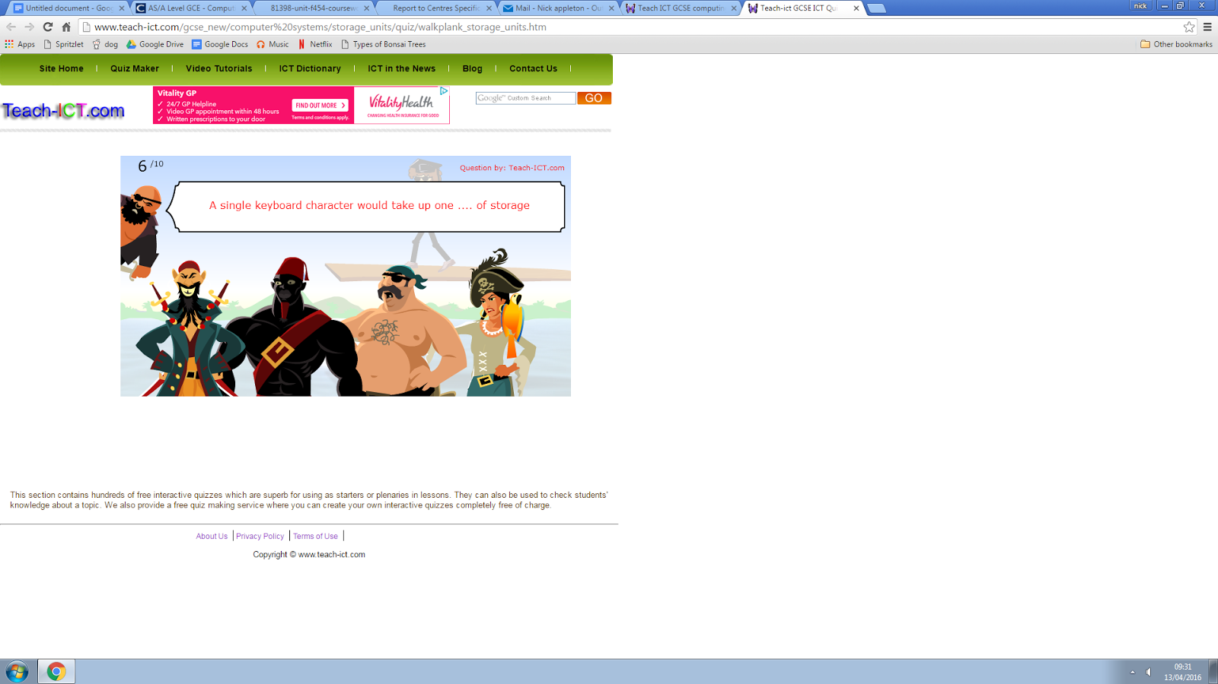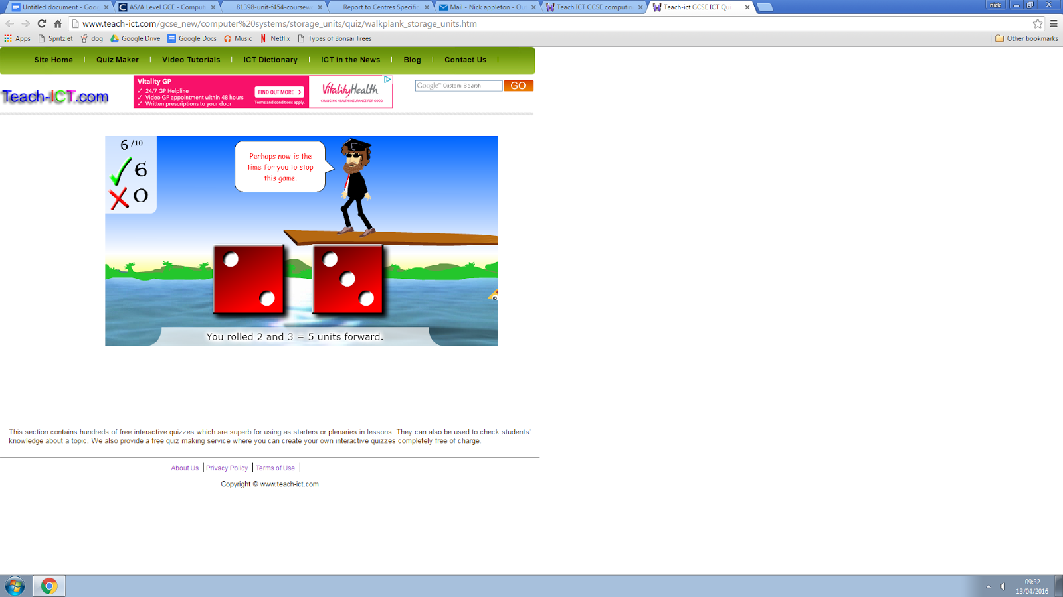

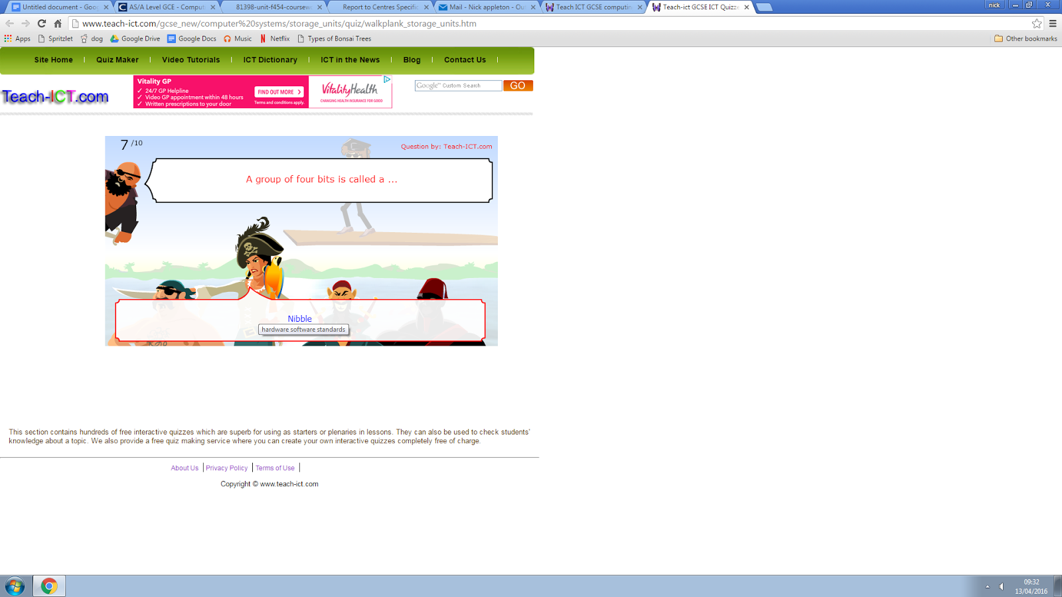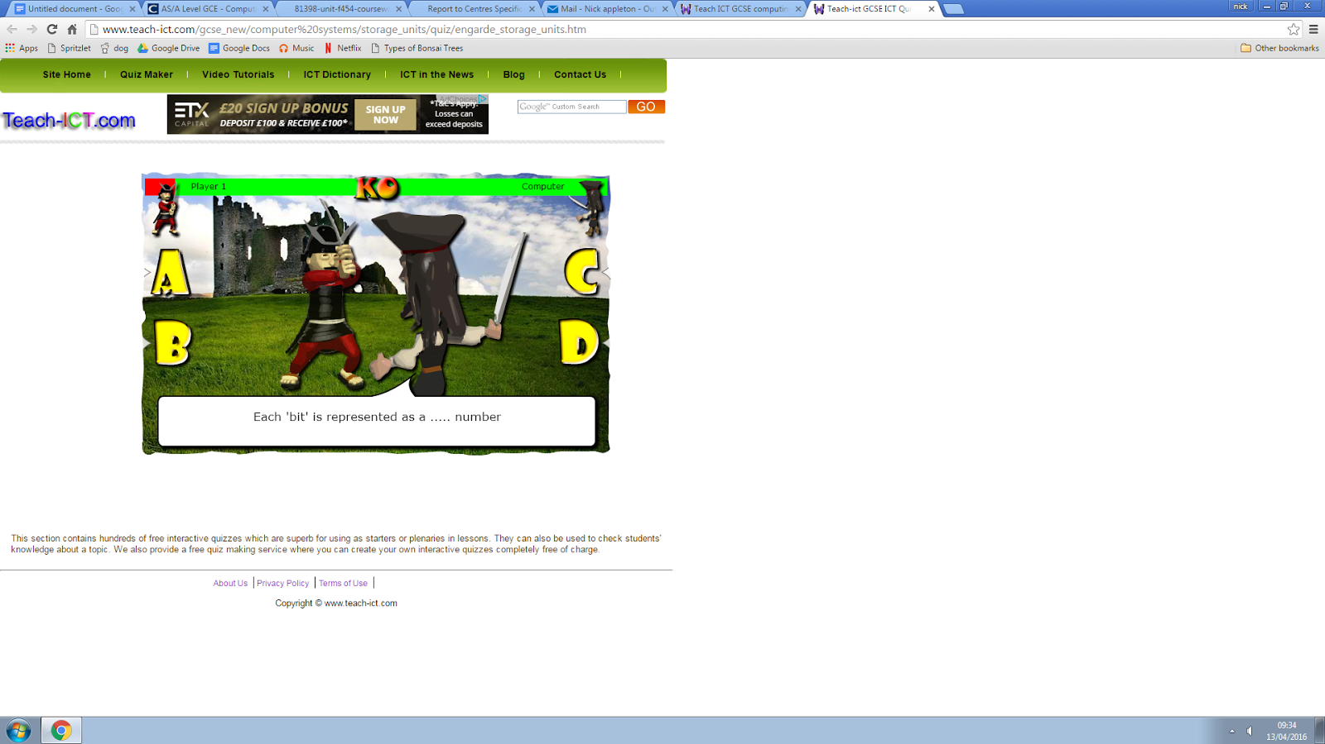

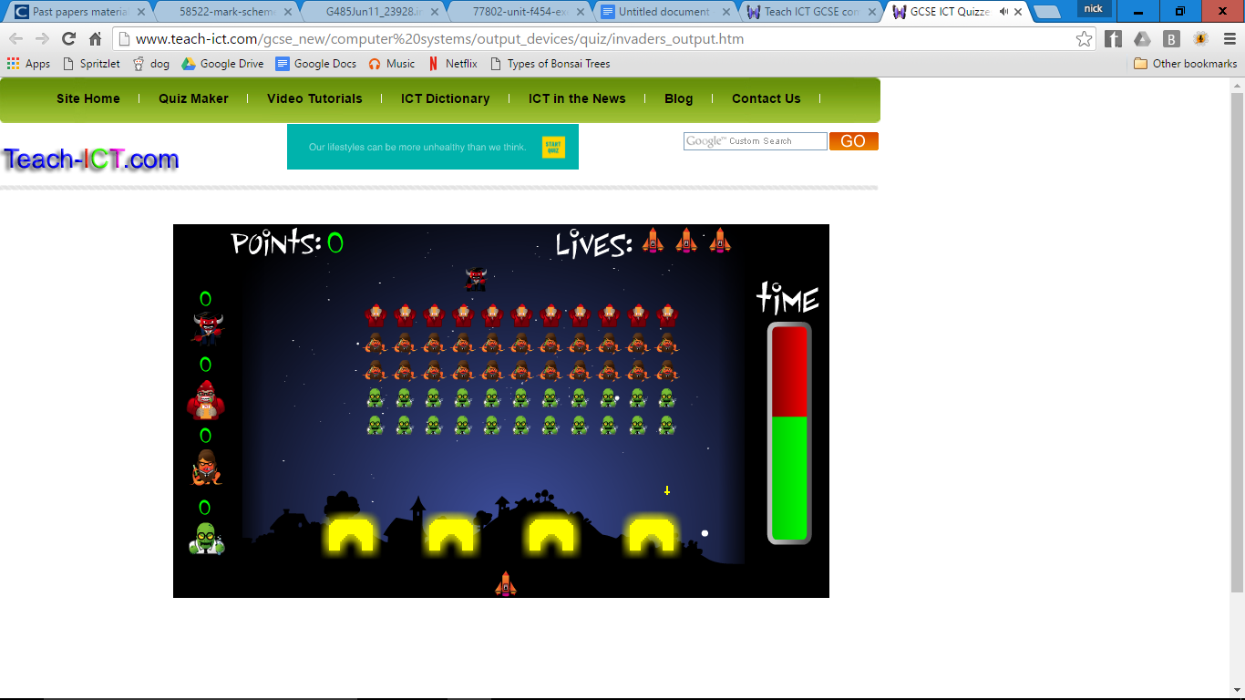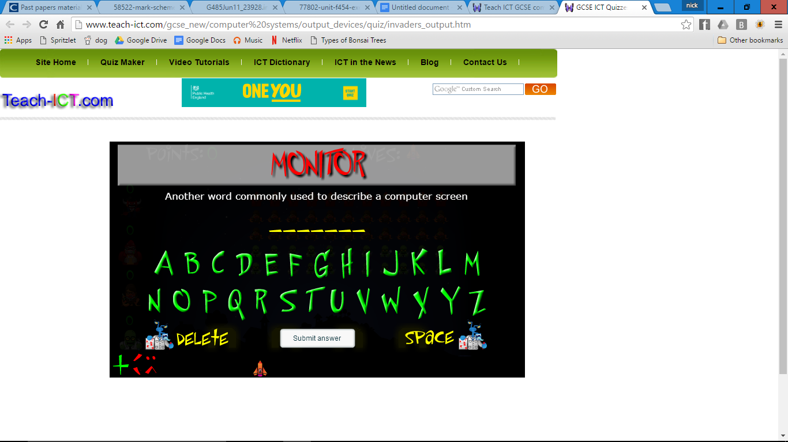

As you can see, the games are all based around the quiz. The quiz is just a simple text question, it never varies, there are no inputs from the keyboard: everything Is done with the mouse, even on the games that require you to type your answer, an onscreen keyboard is brought up that you have to click to get the letters required. I will make sure that my game is first and foremost a game; albeit one for revising. I need to make sure it feels like a game and not a cheesy way of getting students to revise.

After looking deeper, I have failed to find any interactive games for converting binary to denery. There are resources to help you, but there aren’t any games. All of the games on the teach ICT website, and anywhere else I’ve found them have only been simple quizzes with text answers. While this may be useful for those topics, it is not useful for students that struggle with binary to denery conversions.

## Initial Idea

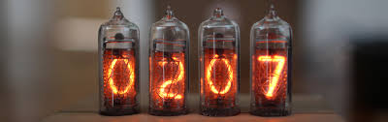 I learnt from my survey that the students wanted multiple games in the single program, and that they wanted a knowledge based game. This will include a few different games based on matching the binary to the denery (decimal) of a number. This will be a loosely steampunk themed game by using switches and nixie tubes to represent the binary and the deanery numbers respectively. By flicking the switches to the right orientation to match the given number, the level will be passed and the user will be given another, harder level with a more difficult number.

Nixie tubes

The alternate game is the other way around: the switches are oriented in a certain way and the user must adjust the nixie tubes to match the binary number. These ideas are very simple to operate and won’t be hard for the users to learn and play.

## Futher Investigation

After I finished the analysis of the first investigation I did I decided to talk to some of the target users again to make sure that they agreed with all the decisions that I made on how the game will run and look and the interactions that will happen in game. I showed them the ideas that I had and asked them what they thought of it and what they would want to change (if anything), their responses are recorded below.

The students said that while it was a good concept for helping them to revise, that it didn’t seem very enthralling and they probably wouldn’t play it for very long before they got bored and stopped playing to do something else. They suggested that I made more of a game to base it around and keep them entertained for longer. A couple of them told me about a game that they like to play 2D side scrolling retro 8 bit games, and that if I could make a game in that style, then it would be more likely that they would enjoy playing it.

They then went on to say that such a game should definitely have a level system so that you can progress through the game, and that these levels should increase in difficulty as you go on. They also suggested adding a scoring system to add a competitive element to the game that would mean they could compare scores as they felt that this would help encourage them to play the game.

I have decided that the game should be based on airships, flying through a level, with other oncoming enemy airships that you have to shoot down to stop them possibly shooting at something you are trying to protect, or at your airship. Once your airship runs out of health, you will lose the game, this will make up the ‘game’ section, and the test on their binary skill will be the ‘quiz’ section, this will mean that there are multiple parts to the game, which is one of the things the students said that they wanted.

Tiny Airships

### Questionnaire II

I have asked a slightly smaller selection of the students at what point the ‘quiz’ part of the game should be played. Almost all the students agreed that it should be played quite frequently during the game and not just in the same way as this may get boring, so having multiple incarnations of the quiz was a good idea. The majority of people said that it should be played either during the game, or once the level has finished, so I have used this to decide that I will have the ‘quiz’ run at the end of the level, as a sort of boss fight, required to progress to the next level, as well as during the level if your health reaches 0 as a sort of ‘second wind’ ability. This will mean that the revision element will be necessary for the player if they want to move on to the next level, as well as giving them an escape if they don’t get to the end. I discussed it with the students and they agreed that this seems like a good way of implementing it into a game as it will give the game some diversity, not just have one game, but multiple different stages, as well as multiple stages to revise at.

## Requirement Specifications

### User Requirements

The main aim of the game is for it to be used as a revision resource for students that need to practice forming binary numbers, however it must also include a more typical game element to it too. All of these specifications have been derived from my interviews and questionnaires with the students. Next to each specification is a page number and heading referencing where the relevant information or communication occurred to come to the conclusion of that specification point.

#### General

* Must have a level system [pg. 10: “Further Investigation”]
* Each level should get harder than the previous [pg. 10: “Further Investigation”]
* Must have a scoring system [pg. 10: “Further Investigation”]
* Scoring system should scale for levels [pg. 10: “Further Investigation”]

#### Quiz section

* Must effectively help students revise binary [pg. 8: “Researching the Current System”]
* Must have multiple incantations throughout the game that are played at different times [pg. 10: “Questionnaire II”]
* At least one of these should have a scale depending on how well the player is doing [pg. 10: “Further Investigation”]
* Must not discourage players form playing (must be fun) [pg. 10: “Further Investigation”]
* Must link into concept of the main game smoothly [pg. 7: “Response”]

#### Game section

* Should change difficulty depending on level [pg. 10: “Further Investigation”]
* Should keep players entertained [pg. 10: “Further Investigation”]
* Should make up more of the game than the ‘quiz’ section [pg. 10: “Further Investigation”]

### Hardware and Software Requirements

* Requires a computer with both python and Pygame installed.
* Requires a Standard English or American keyboard.
* Requires full game files to be installed on computer.
* Requires 512MB of RAM
* Windows 98 or later
* 40GB of free space

# Design

## Design Specifcation

I have researched popular designs in games as well as asking my final user-base what they would like to see in the game, and have decided that I will base the game on airships, using this base, I have put together some design specifications:

* All aspects must link into the overall theme (airships)
* Must conform loosely to steampunk style
* All displays must be creative (e.g. Nixie tubes rather than a TV screen)
* Must be easy to see all the information needed by the user

## Design

### How the Game Will Run

Run level end quiz

Is it the end of the level?

No

Run repair quiz

Success?

End

Has the player run out of health?

Run sidescroller

Keep running sidescroller

Start

Yes

Yes

No

Success?

Level increase

Yes

Yes

No

No

### UI design

#### Quiz section

In the quiz section of the game, the inputs needed will only be those needed to flip the switches, the outputs needed will be the target value, and the visual countdown.

As I agreed with my end users, I will make the main quiz section will be at the end of the level as a sort of boss fight, so I have decided to make it a missile defence exercise in which a missile is fired towards the player and they will have to solve the binary problem before the missile hits them. I think that this should take part in the cockpit of the airship. I talked to my users about some of the potential designs and they liked the idea of an abstract timer: not having a number timer in favour of the missile’s animation being the only way to tell how much time remains; I have drawn up a basic design below.

Windscreen with view of oncoming missile

(Used as timer)

Switches

Target number

The windscreen with the view of the missile will act as the timer, the missile will slowly get closer until it eventually hits, causing you to lose the game. However if you get the correct answer before the missile hits the screen, it will detonate it in the air, avoiding your airship.

I have also designed a similar thing for the game which will be played if the player runs out of health, again taking into account that the users don’t want a quantitative timer:

Switches

Altimeter

Target

Engine

In this design, the engine will have to be re-tuned to keep the airship flying and stop it plummeting to earth. The switches or valves on the engine will act exactly like they do in the missile defence game, you will use them to make a target number given to you on the right of the screen. This time the timer is in the form of an altimeter measuring how long it is until you crash into the ground.

The two sections will both run in a very similar way, this means that re-writing the game for a second time, for the other event should be relatively simple; however the code will have to be quite different to incorporate the different features. This means I should completely write one program first, then using the same algorithms and code as a guideline, write the second version.

As has already been outlined, the design of this section is such so that the player will be given a randomly generated number between 0 and 255 (labelled as target in the above diagrams) and they will have to try to flick the correct switches to create that numbers binary counterpart, for example, if they were given the number 73 as a target, they would have to flick the switches to [off, on off, off, on, off, off, on], equivalent to 01001001, which would then stop the imminent event from occurring, saving the players in-game character.

I will associate the switched to different keys on the keyboard, this way the player doesn’t have to keep track of the mouse and can change multiple switches at once. It will also act as a validation so that they can only press things that they are allowed to.

#### Sidescroller

This will be the main body of the game, so it has got to be easy to understand, however, as the main function of the game is to help the students revise, this will be a less important function of the game, so it is important it is designed nicely, however, I should design and make this area last, as if I have a working educational part, then I can still use the game, however, if I only have a sidescroller, then the students cannot revise from it.

The basic design will include information about your status at the top (i.e. health, super, lives) and the main game taking up the majority of the window underneath.

Enemy airship

Enemy airship

Player airship

Status things

The background will be moving sideways (from left to right) to simulate the airships moving to the right. Each level will use a different background, slowly getting darker as you progress through the game.

The buttons for firing the gun and moving your airship will be far apart, this means it is unlikely that the player will accidently press the wrong button. Also, a problem that my user based flagged up about this type of game is that usually the fire and special are bound to X and C, which are difficult to quickly locate on the keyboard, this is why I will be using the space bar as the firing button.

## Quiz

### Design Objecives

These designs are specifying the aesthetics, inputs and outputs, and processes of the game, I will show these to my users and get their feedback on my choices.

#### Aesthetic Considerations

The screen size will be 900 X 700px

I will draw separate images for the switches and the background

It will be set in a cockpit, with the switches on the control panel in front of you, with the nixie tubes to your left

The cockpit will mostly be brass and wood coloured

The current value will be displayed on an old fashioned alarm clock style flipper system

#### Input Consideration

The player can click on the switches to change them from off to on and vice versa

The player can press enter to find the current value of the switches added together

The player can press escape to pause the game

The player can press the question mark (?) key to view an overlay of the instructions

#### processor considerations

The missile will have to increment, with each frame lasting the same amount of time (depending on the level)

When enter is pressed, it will take time for the value to be displayed, and each digit will be displayed one at a time

If the switches are equal to the target number, then the missile will explode in the air and the main game loop will stop

If the timer is equal to 0, then the cockpit will explode, ending the main game loop

The tutorial overlay will come up at the beginning of level 1 for a limited time, as well as if you hold (?)

#### Response

I took this list to my end users to see if they agreed with the decisions I’d made. I gave them 5 minutes to look through each part as well as the UI designs and discuss any areas that they thought needed more development or should be changed in any way. I then came back and discussed these thoughts with them. These were the conclusions:

Clicking should not be used, rather it should be key presses as clicking it will be hard to change a lot of the switches in a short amount of time, and if they feel under pressure they say they are likely to miss click, possibly ruining their game. Also they pointed out that as this is a timed game in which you have to think under pressure, it would be very easy to cheat at this if there was a pause function, so I will save that for the main game, not the quiz section.

### Algorithms

Is button a switch or enter?

#### Flow Diagram

Yes

Is button pressed?

No

Put everything on screen

Start

Enter

Switch

Display current number animation

Timer moves down

Does timer = landmark value?

Does timer = 0?

Move missile to next picture

No

No

Explosion animation

Yes

Finish

Yes

Has player won?

Winning animation

Yes

No

Change value of switch from 0 to the value of that switch

No

Change value of switch from value of that switch to 0

Yes

Is switch on?

The above algorithm outlines how the quiz part of the game will work. Both ‘level end quiz’ and ‘repair quiz’ from the main game algorithm will use this base algorithm. Each round of the flow diagram will be one tick of the game. This means that all of these boxes (between [put everything on screen] and the two final animations) will happen 60 times a second.

#### Pseudocode

##### Main Loop

[START GAME]

Define switches and nixies as sprites

Give nixies and switches at random values

Initialise all variables and images

[START GAME LOOP]

Blit sky depending on the count variable (so it will move)

Blit missile depending on count (so it will come towards the screen)

Draw all sprites on screen

Blit everything else (flippers and such)

IF key being pressed:

IF key is A, S, D, F, G, H, J or K:

Flip the relevant switch

IF key is space bar:

Activate flippers (to find current value)

Move missile animation on (if appropriate)

Check if the player has won or lost

IF the player has won:

Missile explodes animation

Blit ‘VICTORY’ banner

[END GAME]

ELSE if player has lost:

Initialise failure variables

Missile explosion animation

Random explosion animation

Display ‘FALIURE’ banner

[END GAME]

Return to beginning of loop

The pseudocode above is the overarching program that will run when the quiz section is run. It includes the game loop that will run 60 times a second. The following pseudocode is the part of the code that will define the switches and the nixies.

##### Sprites

Switch:

[START]

Define as sprite

Initiating function:

Give sprite position; an on image; an off image

Set it with a random condition (on or off) and a value of how much it’s worth

IF switch is on:

Set picture to the ‘on’ picture

ELSE:

Set picture to ‘off’ picture

Set position

‘Flick’ function:

Change condition to NOT condition

Change the image

[END]

Nixie:

[START]

Initiate:

Get position and random number (given as augments)

FOR x = 0 to 10:

If x is equal to the desired number:

Set image to the image of this number

Set position

[END]

After this, I will initialise all of the variables I’ll need throughout the code, this includes things like assigning sprites and such, as well as counter variables for each part and some Boolean (victory and failure etc.)

##### Moving the Missile and Sky

This section of pseudocode is for the missile animation as well as the movement of the sky for effect and how the program will detect whether it is time for the missile and/or the sky to move onto the next frame. There will be 22 frames overall for the missile and 1 frame for the sky that will move back and forth, and can be in one of four positions. I’ve also tested the timings for the animations for if it’s ticking sixty times every second, and included the correct numbers in the pseudocode below.

The first part is the relevant variables being initiated and what they will be set to, the second part is what will happen in the main game loop. The variable ‘Timer’ will have a value depending on the level that the player is on.

[START]

Start_count = Timer / 21

Count = Start_count

Missile_num = 1

Skycount = 0

[END]

[START (in game loop)]

IF count is less than or equal to 0:

Reset count to Start_count

Load image missile(missile_num).png

IF skycount < 30:

Blit sky left

ELSE IF skycount < 60:

Blit sky mid

ELSE IF skycount < 90:

Blit sky right

ELSE IF skycount <120:

Blit sky mid

IF skycount = 120:

Skycount = 0

Count = count – 1

Skycount = skycount + 1

[END]

#### Functional Testing

Due to the nature of my algorithms (there being no user input or output) it is hard to quantifiably test them. So what I have done is gone through each algorithm systematically checking that the make sense and link up to themselves and the other algorithms. After looking through all of them I’m certain that all of these algorithms are going to work.

I am going to test the switch algorithm using a trace table, as I feel that it is probably the most important of them. I have assigned 3 switches numbers 1, 2, and 3 and run through the algorithm.

|  |  |  |  |  |  |  |  |  |  |  |
| --- | --- | --- | --- | --- | --- | --- | --- | --- | --- | --- |
| Switch no. | Variable name | “Initiate” function line number | | | | | | | “Flick” line no. | |
| 1 | 2 | 3 | 4 | 5 | 6 | 7 | 1 | 2 |
| 1 | Condition |  | ON | true |  | false |  |  | OFF |  |
| Image |  |  |  | ON |  |  |  |  | OFF |
| 2 | Condition |  | ON | true |  | false |  |  | OFF |  |
| Image |  |  |  | ON |  |  |  |  | OFF |
| 3 | Condition |  | OFF | false |  | true |  |  | ON |  |
| Image |  |  |  |  |  | OFF |  |  | ON |

I am also going to do a trace table for the Nixie function to check that it would display the number correctly. I will do it twice, with a random number and 0, as this will happen three times to give you the full target number

|  |  |  |  |  |  |  |  |  |  |  |  |  |  |  |
| --- | --- | --- | --- | --- | --- | --- | --- | --- | --- | --- | --- | --- | --- | --- |
|  | Desired number | Variable name | Line number | | | | | | | | | | | |
| 2 | 3 | 4 | 2 | 3 | 4 | 2 | 3 | 4 | 2 | 3 | 4 |
| 1 | 3 | X | 0 | false |  | 1 | false |  | 2 | false |  | 3 | true |  |
| Image |  |  |  |  |  |  |  |  |  |  |  | 3 |
| 2 | 0 | X | 0 | true |  | 1 | false |  | 2 | false |  | 3 | false |  |
| image |  |  | 0 |  |  |  |  |  |  |  |  |  |

This Trace table has shown me how even once the correct number has been found, the for loop will keep running. This is inefficient, so I will add a break in after setting the image to make it stop looping when the correct number has been found.

### Test Strategy

To test the algorithms, and the final code I will use multiple different types of testing to ensure all of the code works and if there is an error I will be able to find it and correct it.

#### Methods

##### Black Box

The first method I will use will be black box testing, this is when the internal workings of the program are left completely alone and the tester only needs to know the valid inputs and what the outputs will be. Checking that the outputs are as should be expected when you input valid, invalid, or borderline data. I will do this by changing the each of the switches and making sure that the value of them changes properly and add together as they should. As well as testing that the program reacts correctly if the user tries to press the button with the wrong value on the switches, as well as if they finish on the correct value. This will be done when the program is supposedly finished, and it will just be testing the features of the program, without looking at the code. It is only testing the uppermost level of the game, the part of the game that the end user will be interacting with and nothing deeper.

##### White Box

If the testing proves that there is in fact an error in the code then I will use white box testing to pinpoint where the error is. To white box test, I will record what caused the error to occur, then I will find the relevant section of code that is responsible for that part of the program. Once found, I will look through the flawed code line by line, tracing the variables and what goes wrong, then I will come up with a way to fix it and change the section to fix the bug.

#### Types of testing

##### Alpha Testing

I will first give my game to a group of students that can play the game, testing the functionality, then telling me the parts they like and dislike as well as any errors they may have found. I will do this as soon as I have the working game so as to fix any problems as early as possible in development.

##### Beta Testing

When I think I have finished this section of my game, I will give that to another, larger group that will again try to break it as much as they can, reporting back any errors that they find. This will also function heavily as qualitative testing as I will be sure to get their opinion on all aspects of the game. Once the game is completely finished, I’ll give it to a more select group of students, asking their initial feedback, then use these responses to look into ways the game could be improved.

#### Qualitative Testing

Once I have drawn up the images that will be used in the game, I will show them to my end user group and ask them if they think that they are all good enough at this early stage. Once I’ve put the rest of it together and combined all of the images with the code to make the game I will give some of my screenshots to the users to see if they think that they’re good enough, if not then I will redesign the images for the part that they didn’t like.

#### Stratergy

To test the game, I will have to test every possible outcome. To help me look at every possible direction it could go, I’ve drawn up another simple flow diagram, and I aim to test every box on it. A lot of the boxes are big enough that I’ll have to test them separately, too, using the other flow diagrams above.

Outcome of engine room quiz

Outcome of sidescroller

Engine quality remains?

No

Quit game

Yes

Increment level

Win

Lose

Outcome of cockpit quiz

Finish

Lose

Win

Dead

Start

#### Table

|  |  |  |  |
| --- | --- | --- | --- |
| No. | Test | Expected Outcome | Purpose |
| 1.a | Pressing each of the buttons that will change the switches | The corresponding switches should change to the opposite orientation and the overall value of the switches will also change. | To check that all of the switches basic functions work correctly. |
| 1.b | Pressing multiple switches at the same time. | This should change all of the switches that are pressed to the opposite orientation as well as changing the overall value correctly | To check that the switches still work even when the user presses multiple switches |
| 2.a | Flipping the flippers | The flippers should spend some time flipping then one by one should stop moving and rest on a number until the final number is made. | This is to test the basic function of the flippers and make sure they work correctly |
| 2.b | Press some of the switches while the flippers are flipping | The flippers should continue as before, but when the buttons are pressed, the number should NOT change on the flippers. | To check that the flippers do not continue to update the number when the flipper is flipping |
| 2.c | Press the button to flip the flippers once the flippers are already flipping. | The flippers should restart with whatever the number is now (if it’s been changed since the first time it was flipped) and flip like normal | To check that the flipper restarts itself properly. |
| 3.a | Get the correct number | The missile should explode in the air, and the victory banner should display, as well as then close the game. | To check that the game ends correctly when you get the right answer. |
| 3.b | Let the missile hit the cockpit | One large explosion should appear in the middle of the screen (where the missile hit), and a lot of small explosions all over the dashboard. Then the game should close. | To check that the game ends correctly after you lose the game. |

### Final Design

I have used an online editor (piq.codeus.net) to develop pixel art for the background of the quiz sections.

#### Cockpit

This is the finished cockpit: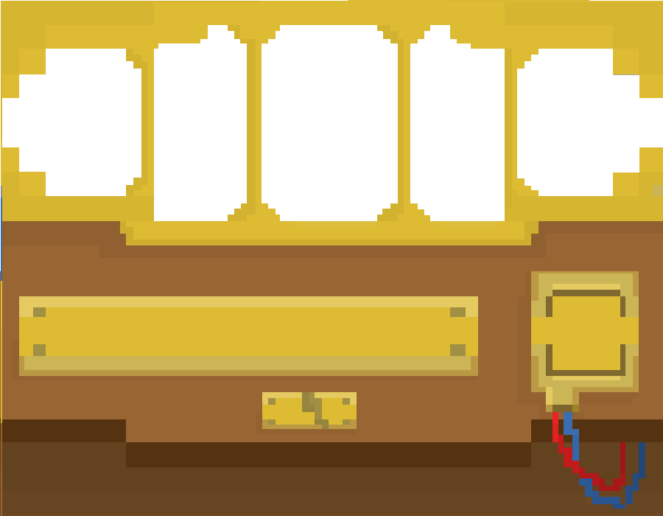

The windscreen of the cockpit did have the sky with it so I could blit the missile atop this image, it would appear above the sky but look as if it’s behind the cockpit. However, I thought it would be nice if the sky were to move back and forth to make it look less static, so I removed the sky and will blit the sky behind it.

This is the sky:

I have also drawn all the images for the missile. I have done 22 images that it will flick through as the animation moves along. 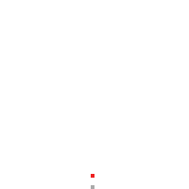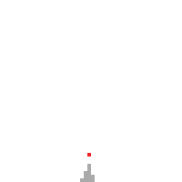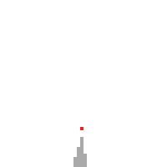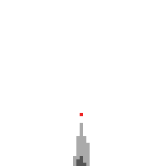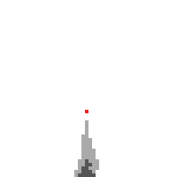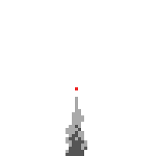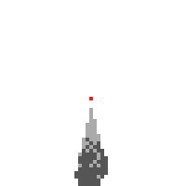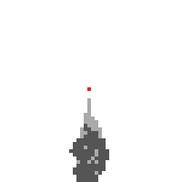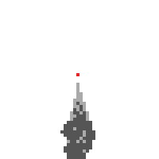 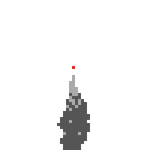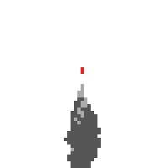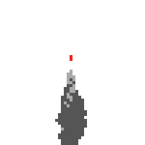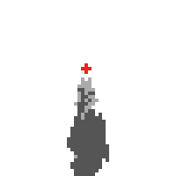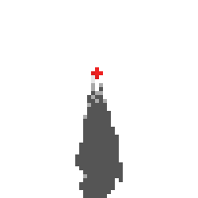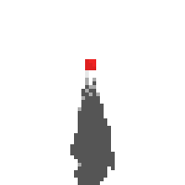 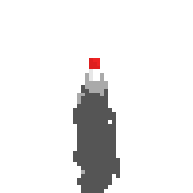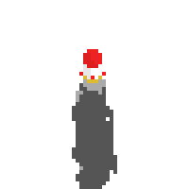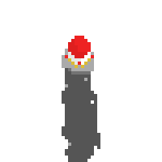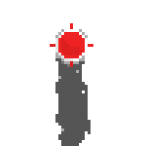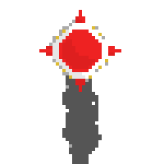

#### Explosion

Following this will be the explosion animation:

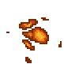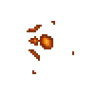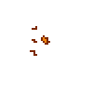

#### Flippers

I have also drawn the images for the flippers at the bottom of the screen. This is how the flippers will start:

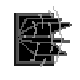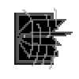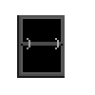Then there are 2 parts to the animation:

There are also all of the numbers that it could display:

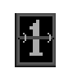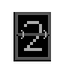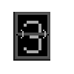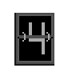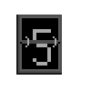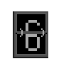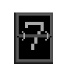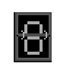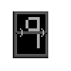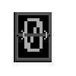

#### Switches

Then there are the 8 switches, which I drew individually so I could have the corresponding letter on them. I drew each on and off.

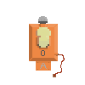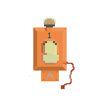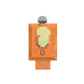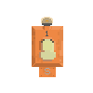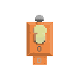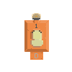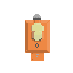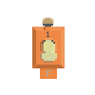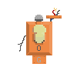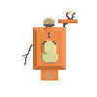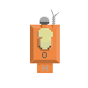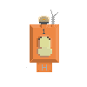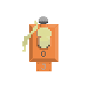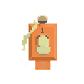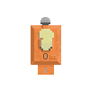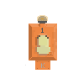

#### Feedback

I showed all of these images to my users and explained where they’d go and how they would interact with each other visually, and they told me that they liked the pixel art style and they said that the images were ‘good enough’. I think it’s more important to develop a working game with ‘good enough’ visuals, then if I have time at the end update the visuals to better ones.

## Sidescroller

### Design Objecives

These designs are specifying the aesthetics, inputs and outputs, and processes of the game, I will show these to my users and get their feedback on my choices.

#### Aesthetic Considerations

The screen size will be 900 X 700px

I will draw separate images for the foreground, background and sky

It will be set in different environments depending on the level

The levels will slowly become more urban and darker

The players health will be displayed as a bar in the top right

#### Input Consideration

The player can move with the W, A, S & D keys

The player can press space to fire his/her weapons

The player can press escape to pause the game

The player can press the question mark (?) key to view an overlay of the instructions

#### processor considerations

The enemy ships will be loaded before they come on the screen, then destroyed when they get to the other side

The players’ weapon will have to have a small delay between firing

If the player has reached the end of the level, a small animation will be played and the main game loop will stop

If the health is equal to 0, the player will fall off the bottom of the screen and the game loop will end

The tutorial overlay will come up at the beginning of level 1 for a limited time, as well as if you hold (?)

#### Response

I took this list to my end users to see if they agreed with all of these points and think that this is a good setup.

### Algorithms

#### Flow Diagram

Is button pressed?

Run cockpit quiz

Play missile animation

Yes

No

Return to start

End of level?

Yes

Is engine quality <= 0?

Run engine quiz

No

Yes

Is health <= 0?

No

Yes

Lose health

Has enemy reached the end of the screen?

No

Yes

Remove enemy from onscreen and play explosion animation

Has bullet collided with enemy?

No

Yes

Add ship to the onscreen ships and start it moving

No

Enemy coming onto the screen?

No

Yes

No

Fire

Yes

Move

Space?

Yes

WASD?

Put everything on screen

Start

This outlines the main game loop of the sidescroller section, again happening 60 times a second. There are 3 different ways of ending the loop: 2 of them are for the different quizzes, and the other is if you run out of health when you have 0 engine quality, then the game will end

#### Pseudocode

##### Main Game

[START]

Set up level

Define Player and Enemy sprites

Define all the background movements

Add all enemies from external file to in-game enemy_list

[START GAME LOOP]

Check for button presses:

IF escape is pressed:

WHILE TRUE:

IF escape is pressed

END WHILE

IF [?] key is pressed:

DISPLAY Tutorial until BUTTON_UP

IF space is pressed:

Add bullet to on-screen list at player location

IF finished is FALSE and victory is FALSE:

FOR enemy in enemy_list:

IF enemyStart is just off screen:

Add enemy to on-screen list

Update all sprites

Scroll screen

ELIF finished is TRUE:

Blit missile (depending on variable)

LOAD cockpit_quiz

ELIF dead is TRUE:

Player falls parabolically

Remove engine quality depending on level

LOAD Engine_quiz

Return to beginning of loop

The above is the pseudocode for the main part of the code that will run when the game is run. The functions included in the above code are outlined below.

##### Sprites

Player:

[START]

Initiate:

Set player position and image

Update function:

Change image

IF not at edge of screen:

IF [W] is pressed:

Y position = Y position – 10

IF [A] is pressed:

X position = X position – 10

IF [S] is pressed:

Y position = Y position + 10

IF [D] is pressed:

X position = X position + 10

[END]

Enemy:

[START]

Initiate:

Set position and image

Update:

Change picture

IF bullet collides, run boom

Boom:

Remove self and bullet from on-screen list

Play explosion animation

[END]

Bullet:

[START]

Initiate:

Set position to player and image

Update:

Move forward

[END]

#### Functional Testing

Again I have looked through my algorithms very carefully and have once again deduced that they should all work.

# Development:

# First Quiz

## Making the First Quiz

### Setup

#### Imports

1. #importing modules I need to use throughout the game
2. **import** pygame
3. **from** pygame **import** *
4. **import** random
6. #setting the level
7. level = 1

This is the basic imports for the things that I will use later in the game. Pygame is the most important, it lets me use all of the pygame functions to help me produce my game. ‘From pygame import *’ makes it import everything from pygame. The ‘Random’ library lets me make random integers and bools etc.

#### Sprites

1. #defining sprites for switches
2. **class** switch(pygame.sprite.Sprite):
3. **def** __init__(self, position, image_on, image_off, condition, worth):
4. #tells the sprite to initiate itself
5. pygame.sprite.Sprite.__init__(self)
6. #loads image depending on state
7. **if** condition == True:
8. #if the switch is on, load image on
9. self.image = pygame.image.load(image_on)
10. #and set the value to the value of the switch
11. self.worth = worth
12. **else**:
13. #or, set the image to imageoff
14. self.image = pygame.image.load(image_off)
15. #and set the worth to 0
16. self.worth = 0
17. #loading a box around the switch so it can be put on screen
18. self.rect = self.image.get_rect()
19. #sets the starting position by telling where the ropleft of the rect needs to go
20. self.rect.topleft = position
21. #defining conditional images for use when changing in switch.flick
22. self.image_on = image_on
23. self.image_off = image_off
24. self.condition = condition
26. #when the button is pressed, the switch is flicked
27. **def** flick(self, image_on, image_off, condition, worth):
28. #changing the condition from on to off or visa versa
29. self.condition = **not** condition
30. #resetting the image depending on condition
31. **if** self.condition == True:
32. self.image = pygame.image.load(image_on)
33. self.worth = worth
34. **else**:
35. self.image = pygame.image.load(image_off)
36. self.worth = 0

This is the first of the classes that I design. I define the class as a sprite at the beginning with the (pygame.sprite.Sprite). To begin classes, you need to define the __init__ , which will run as soon as you create an instance of the class. The first thing I do in the __init__ function is set self.image to either on or off (locations are both given as augments), depending on the condition of the switch (also given as an augment that is defined when you create the sprite). To set and change the image of the sprite, I use self.image = … By using ‘self.something’, you change the attribute ‘something’ that is attributed specifically to that instance of that sprite, so self.image will change the image, then pygame looks at the image attribute of the sprite before displaying it. Because it is attributed to the sprite, it will work across functions within a class. I use self.condition to store whether the switch is on or off, self.worth is how much that switch adds to your current number at that time, the value of that switch is given as an augment, if the switch is on, it will be worth this, if it is off, it will be worth 0. I then also set the self.rect, a rectangle around the image used for positioning; then self.image_on and self.image_off, these do not affect the sprites appearance as they are only memory locations, but it is useful to be able to refer to them in later functions so I won’t need to give them as augments again.

I then have the ‘flick’ function, called when given the command ‘switch.flick’. I have used this so that when you press the button on the keyboard that is linked to that switch, it will ‘flick’ it, changing its image, value and condition from on to off, or off to on.

1. #defining the nixie sprites
2. **class** nixie(pygame.sprite.Sprite):
3. **def** __init__(self, position, number):
4. pygame.sprite.Sprite.__init__(self)
5. #loads image depending on number
6. self.number = number
7. **for** num **in** range(0, 10):
8. **if** num == self.number:
9. self.image = pygame.image.load('sprites/nixie/nixie_'+str(num)+'.png')
10. #hitbox
11. self.rect = self.image.get_rect()
12. #starting position
13. self.rect.topleft = position

Next I did the nixie sprite. This is the sprites that will be used to display the target number. For this sprite I only have the __init__ function, because it won’t change as long as it’s on-screen. In the augments for this sprite, I have added ‘number’, this is a variable telling the class what number each nixie should display. To start, I set self.number to the augment number so it can be used later, I then initiate a for loop that will increment the value of ‘num’ from 0 up to 10 every time it’s run everything inside it. Every time it loops, it checks whether ‘num’ is equal to the number that needs to be displayed, and if it is, it sets self.image (the image that will be displayed to load the image at the location ‘sprites/nixie_[number to display].png’. once it has finished this, it sets the rect and position.

#### Initiating Everything

1. #starting pygame
2. pygame.init()
3. screen = pygame.display.set_mode((900, 700))
4. background = pygame.image.load('sprites/cockpit.png')
5. sky = pygame.image.load('sprites/sky/1.png')
6. sky = pygame.transform.scale(sky, (910, 300))
7. fps = pygame.time.Clock()
9. score = 1000

This section is everything needed to start the game up, it initiates pygame, which has to be done before the game can run. It then sets up the screen size and makes it into a surface that I will use later. It then sets the background and sky images by using pygame.image.load to load the image at the location given. Because the sky is the wrong size, I then transform the scale of it to fit the screen. I set ‘fps’ to pygame.time.clock(). This is used to tick on the game and restart the loop, however it’s easier to just type fps each time. And finally, I set score to 1000, this will act as a timer that will count down.

#### Target Number

1. #setting the target number
2. target = random.randint(0, 255)
3. **print**(target)
4. #splitting the target into 3 digits
5. **if** len(str(target)) == 1:
6. digit_1 = 0
7. digit_2 = 0
8. digit_3 = int(str(target)[0])
9. **elif** len(str(target)) == 2:
10. digit_1 = 0
11. digit_2 = int(str(target)[0])
12. digit_3 = int(str(target)[1])
13. **else**:
14. digit_1 = int(str(target)[0])
15. digit_2 = int(str(target)[1])
16. digit_3 = int(str(target)[2])

This section is the part that generates the target number. To start with, it chooses a random number between 0 and 255, it then splits the number into 3 by first checking how long the number is, if the number is only 1 digit long, then it sets the first 2 variables to 0, and the last one to the target number, if it’s 2 long then it sets the first variable to 0, the second to the first digit of the target number and the last to the second, if it’s 3 long, it separates it into the 3 variables.

##### White Box Testing

I am first going to create a trace table for this section of code, then I’m going to test the code to make sure it all works. I will use the values 81, 255, and 0 to check the two most extremes, and another random number.

|  |  |  |  |  |  |  |  |  |  |  |  |  |  |  |  |  |
| --- | --- | --- | --- | --- | --- | --- | --- | --- | --- | --- | --- | --- | --- | --- | --- | --- |
|  | Variable name | Value of variables on each line | | | | | | | | | | | | | | Final Value |
| 2 | 3 | 5 | 6 | 7 | 8 | 9 | 10 | 11 | 12 | 13 | 14 | 15 | 16 |
| 1 | Target | 81 | (print) | False |  |  |  | True |  |  |  |  |  |  |  |  |
| Digit_1 |  |  |  |  |  |  |  | 0 |  |  |  |  |  |  | 0 |
| Digit_2 |  |  |  |  |  |  |  |  | 8 |  |  |  |  |  | 8 |
| Digit_3 |  |  |  |  |  |  |  |  |  | 1 |  |  |  |  | 1 |
| 2 | Target | 255 | (print) | False |  |  |  | False |  |  |  | True |  |  |  |  |
| Digit_1 |  |  |  |  |  |  |  |  |  |  |  | 2 |  |  | 2 |
| Digit_2 |  |  |  |  |  |  |  |  |  |  |  |  | 5 |  | 5 |
| Digit_3 |  |  |  |  |  |  |  |  |  |  |  |  |  | 5 | 5 |
| 3 | Target | 0 | (print) | True |  |  |  |  |  |  |  |  |  |  |  |  |
| Digit_1 |  |  |  | 0 |  |  |  |  |  |  |  |  |  |  | 0 |
| Digit_2 |  |  |  |  | 0 |  |  |  |  |  |  |  |  |  | 0 |
| Digit_3 |  |  |  |  |  | 0 |  |  |  |  |  |  |  |  | 0 |

As can be seen from the trace table, all of the three possibilities work correctly: the original target number is written as a three digit number vertically on the very right of the table.

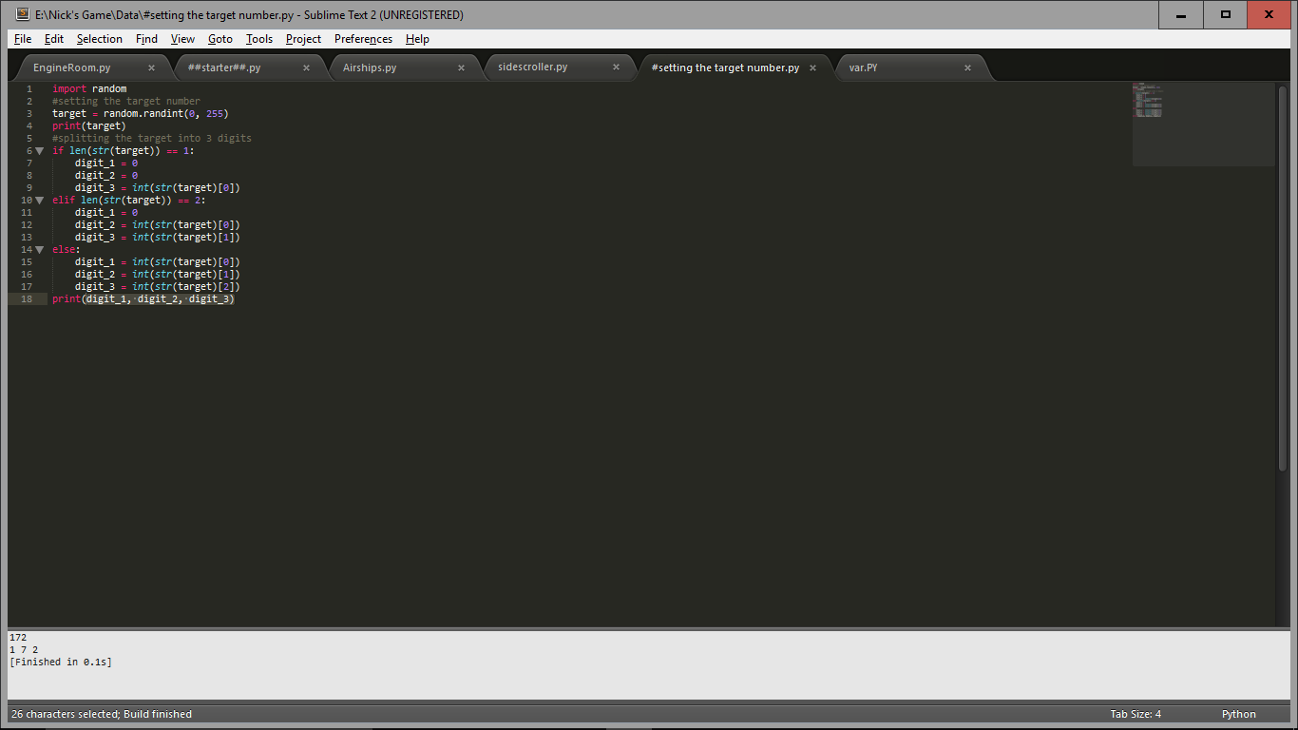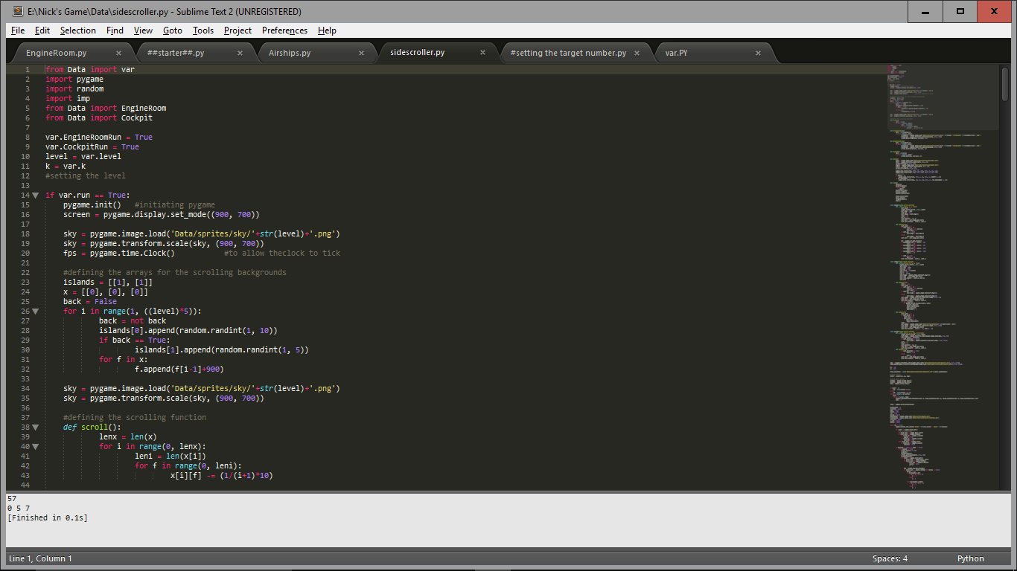I have tested this section as it is one of the more, accident prone sections I added print(digit_1, digit_2, digit_3) at the end, so it will print the number, then it separated on the next line.

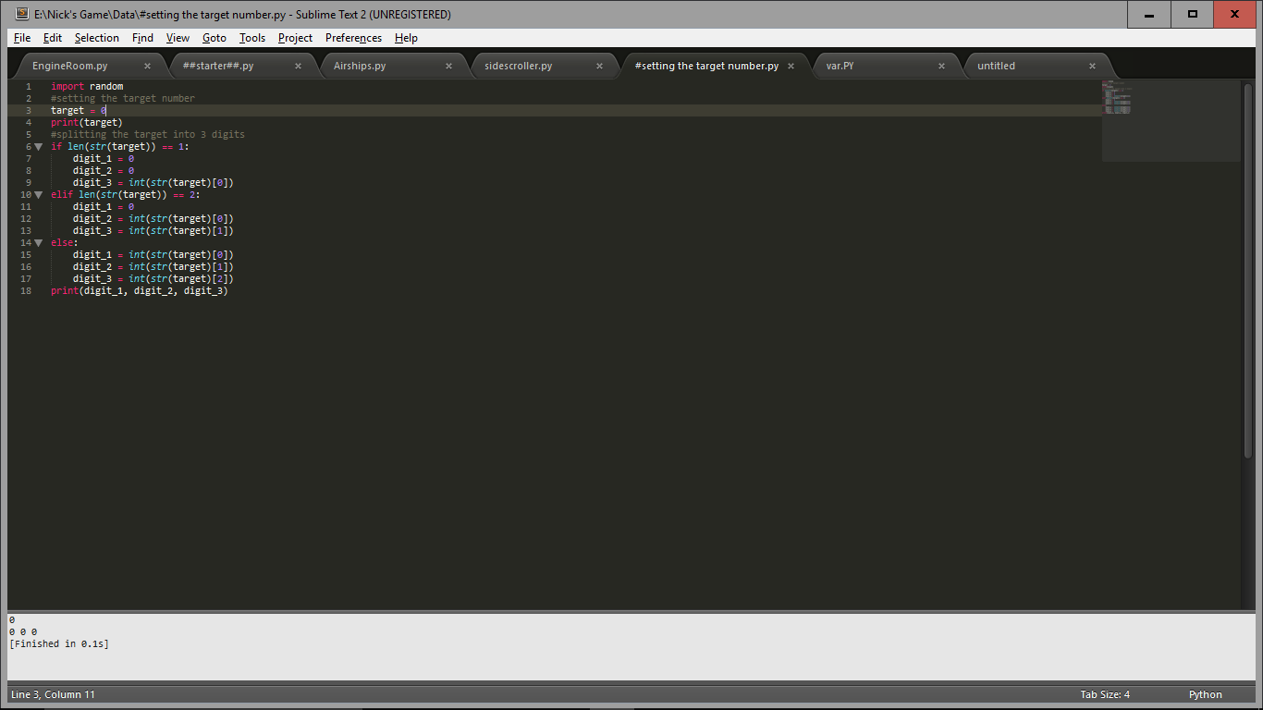The output is as expected, I have tested this quite a few time and it seems to work every time. I will check the boundaires by testing if 0 works, as this could pose a problem.

0 works fine, and because of the restrictions on my random number genoration there are no ways to test extraordinary circumstances.

#### Realising The Sprites

1. #making the 6 sprites
2. switch_1 = switch((35, 400), 'sprites/switches/switch-1-on.png', 'sprites/switches/switch-1-off.png', random.choice((True, False)), 128)
3. switch_2 = switch((105, 400), 'sprites/switches/switch-2-on.png', 'sprites/switches/switch-2-off.png', random.choice((True, False)), 64)
4. switch_3 = switch((175, 400), 'sprites/switches/switch-3-on.png', 'sprites/switches/switch-3-off.png', random.choice((True, False)), 32)
5. switch_4 = switch((245, 400), 'sprites/switches/switch-4-on.png', 'sprites/switches/switch-4-off.png', random.choice((True, False)), 16)
6. switch_5 = switch((321, 400), 'sprites/switches/switch-5-on.png', 'sprites/switches/switch-5-off.png', random.choice((True, False)), 8)
7. switch_6 = switch((400, 400), 'sprites/switches/switch-6-on.png', 'sprites/switches/switch-6-off.png', random.choice((True, False)), 4)
8. switch_7 = switch((470, 400), 'sprites/switches/switch-7-on.png', 'sprites/switches/switch-7-off.png', random.choice((True, False)), 2)
9. switch_8 = switch((540, 400), 'sprites/switches/switch-8-on.png', 'sprites/switches/switch-8-off.png', random.choice((True, False)), 1)
11. #adding the nixie
12. nixie_1 = nixie((720, 400), digit_1)
13. nixie_2 = nixie((745, 400), digit_2)
14. nixie_3 = nixie((770, 400), digit_3)
16. #grouping sprites
17. switches = pygame.sprite.Group()
18. switches.add(switch_8, switch_7, switch_6,switch_5, switch_4, switch_3, switch_2, switch_1)
19. nixies = pygame.sprite.Group()
20. nixies.add(nixie_1, nixie_2, nixie_3)
21. sprites = pygame.sprite.Group()
22. sprites.add(switches, nixies)

This section is creating the instancees of the sprites, then grouping them together. Lines 1 to 9 are creating the switch sprites, first telling it it’s a switch, then telling it it’s position, on image, off image, a random boolian value of whether it’s on or off, and finally, how much it’ll be worth when it’s on.

Lines 11 to 14 are making the nixie sprites, setting the position and number that will show. And finally I put them into groups, switches, nixies, then sprites (all).

#### Setting Values

1. get_value = False
2. #ticking the missile
3. count_s = score/21
4. count = count_s
5. missile = 1
6. failed = False
7. victory = False
8. boom_num = 1
9. skycount = 0
11. flip_count = 1
12. flipping = True
13. flipper_1 = pygame.image.load('sprites/flipper/None.png')
14. flipper_2 = pygame.image.load('sprites/flipper/None.png')
15. flipper_3 = pygame.image.load('sprites/flipper/None.png')

this part of the game is setting all of the variables that I will need in the main loop. Also it loads the flippers image.

#### White Box Testing

I’m testing the program so far to check that it all works correctly and doesn’t crash anywhere during the code before I go on to create the main loop for the game. Simply running the game by itself in its current state, the output window looks like this:

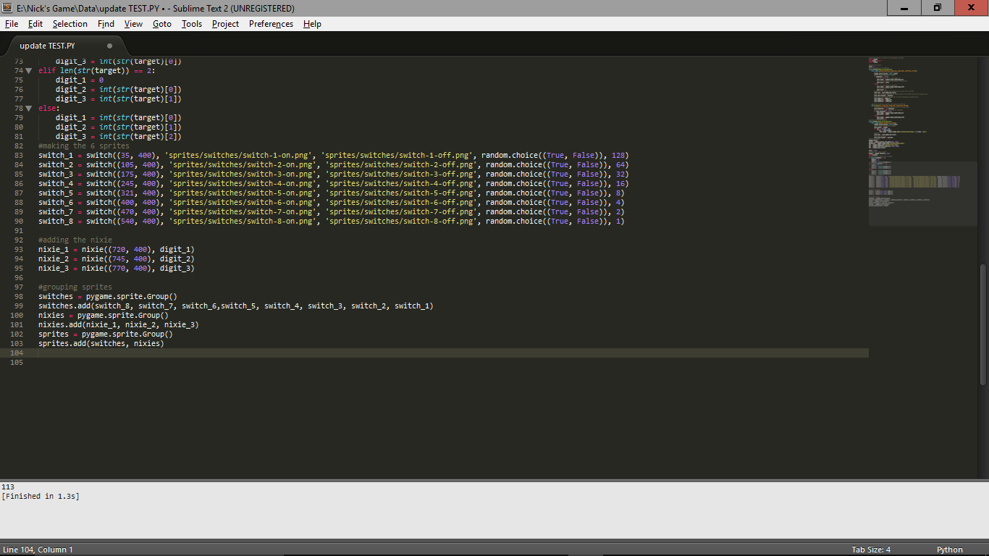  
The number 113 being the target number that it happened to generate that time of running.

After adding the following lines, the output changes significantly. The sprites are now drawn to the screen and the display is updated so that you can see the result.

1. sprites.draw(screen)
2. pygame.display.update()

The result of running the program now looks like this:

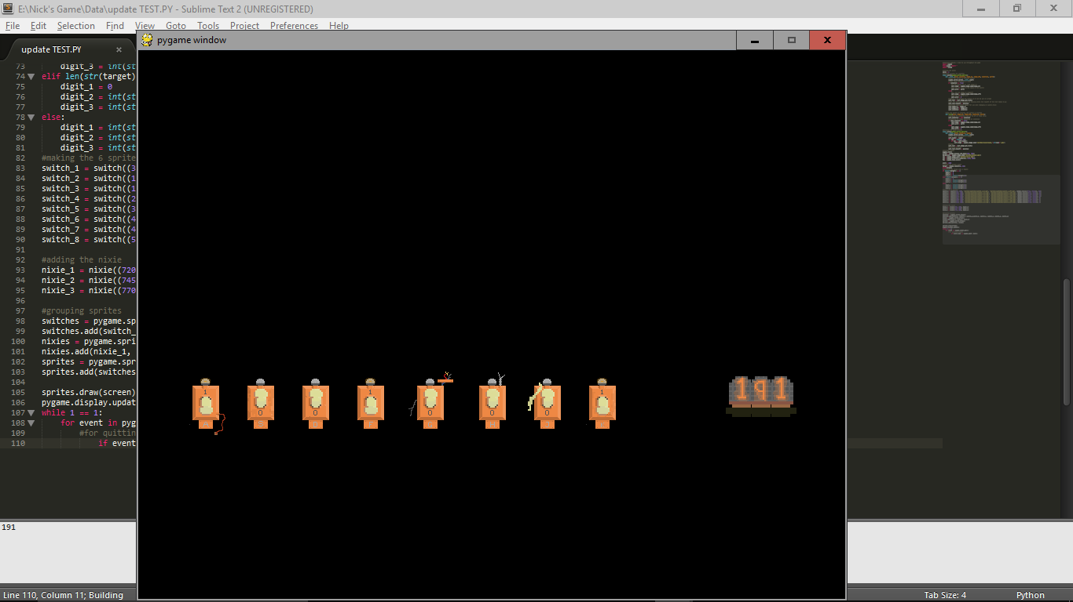

This time, 191 is the target numeber, this number was displayed both on the nixie tubes and the output window, which means that the number is being displayed correctly on the nixie tubes, as it correlates to the directly outputted number. The conclusion of this is that both the number splitting system (which was tested earlier) and the nixie display system both work correctly. The switches are all also oriented randomly as intended, the correct image is being used for the correct switch as well, which is good. Therefore, at this point, there are no bugs in the program, and I am ready to move on to the main game loop.

### Main Loop

#### Setting up background

1. #starting event loop
2. **while** True:
3. #Drawing the background and sprites
4. screen.fill((255, 255, 255))
5. **if** skycount < 30:
6. screen.blit(sky, (-5, 10))
7. **elif** skycount < 60:
8. screen.blit(sky, (-2, 10))
9. **elif** skycount < 90:
10. screen.blit(sky, (0, 10))
11. **elif** skycount < 120:
12. screen.blit(sky, (-2, 10))
13. skycount += 1
14. **if** skycount == 120:
15. skycount = 0
17. screen.blit(background, (0, 0))
18. sprites.draw(screen)
20. #flipper
21. screen.blit(flipper_1, (480, 500))
22. screen.blit(flipper_2, (550, 500))
23. screen.blit(flipper_3, (620, 500))

to start the main game loop, I used ‘while True’, because True means it will always work, it will keep looping forever. The first thing I do is fill the screen so it’s all white, this means that every time the game loops back to the start, it’ll clear the screen and won’t overlap with itself. I then check the variable ‘skycount’, depending on what this variables value is, I blit the sky to a slightly different position, then add one to ‘skycount’. This means that the sky will move back and forth slowly as you play the game. Once skycount gets to 120, it resets back to 0 to start the movement cycle again. After this, it blits the background, which we earlier set to be a picture of the cockpit, and draws all the sprites on top of it. Finally it blits the flippers to the screen, these are just images, not sprites. I have drawn all of the images I need and white box tested what I have so far. 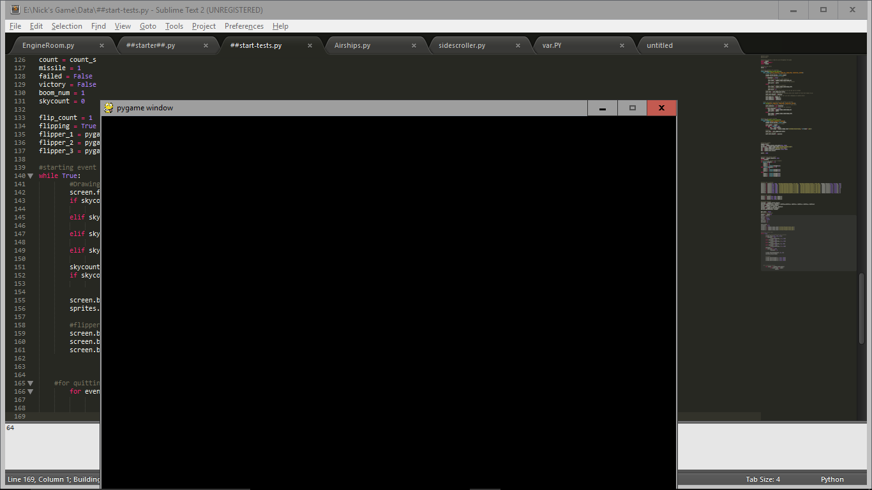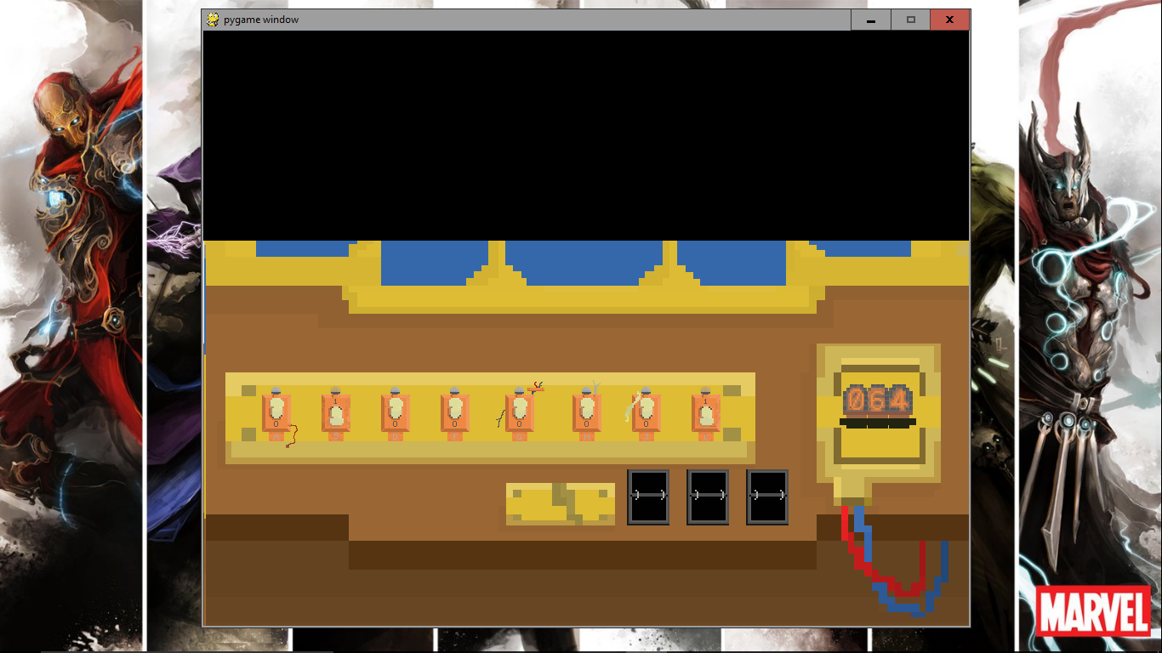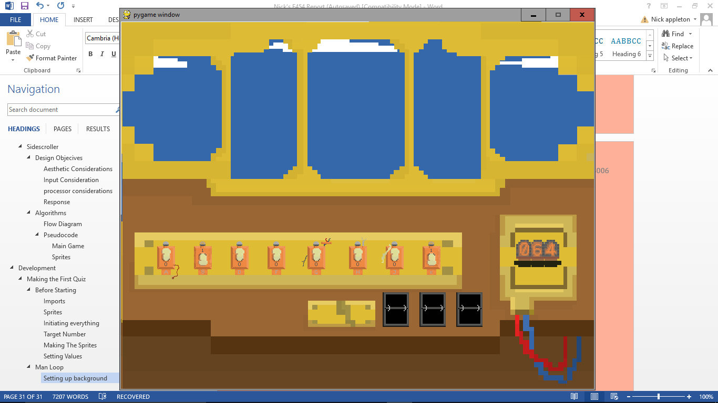

When I first ran it, the screen was completely black. I dragged it off the bottom of the screen and when it came back onscreen it was correct, however, the sky wasn’t moving. I realise that this is because I didn’t update the display, so it doesn’t show up properly. I also had no way to quit the game;when you try to press the close button the game freezes and then stops responding, so the next thing I will add is the quit feature.

#### Quitting the game

1. #for quitting pygame
2. **for** event **in** pygame.event.get():
3. **if** event.type == QUIT:
4. exit()

I added these lines to let the game quit properly. When the program gets an event (mouse click, button press, etc.) it checks if the event was pressing the x in the top right, if it is, it quits the game.

##### White Box Testing

I also added these lines at the very end of the loop and tested it again:

1. pygame.display.update()
2. 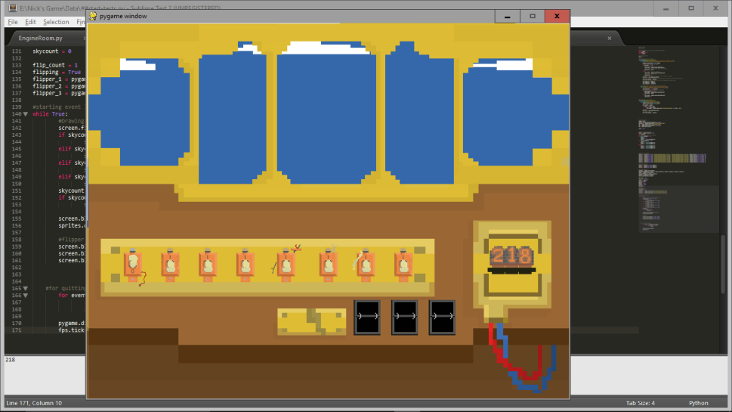fps.tick(60)

The top line updates the display, so puts in all of the changes the program has made in the loop, and the second line means that the loop will tick 60 times every second.

After testing, I found that the sky does move back and forth, and everything is in the right place. Pressing the quit button also successfully closes the game.

#### Pressing the buttons

1. #while game in progress
2. **if** failed == False **and** victory == False:
3. #run switch.flick to flick the switch when key pressed
4. **if** event.type == pygame.KEYDOWN:

Line 2 is making sure this only works while the game is being played, not when you’ve either won or lost. Line 4 is saying, if the event which we detected earlier before quitting is a button being pressed. Nested within this is as follows:

1. **if** event.key == pygame.K_a:
2. switch_1.flick(switch_1.image_on, switch_1.image_off, switch_1.condition, 128)
3. **if** event.key == pygame.K_s:
4. switch_2.flick(switch_2.image_on, switch_2.image_off, switch_2.condition, 64)
5. **if** event.key == pygame.K_d:
6. switch_3.flick(switch_3.image_on, switch_3.image_off, switch_3.condition, 32)
7. **if** event.key == pygame.K_f:
8. switch_4.flick(switch_4.image_on, switch_4.image_off, switch_4.condition, 16)
9. **if** event.key == pygame.K_g:
10. switch_5.flick(switch_5.image_on, switch_5.image_off, switch_5.condition, 8)
11. **if** event.key == pygame.K_h:
12. switch_6.flick(switch_6.image_on, switch_6.image_off, switch_6.condition, 4)
13. **if** event.key == pygame.K_j:
14. switch_7.flick(switch_7.image_on, switch_7.image_off, switch_7.condition, 2)
15. **if** event.key == pygame.K_k:
16. switch_8.flick(switch_8.image_on, switch_8.image_off, switch_8.condition, 1 )
17. **if** event.key == pygame.K_RETURN:
18. get_value = True

This part just goes through every key from A to K, if that key is pressed, it does the ‘flick’ function of the relevant switch, giving it the augments it needs. If the key that’s pressed is return, then it sets ‘get_value’ to true, this will be used later to initiate the flippers.

#### While game’s running

1. #while game in progress
2. **if** failed == False **and** victory == False:
4. #moving on the missile animation
5. **if** count <= 0:
6. count = count_s + count
7. missile += 1

The next section of the program will only run if both ‘failed’ and ‘victory’ are equal to false. To start, the game checks if count is below 0, if it is, it resets count to what count started as (count_s) and adds what count is left, which will be negative. This is because when I tested it, if count didn’t ever equal 0, when the game ended, the missile wasn’t on the number it should have been, this means when I add the images, the missile would have been further away than it should have. By adding ‘count’, I take away the amount of time that would have been lost, keeping the overall time correct.

1. #adding the timer and victory/failure conditions
2. score -= 1
3. value = switch_1.worth + switch_2.worth + switch_3.worth + switch_4.worth + switch_5.worth + switch_6.worth + switch_7.worth + switch_8.worth
4. **if** get_value == True:
5. **if** len(str(value)) == 1:
6. flip_num_1 = '0'
7. flip_num_2 = '0'
8. flip_num_3 = str(value)[0]
9. **elif** len(str(value)) == 2:
10. flip_num_1 = '0'
11. flip_num_2 = str(value)[0]
12. flip_num_3 = str(value)[1]
13. **else**:
14. flip_num_1 = str(value)[0]
15. flip_num_2 = str(value)[1]
16. flip_num_3 = str(value)[2]

To begin this section, I take one from score, so it’ll count down 1 every tick. I then set the variable ‘value’ to each of the values of the switches (either 0 or their specific number). If get_value is true (if they’ve pressed enter), it uses a very similar piece of code to the one used for the nixies to separate the variable ‘value’ into three digits, one for each flipper.

1. **if** flip_count < 25:
2. flipper_1 = pygame.image.load('sprites/flipper/'+str(flipping)+'.png')
3. **else**:
4. flipper_1 = pygame.image.load('sprites/flipper/'+flip_num_1+'.png')
5. **if** flip_count < 50:
6. flipper_2 = pygame.image.load('sprites/flipper/'+str(flipping)+'.png')
7. **else**:
8. flipper_2 = pygame.image.load('sprites/flipper/'+flip_num_2+'.png')
9. **if** flip_count < 75:
10. flipper_3 = pygame.image.load('sprites/flipper/'+str(flipping)+'.png')
11. **else**:
12. flipper_3 = pygame.image.load('sprites/flipper/'+flip_num_3+'.png')
13. get_value = False
14. flip_count = 0

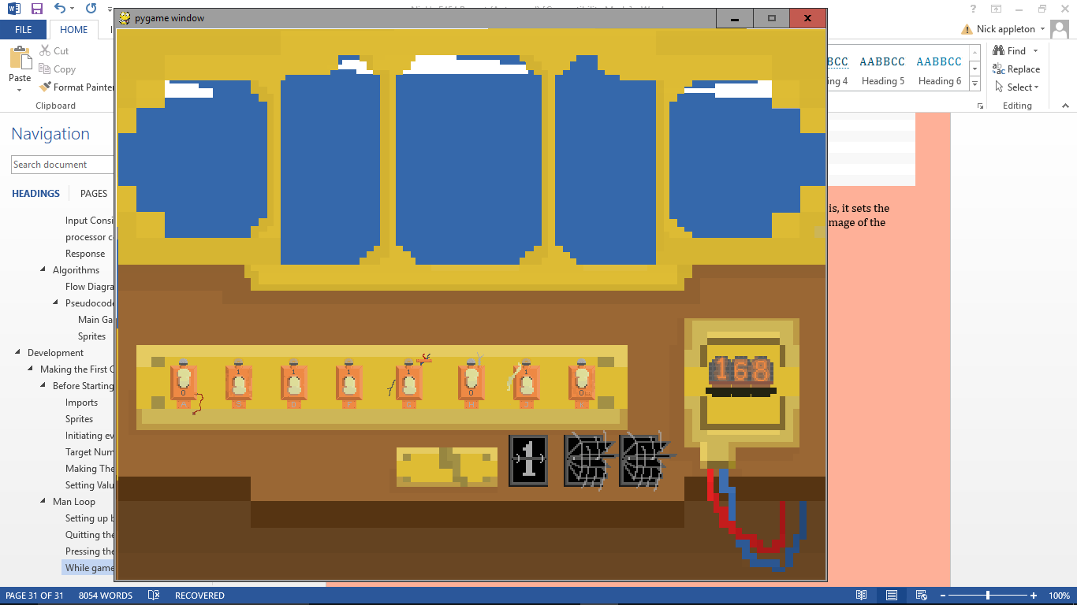To start, it checks whether the ‘flipper_count’ variable is below the three milestone values, if it is, it sets the relevant flippers image to one of two images (constantly changing), if not, then it sets it to the image of the number on the flipper, it has three milestone values so that each flipper stops one at a time.

##### White Box Testing

After testing, I found that everything works, switches switch and flippers flip. The switches also successfully change the value correctly. The only problem is that if you flip any switches while the flippers are flipping, it changes the value instantly on the flippers, rather than waiting until the flipping has ended.

To fix this I’m going to add a line when the player presses enter, that sets a variable called value_temp to the same value as value, then set the flip_num variables will be set to this new temp value so it won’t change during flipping.

This seems to have fixed the problem.

#### Victory/Faliure conditions

1. **if** value == target:
2. **print**('CORRECT')
3. victory = True
4. count = 0
5. **if** score <= 0:
6. **print**('FAILED')
7. failed = True
8. count = 0

If the value you’re on is equal to the target value, it will set victory to true, print ‘correct’, and reset the count variable. If the score is all the way to 0, it will print ‘failed’, set failed to true, and reset count.

1. #drawing and animating the missile
2. **if** missile < 22:
3. missile_img = 'sprites/missile/'+ str(missile) +'.png'
4. load_missile = pygame.image.load(missile_img)
5. screen.blit(load_missile, (350, 100))
6. count -= 1

There are only 21 missile sprites, so if it is above 21, it will crash if it tries to run this section so I’ve done a validity check on line 2.

#### Victory

1. #applying victory
2. **if** victory == True:
3. count += 1
4. victory_banner = pygame.image.load('sprites/VICTORY.png')
5. screen.blit(victory_banner, (75, 300))
6. **if** missile < 13:
7. **if** boom_num < 3:
8. screen.blit(load_missile, (350, 100))
9. explosion = pygame.image.load('sprites/explosion/'+str(boom_num)+'.png')
10. screen.blit(explosion, (400, 230 - missile*8))
11. **elif** boom_num < 9:
12. explosion = pygame.image.load('sprites/explosion/'+str(boom_num)+'.png')
13. screen.blit(explosion, (400, 230 - missile*8))
15. **elif** missile < 18:
16. **if** boom_num < 3:
17. screen.blit(load_missile, (350, 100))
18. explosion = pygame.image.load('sprites/explosion/'+str(boom_num)+'.png')
19. explosion = pygame.transform.scale(explosion, (10*missile, 10*missile))
20. screen.blit(explosion, (377, 100))
21. **elif** boom_num < 9:
22. explosion = pygame.transform.scale(explosion, (10*missile, 10*missile))
23. screen.blit(explosion, (377, 100))
25. **elif** missile < 21:
26. **if** boom_num < 3:
27. screen.blit(load_missile, (350, 100))
28. explosion = pygame.image.load('sprites/explosion/'+str(boom_num)+'.png')
29. explosion = pygame.transform.scale(explosion, (15*missile, 15*missile))
30. screen.blit(explosion, (323, 35))
31. **elif** boom_num < 9:
32. explosion = pygame.image.load('sprites/explosion/'+str(boom_num)+'.png')
33. explosion = pygame.transform.scale(explosion, (15*missile, 15*missile))
34. screen.blit(explosion, (323, 35))
36. **elif** missile < 23:
37. **if** boom_num < 3:
38. screen.blit(load_missile, (350, 100))
39. explosion = pygame.image.load('sprites/explosion/'+str(boom_num)+'.png')
40. explosion = pygame.transform.scale(explosion, (15*missile, 15*missile))
41. screen.blit(explosion, (300, 35))
42. **elif** boom_num < 9:
43. explosion = pygame.image.load('sprites/explosion/'+str(boom_num)+'.png')
44. explosion = pygame.transform.scale(explosion, (15*missile, 15*missile))
45. screen.blit(explosion, (300, 35))
47. **if** count == 3:
48. count = 0
49. boom_num += 1

If victory is True, then it loads the ‘victory’ banner and displays it. The rest of the code is checking where the missile is and blitting the explosion and counting up more.

#### Starting the End

1. #initialising failure variables
2. **if** failed == True:
3. count_boom = []
4. position_boom = []
5. size_boom = []
6. **for** x **in** range(0, 10):
7. count_boom.append(random.randint(-15, 1))
8. position_boom.append((random.randint(0, 900), random.randint(0, 700)))
9. size_boom.append(random.randint(75, 300))
10. boom_tick = 1

while the game is running, if failure is equal to true then it will set all of these variables, like before the main game loop, as it’s before the failure game loop. In this list I make an array called count_boom, used for counting on the explosion animation because there’ll be multiple explosions requiring different timers.

#### Faliure Loop

1. #failure
2. **while** failed == True:
4. #reblitting background etc.
5. screen.fill((255, 255, 255))
6. **if** skycount < 30:
7. screen.blit(sky, (-5, 10))
8. **elif** skycount < 60:
9. screen.blit(sky, (-2, 10))
10. **elif** skycount < 90:
11. screen.blit(sky, (0, 10))
12. **elif** skycount < 120:
13. screen.blit(sky, (-2, 10))
14. skycount += 1
15. **if** skycount == 120:
16. skycount = 0
18. screen.blit(background, (0, 0))
19. sprites.draw(screen)
21. screen.blit(flipper_1, (480, 500))
22. screen.blit(flipper_2, (550, 500))
23. screen.blit(flipper_3, (620, 500))

This is the same as the main game loop to keep the sky moving and keep all the sprites onscreen once you fail.

1. #all small random explosions
2. **for** num **in** range(0, 10):
3. #making sure they don't overlap the large explosion
4. **if** count_boom[num] < 9 **and** count_boom[num] > 0:
5. explosion = pygame.image.load('sprites/explosion/'+str(count_boom[num])+'.png')
6. explosion = pygame.transform.scale(explosion, (size_boom[num], size_boom[num]))
7. screen.blit(explosion, position_boom[num])
8. **elif** count_boom[num] > 9:
9. count_boom[num] = random.randint(-5, 0)
10. position_boom[num] = (random.randint(0, 900), random.randint(0, 700))
11. size_boom[num]=(random.randint(75, 300))
13. count_boom[num] += 1

This code is blitting a lot of small explosions to the screen in random places. If the number is below 9, then it will blit to the screen at whatever stage it’s at in the explosion, which lasts 9 frames. If it is beyond the last frame, it will set the time until that particular explosion starts again to a random time, and it’ll give it a new random position and size.

1. #blitting the large explosion
2. lrg_explosion = pygame.image.load('sprites/explosion/'+str(boom_tick)+'.png')
3. lrg_explosion = pygame.transform.scale(lrg_explosion, (600, 600))
4. screen.blit(lrg_explosion, (160, -30))
6. #ticking the large explosion
7. **if** count == 5:
8. boom_tick += 1
9. count = 0
11. **if** boom_tick == 7:
12. exit()

This part of the code is for blitting the main missile explosion in the middle of the screen. It defines the image of the large explosion depending on the boom_tick variable, It then checks if the animation has finished (if boom_tick is 7) if not, it increments boom tick, but if so, it exits the game window and stops the program.

1. faliure_banner = pygame.image.load('sprites/FAILED.png')
2. screen.blit(faliure_banner, (135, 50))
3. pygame.display.update()
4. fps.tick(60)

This final part to my program loads the failure banner and displays it in the middle of the screen, and then updates the screen, and restarts the failure loop. This is the end of the program.

## Testing the First Quiz

### Alpha Testing

#### Testing the Fuctionality

I began by testing the general functionality of the game. When first starting the game, the number was randomly generated successfully, along with all the sprites and everything else. The switches all start in a random orientation, too.

Showing the random nature of the target number and the switch orientation:

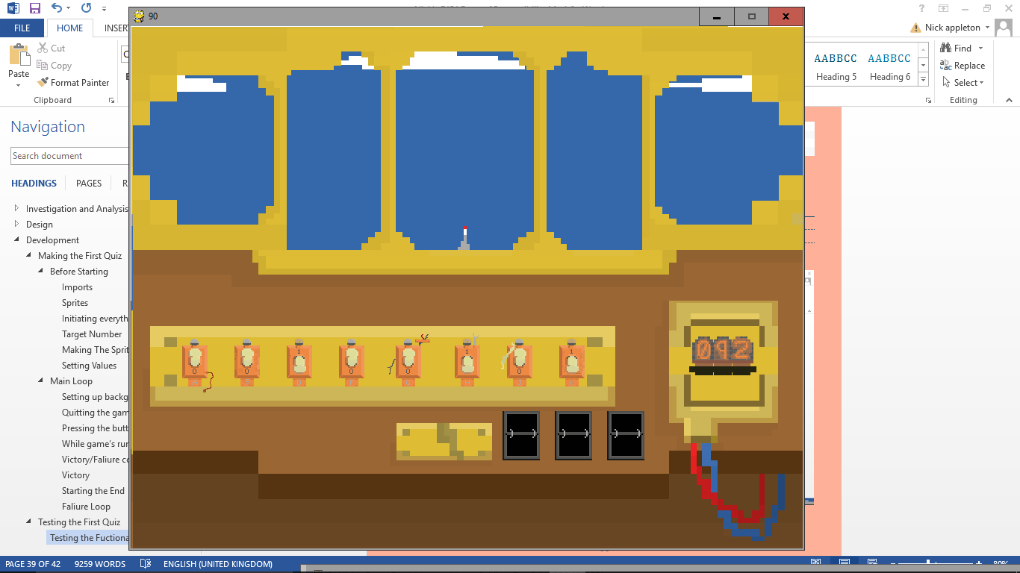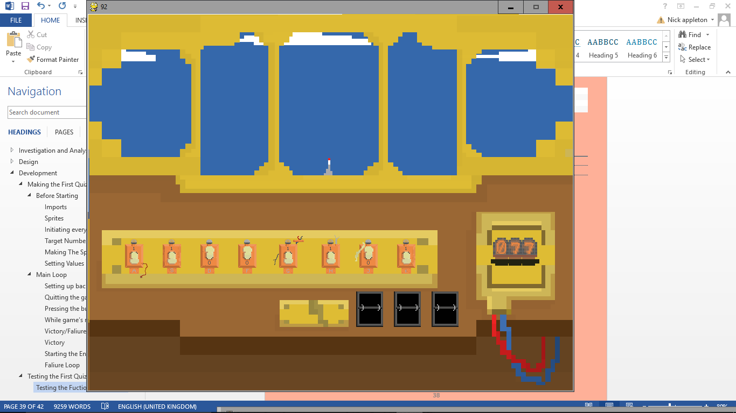

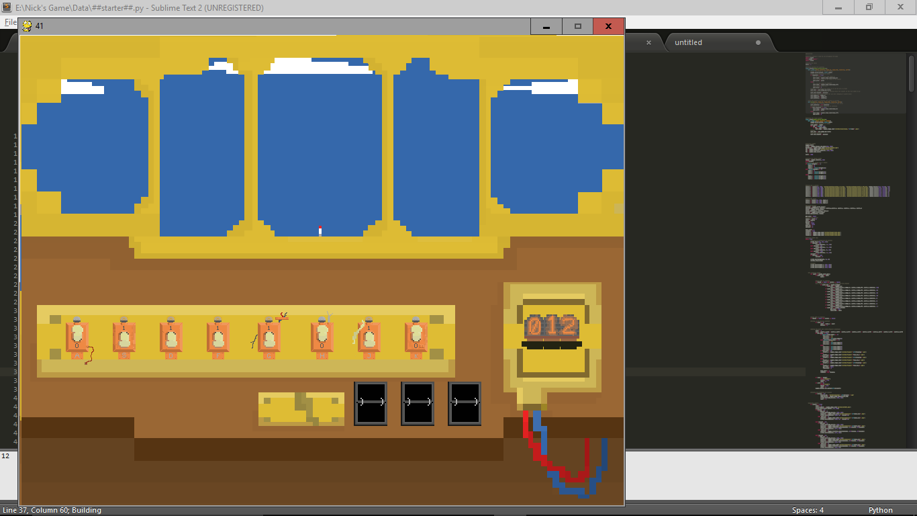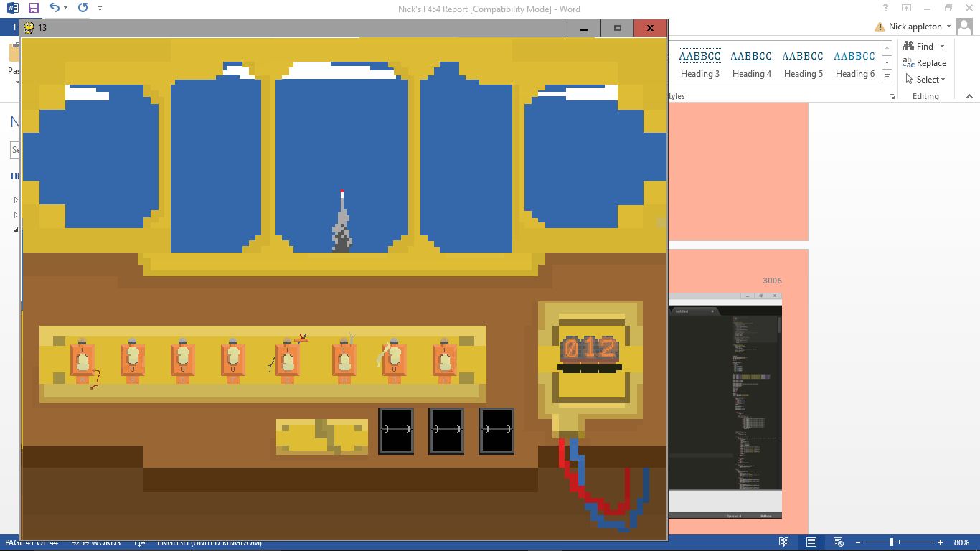

After this I checked that the values changed successfully when the switches are flicked, starting with the borderline values: 0 and 255, making sure it adds up correctly, then doing 1, 2, 8, 10, and 50.

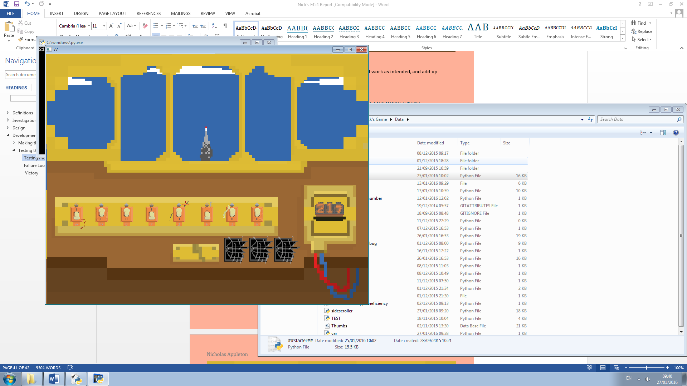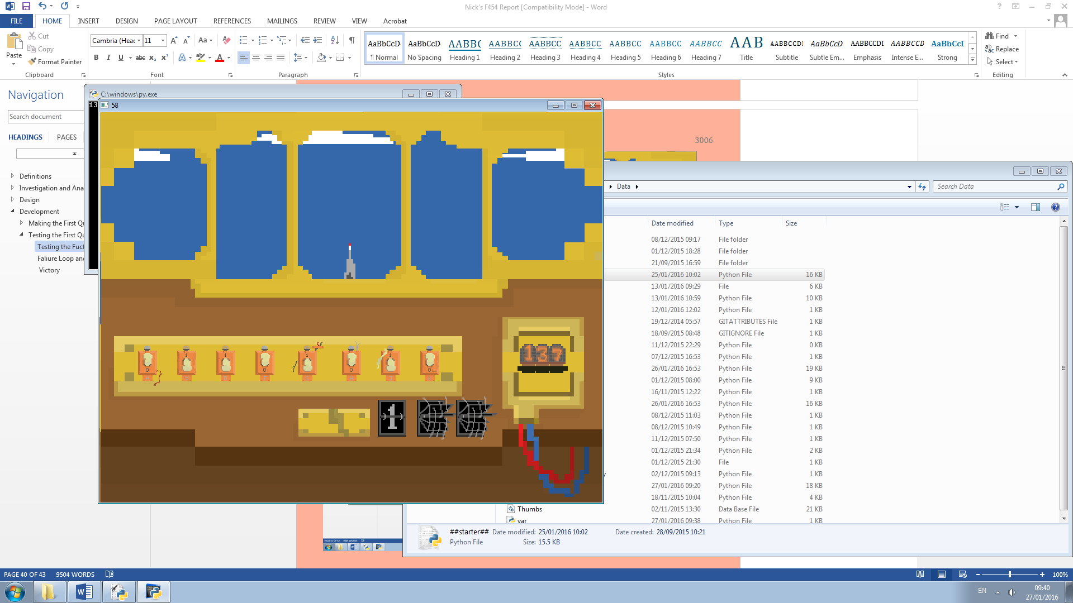

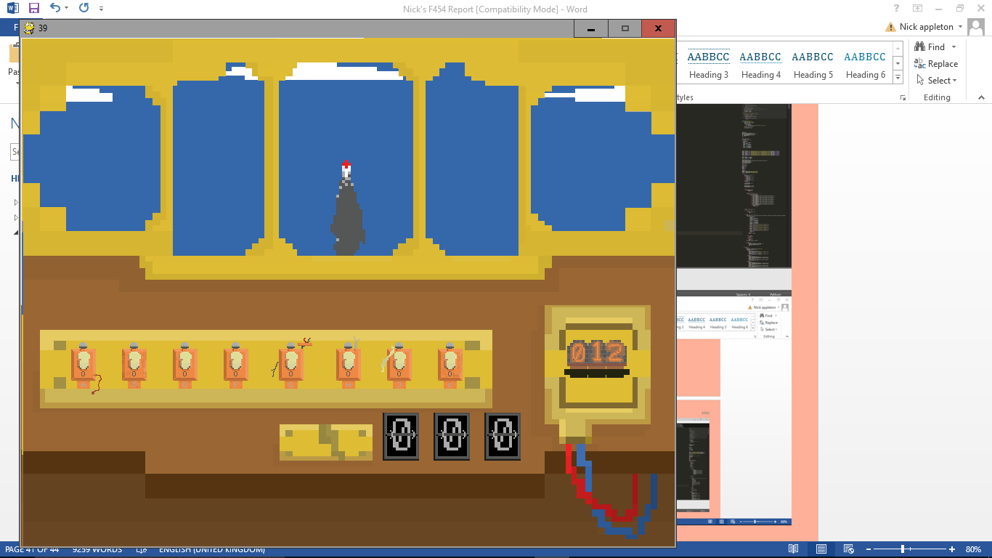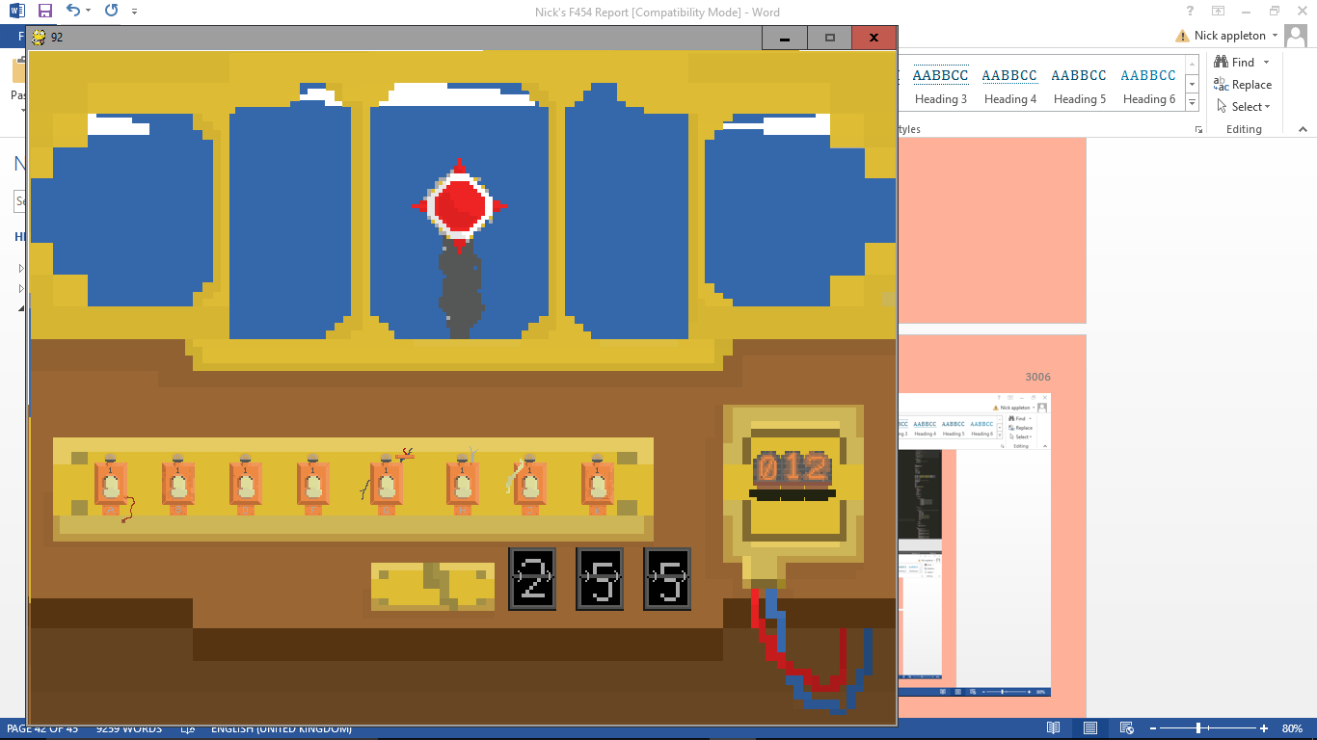

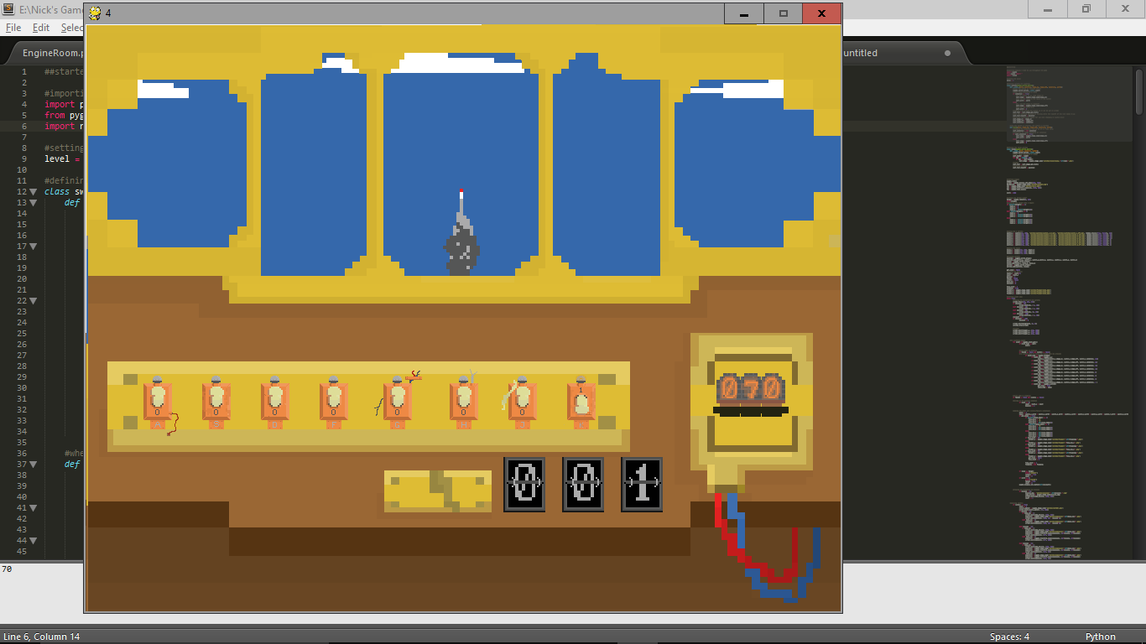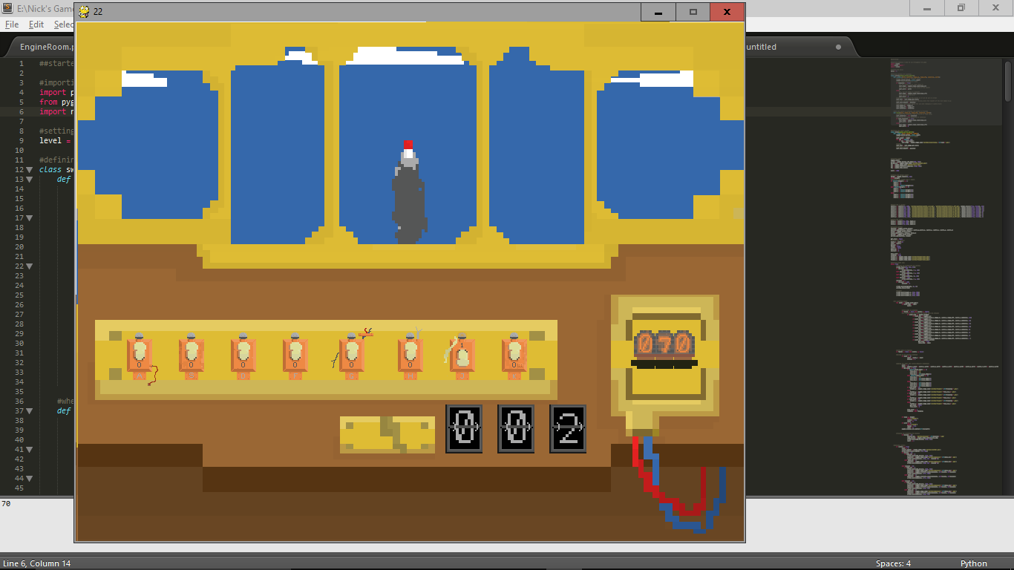

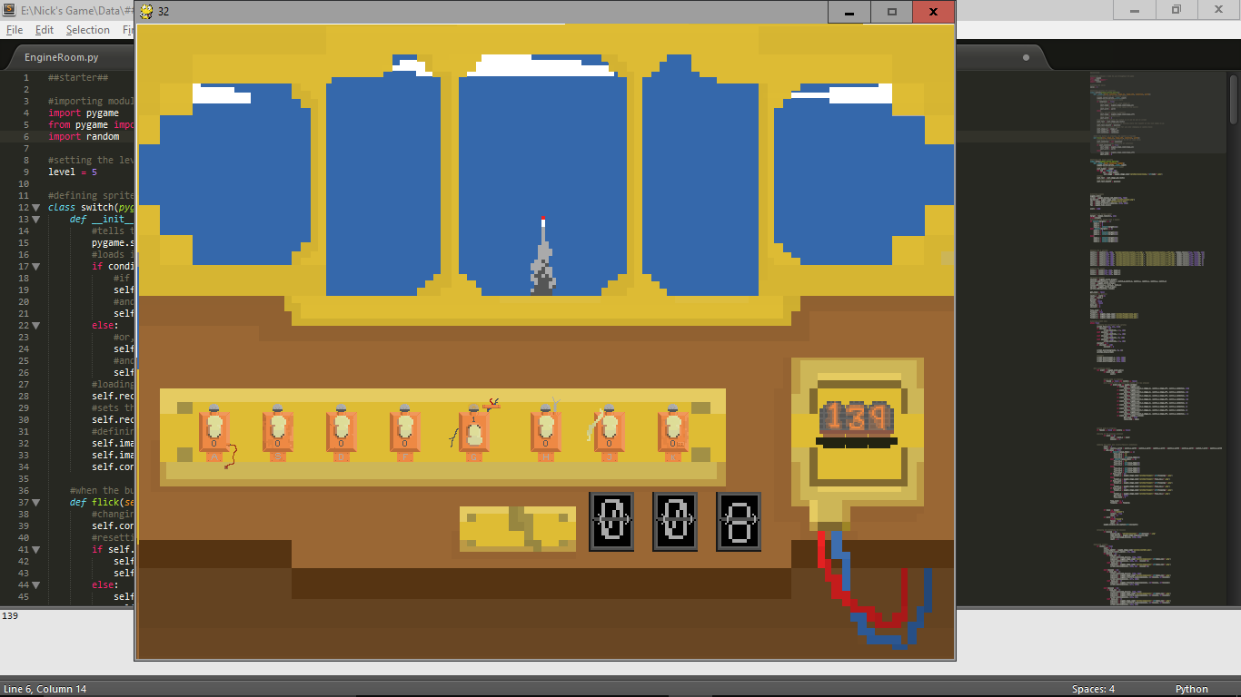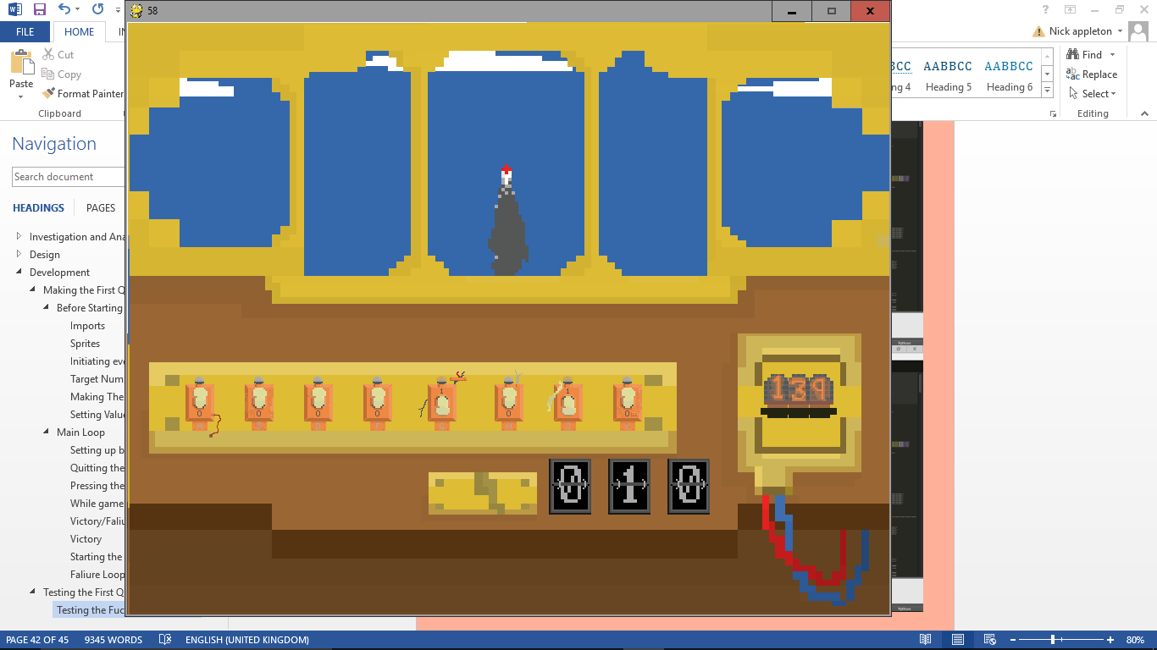

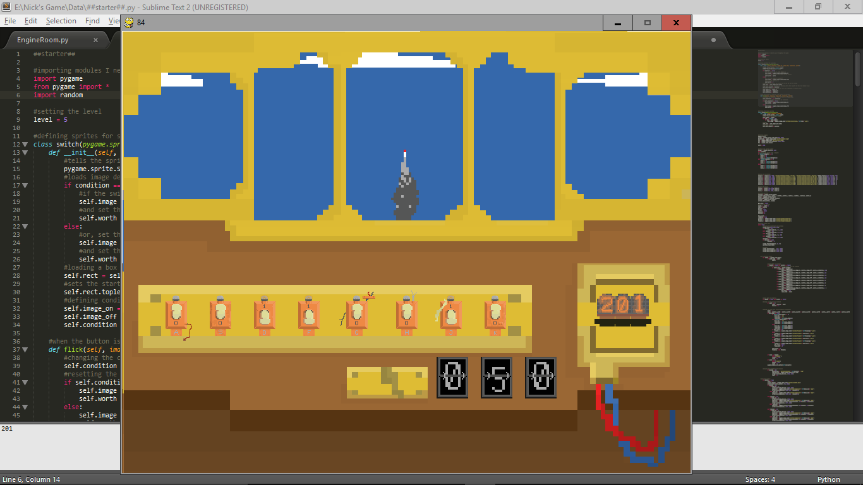The switches all work as intended, and add up correctly. Also the flipper animation works correctly. One bug I did find however, is that while the flippers are flipping, like before when changing the value on the switches would change the value on the flippers, if you press enter while they are still flipping, the number will change to whatever the number is now, rather than starting the animation again. This is something I will change in the next version.

#### Faliure Loop and missile Test

The next test I’m conducting will be just letting the game run, making sure the missile animation works correctly, as well as the failure loop.

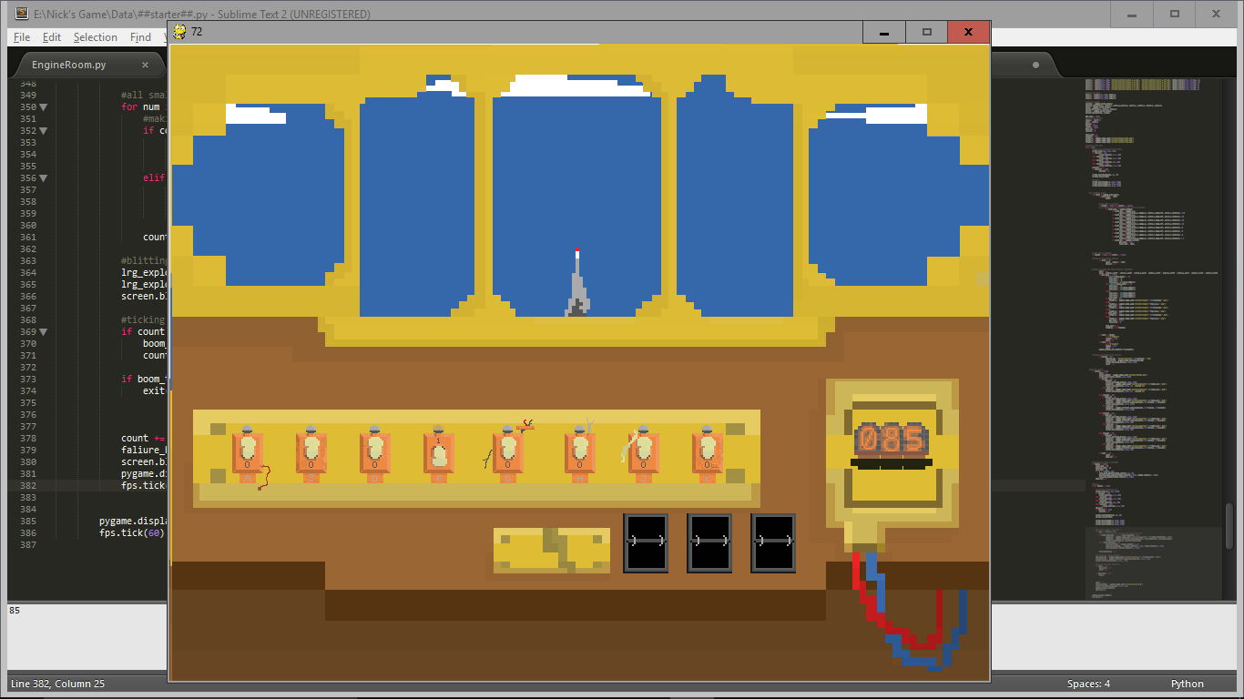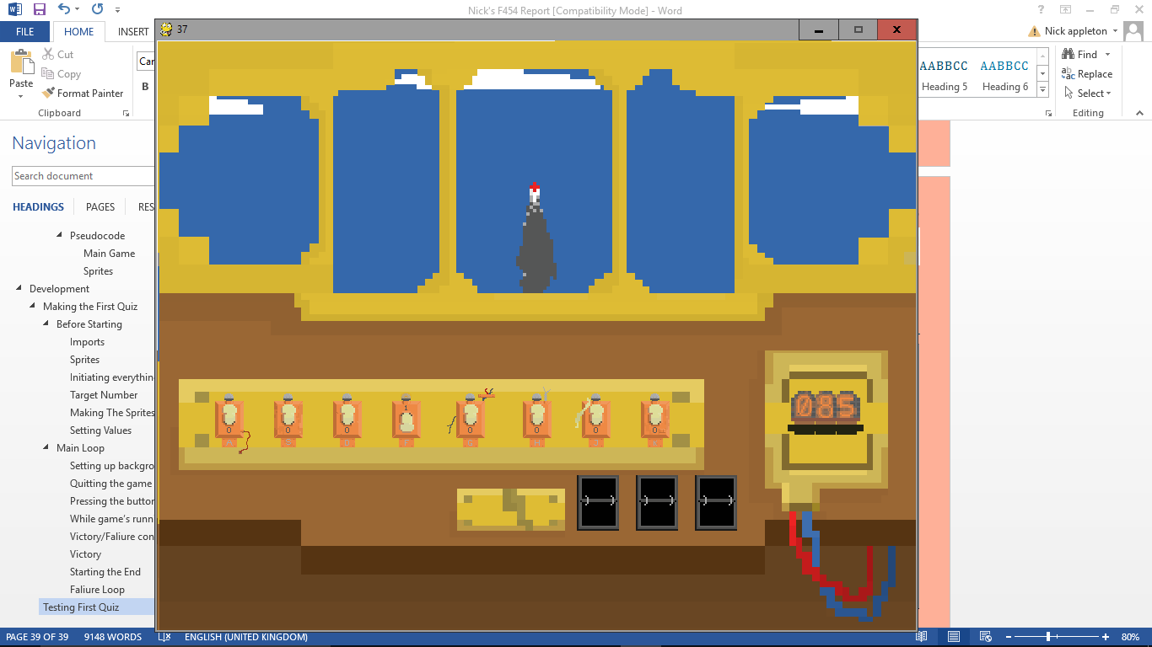

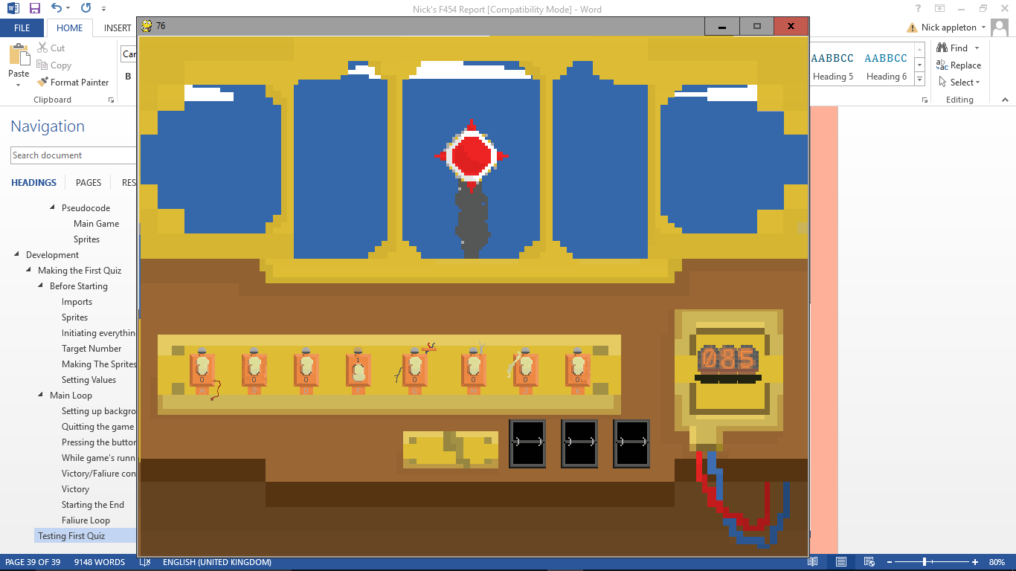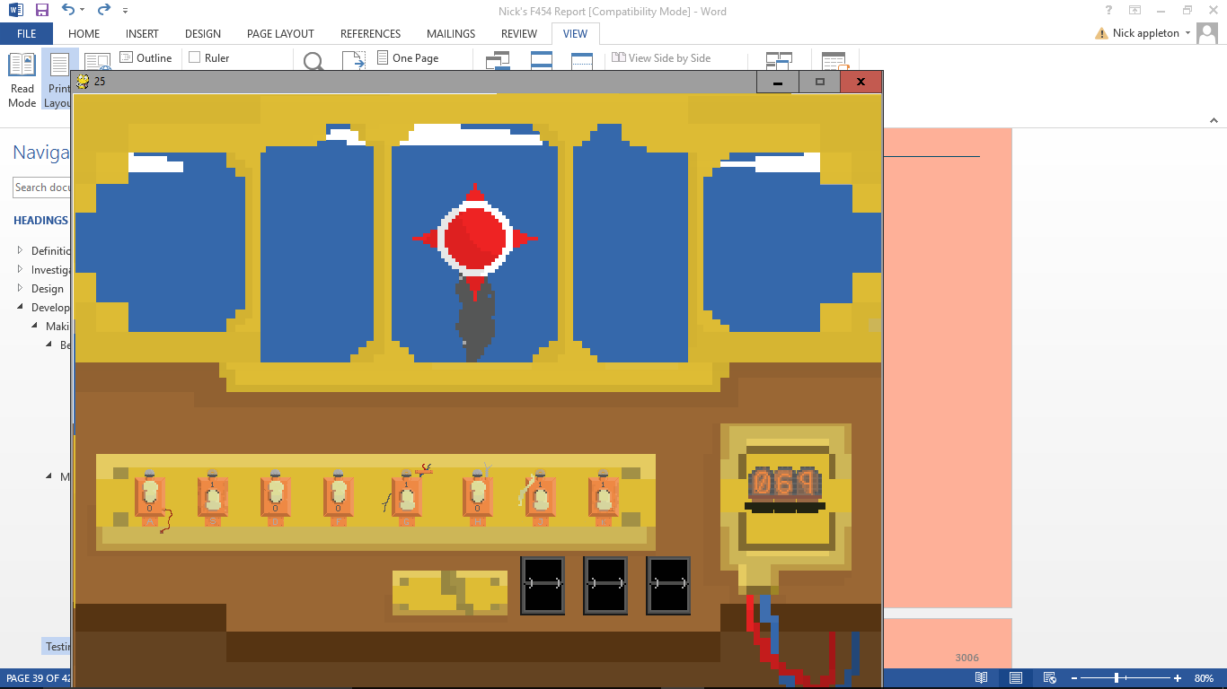

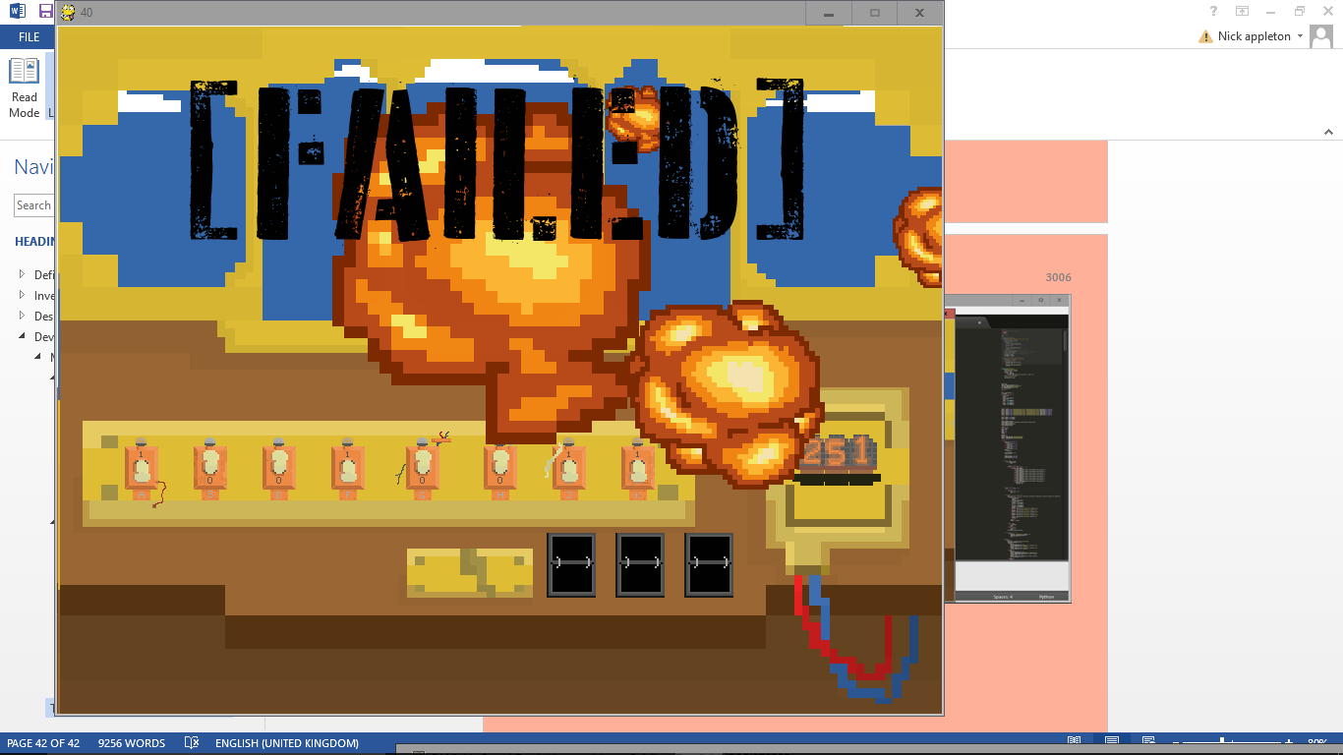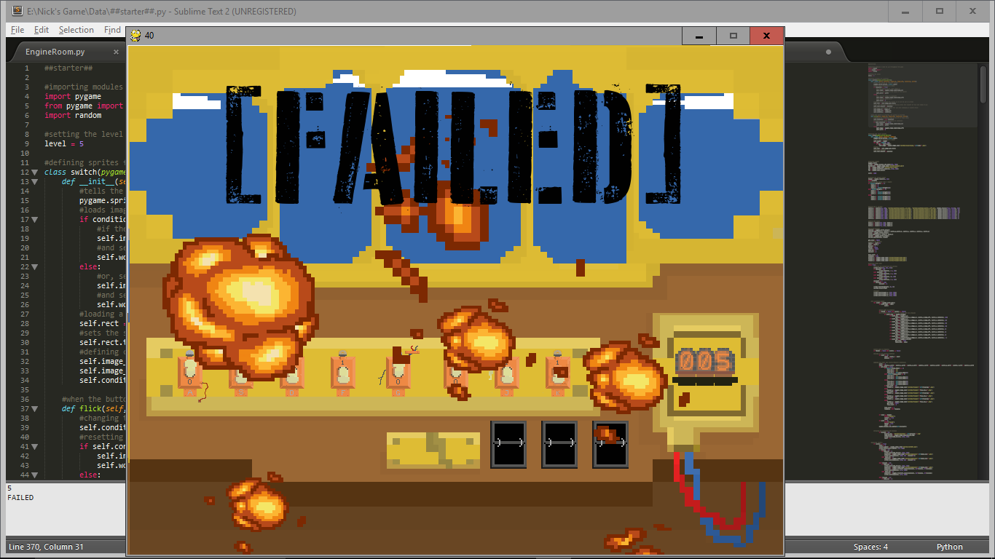

The missile animation and Faliure loop all works, as well as the explosion no longer can explode premeturely. The explosions all appear to be random and onscreen, apart from some bits that are only partially onscreen, but I don’t feel that this matters as you can still see the explosion. However, I could fix this by changing the parameters of the random selection of the location.

#### Victory

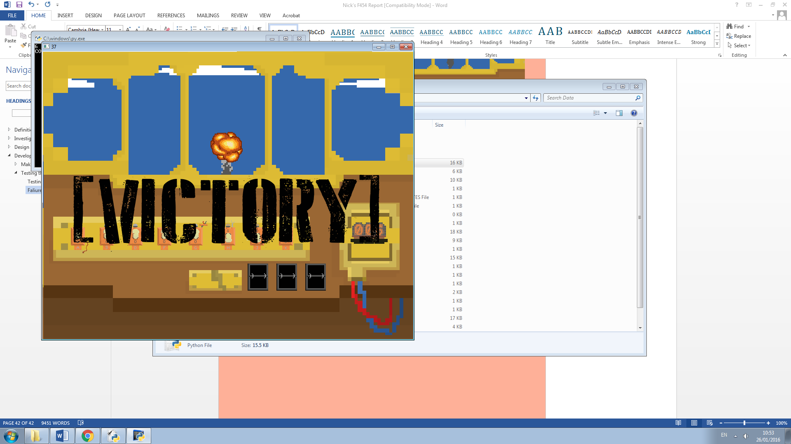When the number on the switches is equal to the target number, the missile explodes in the air. The animation works as the smoke disappears half way through the explosion animation so the missile is gone when the explosion fades, but doesn’t just disappear immediately. The victory banner also does blit correctly.

### Beta Testing

I gave my game to a class of year 8 students that are currently learning this topic on Wednesday, January the 6th. They played with the game for 15 minutes, and gave me some feedback at the end of their lesson on a feedback form that I gave them 1 between 3. The form is as follows:

Response to ‘First Quiz’ Game feedback form.

Please answer as truthfully as you can, your feedback is appreciated.

1. Did you understand the game? Y/N
2. Did you enjoy the game? Y/N
3. Did you find the game too difficult? Y/N
4. What did/didn’t you like about the game?
5. What could be improved in the game?

The answers to the Y/N questions were quite standard.

1. 10Y/0N
2. 8Y/2N
3. 9Y/1N

Questions 4 and 5 on the other hand told me a few very important problems with the execution of some of the aspects of the game. These included that some of the people thought that the flippers were too slow (a common answer to question 4), however, I talk to some of them afterwards and explained to them that the purpose was to stop them spamming it and to discourage them using it as much as possible, and they said that that made sense. The most prominent problem brought up in question 5 however, was when someone said that they could just hit the buttons randomly and win the game. I had also seen other people doing this while walking around the class. This is because as soon as you get the right answer, you win; you don’t have to confirm that you think you have the right answer first. I also found this when playing, I’d get near the number, think of some changes I’d need to make to it, but before I’d finished my corrections it’d finish, saying I won. To change this I think I’m going to add a button that you have to press to confirm your guess, if you’re right you win, but if you’re wrong then the missile will speed up temporarily.

All the changes that I will make from testing will be implemented along with optimsation when I have made the rest of the parts to the game as I’ll also need to add in things to make them all interact correctly as well as adding the fixes.

# Engine Room Quiz

## Plan

Because of the similarities between this and the first quiz, I’ll be using it as a template, so in this first form they’ll probably be quite similar, however, I’ll continue to develop both as the game becomes more comprehensive, so they will most likely diverge.

## Making the Assets

While functionally it’s quite similar, the aesthetics of the engine room and the cockpit are very different, so I’m drawing up all of the images for the new quiz before starting to make the testing easier: I’ll just have to call up the images rather than drawing them as I go.

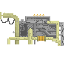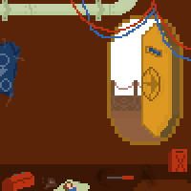This is the room itself. The big blank wall is where most of the stuff will happen, it will house the engine and the switches, as well as the altimeter. The target number will hang down on painted panels from the big pipe at the top. The door acts as a sort of timer, too. The smoke outside will get more intense as the time runs out.

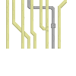This is the engine. It’s to add aesthetic value to the scene. It doesn’t do much, just moves from side to side to simulate the juddering of an engine.

The pipes are there as a platform on which the valves (switches), and altimeter will be. These will also judder.

These are the valves that will act as the switches on this version of the quiz (left, above). The valves can be open or closed, like the on or off of the switches. This time it’s harder to tell whether they’re on or off, so I’m going to add some lights above the valves indicating whether they’re off or on (left, below).



These are all the altimeter images. As the timer runs down it’ll switch the images to the ‘lower altitude’ image.

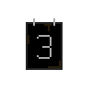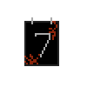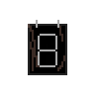

These are the numbers used for the target number. They’ll hang from the pipe at the top.

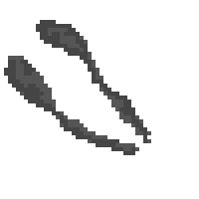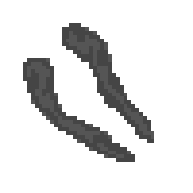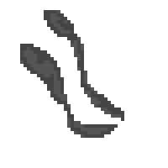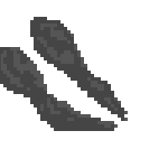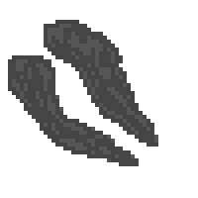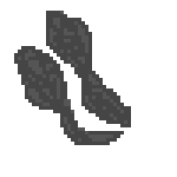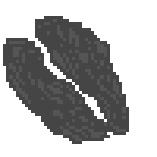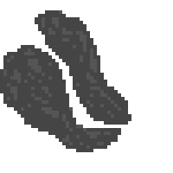

These are three sets of three images used for the smoke on the outside of the ship. The first line will flick between the three, looking like the smoke is blowing about, then, when the timer has run down enough, the second line will take over, then the third. This is a bit like the missile in the first quiz.

## Making the Enigne Room Quiz

### Setup

#### Imports

1. # Engine room #
2. **import** pygame
3. **import** random
5. level = 1

This is the same as the first quiz. Importing both pygame, random, and setting the level to 1.

#### blit_all Function

##### Global Functions

1. **def** blit_all():
2. **global** smoke_count
3. **global** smoke_num
4. **global** smoke_size
5. **global** chug
6. **global** count

This function is used to blit everything onto the screen. It starts by importing all of the variables it needs; as it’s blitting everything it needs all of the visual variables that link to things like the smoke, and engine (chug).

##### Smoke

1. screen.blit(sky, (0, 0))
2. **if** time <= 0: smoke_size = 3
3. smoke1 = pygame.image.load('sprites/smoke/'+str(smoke_size)+'_1.png')
4. smoke1 = pygame.transform.scale(smoke1, (400, 400))
5. smoke2 = pygame.image.load('sprites/smoke/'+str(smoke_size)+'_2.png')
6. smoke2 = pygame.transform.scale(smoke2, (400, 400))
7. smoke3 = pygame.image.load('sprites/smoke/'+str(smoke_size)+'_3.png')
8. smoke3 = pygame.transform.scale(smoke3, (400, 400))

First, this section blits the sky. In this version of the quiz, the sky will not move. After this, it makes sure that if the time is up, the smoke is as large as it can be. It then defines three variables for the smoke: each one represents each of the three images of each size. It loads the image for each, depending on the size the smoke should be, then transforms the scale so that they fit on the screen properly.

1. **if** smoke_count < 4:
2. screen.blit(smoke1, (450, 50))
3. **elif** smoke_count < 8:
4. screen.blit(smoke2, (450, 50))
5. **elif** smoke_count < 12:
6. screen.blit(smoke3, (450, 50))
7. **elif** smoke_count < 16:
8. screen.blit(smoke2, (450, 50))

This section is blitting the correct one of the three smoke variables depending on the variable ‘smoke_count’. As ‘smoke_count’ increases, the smoke will flicker between the three images.

1. smoke_count += 1
2. **if** smoke_count == 16:
3. smoke_count = 0
4. **if** count <= 0:
5. count += count_s
6. smoke_size += 1

this last part increments the smoke_count variable, then checks if it’s equal to 16, if it is then it’ll reset it to so that the smoke cycle starts again. When the ‘count’ variable reaches 0, it resets itself, then adds one to the size of the smoke

##### Engine and Pipes

1. screen.blit(deck, (0, 0))
2. **if** chug < 1:
3. screen.blit(pipes, (60, 46))
4. screen.blit(engine, (-10, 250))
5. **elif** chug < 6:
6. screen.blit(pipes, (60, 47))
7. screen.blit(engine, (-11, 250))
8. **elif** chug < 9:
9. screen.blit(pipes, (60, 48))
10. screen.blit(engine, (-12, 250))
11. **elif** chug < 12:
12. screen.blit(pipes, (60, 47))
13. screen.blit(engine, (-11, 250))
14. chug += 1
15. **if** chug == 12: chug = 0

The deck is blitted over the sky and smoke, then it does something very similar to the sky in the first quiz to decide where the engine and pipes should be depending on the chug variable. At the end it adds one to chug then checks if it needs to be reset.

##### Plaques

1. #the plaques
2. screen.blit(pygame.image.load('sprites/plaque/1.png'), (60, 205))
3. screen.blit(pygame.image.load('sprites/plaque/2.png'), (100, 205))
4. screen.blit(pygame.image.load('sprites/plaque/3.png'), (160, 205))
5. screen.blit(pygame.image.load('sprites/plaque/4.png'), (220, 205))
6. screen.blit(pygame.image.load('sprites/plaque/5.png'), (280, 205))
7. screen.blit(pygame.image.load('sprites/plaque/6.png'), (320, 205))
8. screen.blit(pygame.image.load('sprites/plaque/7.png'), (360, 205))
9. screen.blit(pygame.image.load('sprites/plaque/8.png'), (400, 205))

This simply blits the numbers above each of the switches to make it easier to keep track.

##### Lights

1. #lights
2. light = [0, 0, 0, 0, 0, 0, 0, 0]
3. lightcount = 0
4. **for** i **in** valves:
5. **if** i.condition == True:
6. light[lightcount] = 0
7. **else**:
8. light[lightcount] = 1
9. lightcount += 1

It first sets all of the lights to off, and the count to 0. Then checks every valves condition, if the condition is on, it sets the value to 0, otherwise it sets it to 1. The count variable here is used to keep track of which index is relevant to the valve it’s on

1. #blitting the lights
2. x = 42
3. lightcount = 1
4. **for** i **in** light:
5. **if** light[i] == 1:
6. lightstat = pygame.image.load('sprites/light_on.png')
7. **else**:
8. lightstat = pygame.image.load('sprites/light_off.png')
9. **if** lightcount <= 2 **or** lightcount > 5:
10. screen.blit(lightstat, (x+40, 120))
11. x += 40
12. **else**:
13. screen.blit(lightstat, (x+60, 120))
14. x += 60
15. lightcount += 1

This sets the x value to 42, then checks which image it needs, and loads that image. The next part (lines 9-14) is just blitting them to the right place.

To test this I have put it into its own small program and added a print function to make sure it’s processing the numbers correctly.

1. #blitting the lights
2. **import** pygame
3. screen = pygame.display.set_mode((900, 700))
4. light = [0, 1, 0, 1, 0]
5. x = 42
6. lightcount = 1
7. **for** i **in** light:
8. **if** light[i] == 1:
9. lightstat = pygame.image.load('sprites/light_on.png')
10. **else**:
11. lightstat = pygame.image.load('sprites/light_off.png')
12. **print**(light[i])
13. screen.blit(lightstat, (x, 120))
14. x += 100
15. lightcount += 1
16. pygame.display.update()
17. **while** True:
18. x = 1

as you can see from the following screenshots, this did infact work as intended, giving the correct numbers and then blitting the lights themselves also works correctly.

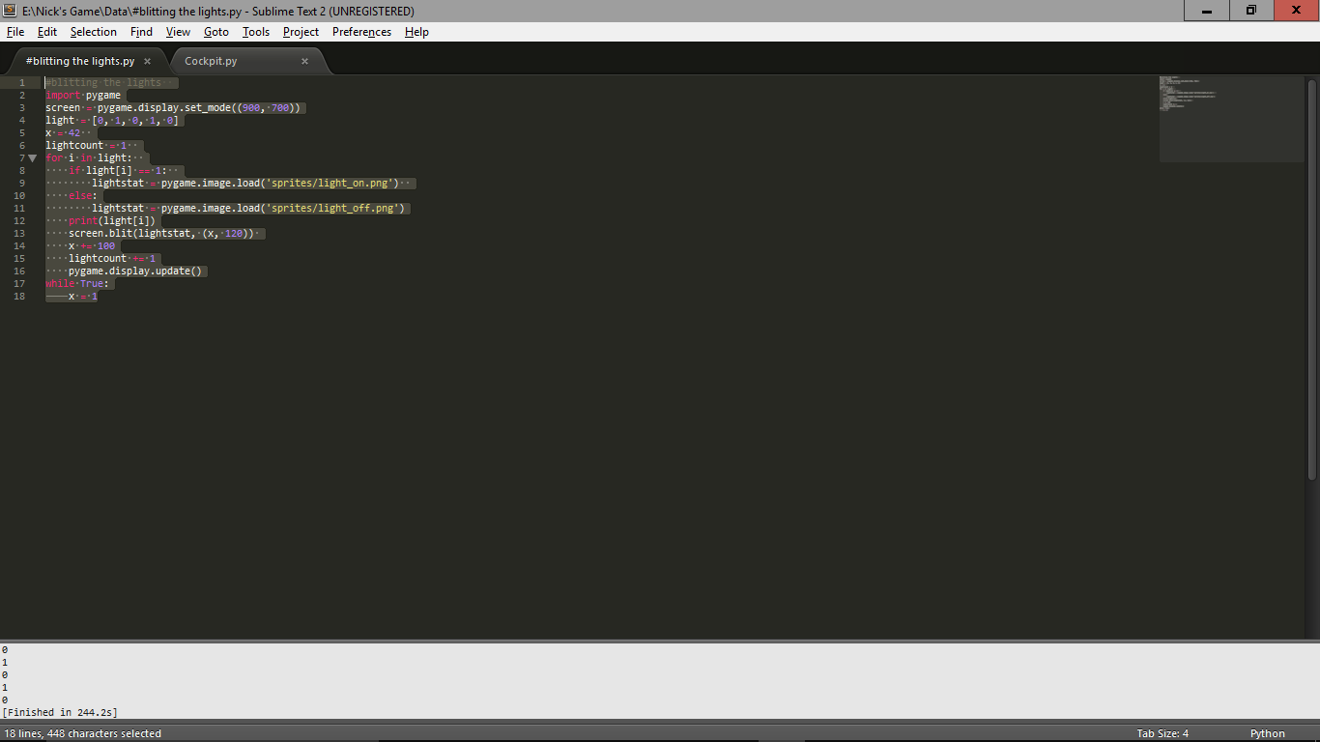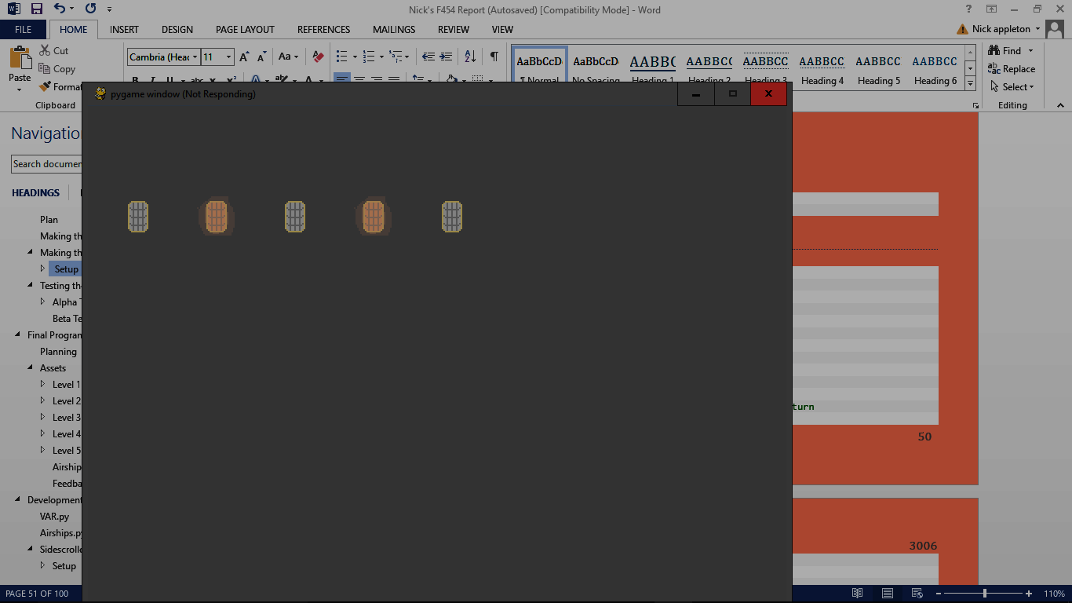

##### Sprites

1. #the sprites
2. sprites.draw(screen)

#### Sprites

1. #sprites for valve_s
2. **class** valve(pygame.sprite.Sprite):
3. **def** __init__(self, condition, worth):
4. pygame.sprite.Sprite.__init__(self)
5. #defining images for turning valves
6. self.image_stat = pygame.image.load('sprites/valve_1.png')
7. self.image_turn = pygame.image.load('sprites/valve_2.png')
8. #setting worth and condition
9. self.worth = worth
10. self.condition = condition
11. self.image = self.image_stat
12. **def** turn(self, position): #when the buton is pressed, the valve will turn
13. self.condition = **not** self.condition
14. #setting image worth of switch
15. **if** self.condition == True:
16. self.image = self.image_stat
17. **else**:
18. self.image = self.image_turn
19. **if** self.condition == True:
20. self.current_worth = self.worth
21. **else**:
22. self.current_worth = 0
23. self.rect = self.image_stat.get_rect()
24. self.rect.topleft = position

This is similar to the ‘switch’ sprite. It sets the type of class to sprite, then the 2 images used by the valve, as the on and off images. This time all of the valves are the same, so they’re loaded in the __init__ procedure, rather than being augments. It then sets the worth and condition (given as an augment), it finally sets the image to the first of the 2 images (stat). In the ‘turn’ procedure it swaps the condition, then sets the image depending on what the condition is. It then sets the worth (the same as the switches) and then the hitbox around the image, and sets the position.

1. #defining the sprites for the target numbers
2. **class** Number(pygame.sprite.Sprite):
3. **def** __init__(self, pos, num):
4. pygame.sprite.Sprite.__init__(self)
5. #loads relevant number image
6. self.num = num
7. **for** x **in** range(10):
8. **if** x == self.num:
9. self.image = pygame.image.load('sprites/hanging_numbers/'+str(x)+'.png')
10. self.rect = self.image.get_rect()
11. self.rect.topleft = pos     #position

This section is for the sprites of the hanging numbers, used as the target number. It sets itself as a sprite, then sets a variable linked to itself to the number it should be, so now it contains the number that will not change. It then goes through the numbers between one and ten, checking which it is, then loading the relevant image. It the sets the rectangle around it and fixes the position.

After reviewing this section, I’ve realised that the image loading is hugely overcomplicated, so I’ve replaced

1. **for** x **in** range(10):
2. **if** x == self.num:
3. self.image = pygame.image.load('sprites/hanging_numbers/'+str(x)+'.png')

With

1. self.image = pygame.image.load('Data/sprites/hanging_numbers/'+str(self.num)+'.png')

This is much more efficient, because it doesn’t loop any numbers and it’ll just find the correct image immediately.

#### Initiating Everything

1. #starting the game
2. pygame.init()
3. #defining background ready for blitting
4. screen = pygame.display.set_mode((900, 700))
5. deck = pygame.image.load('sprites/deck.png')
6. deck = pygame.transform.scale(deck, (900, 700))
7. sky = pygame.image.load('sprites/sky/'+str(level)+'.png')
8. sky = pygame.transform.scale(sky, (910,500))
9. pipes = pygame.image.load('sprites/pipes.png')
10. pipes = pygame.transform.scale(pipes, (500, 600))
11. engine = pygame.image.load('sprites/engine.png')
12. engine = pygame.transform.scale(engine, (550, 600))

These lines are firstly initiating pygame, then setting a lot of relevant variables such as the screen, the background image and size, the sky image and size, and the rest of the aesthetic pieces (pipes and engine). I have done a lot of testing to get these to the right size for the screen and relative to each other.

1. fps = pygame.time.Clock()       #to allow the clock to tick
2. time = 500*(10/level)           #how long they have ‘til crash
3. target = random.randint(0, 256) #random target number

#### Target Number

These parts are the same as the original quiz, setting the fps, time limit, and target number.

1. #splitting the target into 3
2. **if** len(str(target)) == 1:
3. digit_1 = 0
4. digit_2 = 0
5. digit_3 = int(str(target)[0])
6. **elif** len(str(target)) == 2:
7. digit_1 = 0
8. digit_2 = int(str(target)[0])
9. digit_3 = int(str(target)[1])
10. **else**:
11. digit_1 = int(str(target)[0])
12. digit_2 = int(str(target)[1])
13. digit_3 = int(str(target)[2])
14. #putting targets into sprites
15. Number_1 = Number((0, 0), digit_1)
16. Number_2 = Number((140, 0), digit_2)
17. Number_3 = Number((70, 0), digit_3)

This is the same as in the first quiz, splitting the target number into three different digits.

#### Realising the Sprites

1. #making the valve sprites
2. valve_1 = valve(random.choice((True, False)), 128)
3. valve_1.turn((60, 150))
4. valve_2 = valve(random.choice((True, False)), 64)
5. valve_2.turn((100, 150))
6. valve_3 = valve(random.choice((True, False)), 32)
7. valve_3.turn((160, 150))
8. valve_4 = valve(random.choice((True, False)), 16)
9. valve_4.turn((220, 150))
10. valve_5 = valve(random.choice((True, False)), 8)
11. valve_5.turn((280, 150))
12. valve_6 = valve(random.choice((True, False)), 4)
13. valve_6.turn((320, 150))
14. valve_7 = valve(random.choice((True, False)), 2)
15. valve_7.turn((360, 150))
16. valve_8 = valve(random.choice((True, False)), 1)
17. valve_8.turn((400, 150))

This is similar the when I set the switch sprites in the first quiz. I set the condition argument to a random choice, then the value. Once I’ve set the sprite, I then make it turn once to make sure that its image is in the right orientation and also make sure the worth is set correctly.

1. #grouping the sprites
2. valves = pygame.sprite.Group(valve_8, valve_7, valve_6, valve_5, valve_4, valve_3, valve_2, valve_1)
3. numbers = pygame.sprite.Group(Number_1, Number_2, Number_3)
4. sprites = pygame.sprite.Group(valves, numbers)

Grouping the sprites

#### More Variables

1. #initialising variables for use in loop
2. count_s = time/3 +10            #used for smoke counting
3. count = count_s
4. failed = victory = False
5. smoke_count = 1                 #for moving the smoke on
6. smoke_num = 1
7. smoke_size = 1
8. smoke_tick = 1
9. chug = 1
10. caption = True              #used for caption of window
11. caption_count = time/30

Defining more variables to use in the main loop including count, used for doing a lot of different timed actions, variables to indicate the size, frame, and ticking of the smoke outside the door, ‘chug’ to make the engine and pipes move, and I’ve got a variable to make the cation switch between different things.

1. #initialising failure conditions
2. count_boom = []
3. position_boom = []
4. size_boom = []
5. **for** x **in** range(0, 10):
6. count_boom.append(random.randint(-15, 1))
7. position_boom.append((random.randint(0, 900), random.randint(0, 700)))
8. size_boom.append(random.randint(75, 300))

These variables are used for when you lose the game and the airship explodes. The count, position, and size of the explosion are all defined as empty arrays, then there’s a for loop that iterates 10 times, each time adding a random timer to the explosions, then a random position, and random size. Each index of the three arrays will combine to each make an explosion.

#### Main Loop

##### Key Presses

1. **while** True:
3. screen.fill((255, 255, 255))
4. value = valve_1.current_worth + valve_2.current_worth + valve_3.current_worth + valve_4.current_worth + valve_5.current_worth + valve_6.current_worth + valve_7.current_worth + valve_8.current_worth
6. **for** event **in** pygame.event.get():
7. **if** event.type == pygame.QUIT: exit()
8. **if** failed == False **and** victory == False:
9. **if** event.type == pygame.KEYDOWN:
10. **if** event.key == pygame.K_a:
11. valve_1.turn((60, 150))
12. **if** event.key == pygame.K_s:
13. valve_2.turn((100, 150))
14. **if** event.key == pygame.K_d:
15. valve_3.turn((160, 150))
16. **if** event.key == pygame.K_f:
17. valve_4.turn((220, 150))
18. **if** event.key == pygame.K_g:
19. valve_5.turn((280, 150))
20. **if** event.key == pygame.K_h:
21. valve_6.turn((320, 150))
22. **if** event.key == pygame.K_j:
23. valve_7.turn((360, 150))
24. **if** event.key == pygame.K_k:
25. valve_8.turn((400, 150))
26. **if** event.key == pygame.K_RETURN:
27. **if** value == target:
28. **print**('correct')
29. victory = True
30. count = 0
31. **else**:
32. **print**('incorrect')
33. count -= 50*level
34. time -= 50*level

This part is very much the same as the first quiz, finding the value, checking which buttons are pressed, then turning the valve. However, there are no flippers, and when enter is pressed it checks if the value is equal to the target. If it is, it starts off the victory cycle, and if not, it means you lose a lot of altitude.

##### During Game

1. **if** failed == False **and** victory == False:
2. blit_all()
3. count -= 1
4. time -= 1
5. **if** caption_count <= 0:
6. caption = **not** caption
7. caption_count = time/30
8. **if** caption == True:
9. pygame.display.set_caption('[WARNING: LOSING ALTITUDE]')
10. **else**:
11. pygame.display.set_caption('....................................................')
12. caption_count -= 1
13. **if** time <= 0:
14. **print**('time up')
15. failed = True
16. count = 0

It runs the blit_all function, then lowers the count and time variables. It then has a small part that makes the caption of the window flash between saying [WARNING: LOSING ALTITUDE], and a series of dots. It then checks if you’ve lost the game, if you have, it starts the failure part.

##### Victory

1. #when they win the game
2. **if** victory == True:
3. blit_all()
4. victory_banner = pygame.image.load('Data/sprites/VICTORY.png')
5. screen.blit(victory_banner, (75, 300))

It simply runs blit_all, then blits the victory banner on top.

##### Faliure Loop

1. **if** failed == True:
2. blit_all()
3. #all small random explosions
4. **for** num **in** range(0, 10):
5. #making sure they don't overlap the large explosion
6. **if** count_boom[num] < 9 **and** count_boom[num] > 0:
7. explosion = pygame.image.load('Data/sprites/explosion/'+str(count_boom[num])+'.png')
8. explosion = pygame.transform.scale(explosion, (size_boom[num], size_boom[num]))
9. screen.blit(explosion, position_boom[num])
10. **elif** count_boom[num] > 9:
11. count_boom[num] = random.randint(-5, 0)
12. position_boom[num] = (random.randint(-200, 500), random.randint(-200, 400))
13. size_boom[num]=(random.randint(400, 700))
14. count_boom[num] += 1
15. boom_tick += 1
16. **print**(boom_tick)
17. **if** boom_tick >= 20:          #ends the game after a cetain amount of time
18. exit()
19. count += 1
20. faliure_banner = pygame.image.load('Data/sprites/FAILED.png')
21. screen.blit(faliure_banner, (135, 50))

This is almost exactly the same as the failure loop in the first quiz.

And again, it finishes the loop with

1. pygame.display.update()
2. fps.tick(60)

## Testing the Engine Room

### Alpha Testing

#### Functionality Testing

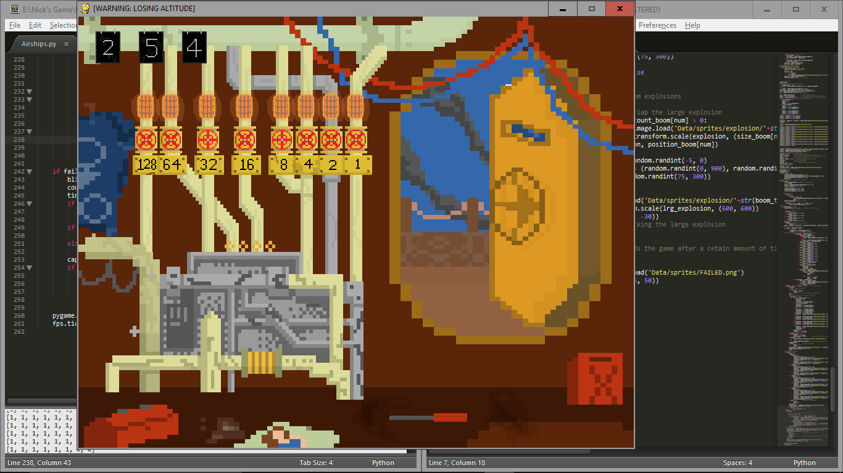 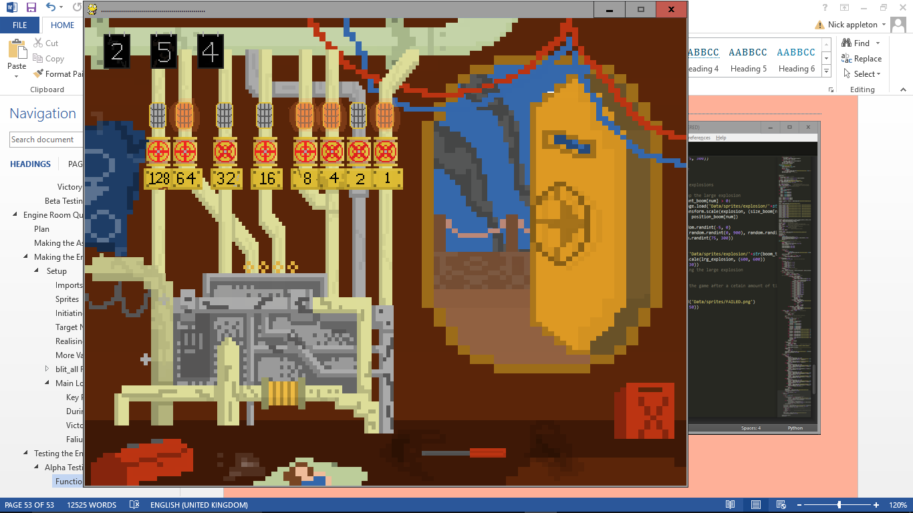

After very brief testing, a major problem was immediately evident: there’s some problem with the lights. I have absolutely no idea what’s wrong with them, as there seems to be no pattern to which valves turned change which lights. Some change more than one, some change none, some have to be turned to let others work. It’s very odd.

After investing a huge amount of time into this problem I’ve realised I don’t know how to fix it so I’m going to completely overhaul the whole lights system. I’ve changed the lights part of the Engine Room to a simpler version:

1. **if** valve_1.condition == True:
2. screen.blit(pygame.image.load('Data/sprites/light_on.png'), (82, 120))
3. **else**:
4. screen.blit(pygame.image.load('Data/sprites/light_off.png'), (82, 120))
5. **if** valve_2.condition == True:
6. screen.blit(pygame.image.load('Data/sprites/light_on.png'), (122, 120))
7. **else**:
8. screen.blit(pygame.image.load('Data/sprites/light_off.png'), (122, 120))
9. **if** valve_3.condition == True:
10. screen.blit(pygame.image.load('Data/sprites/light_on.png'), (182, 120))
11. **else**:
12. screen.blit(pygame.image.load('Data/sprites/light_off.png'), (182, 120))
13. **if** valve_4.condition == True:
14. screen.blit(pygame.image.load('Data/sprites/light_on.png'), (242, 120))
15. **else**:
16. screen.blit(pygame.image.load('Data/sprites/light_off.png'), (242, 120))
17. **if** valve_5.condition == True:
18. screen.blit(pygame.image.load('Data/sprites/light_on.png'), (302, 120))
19. **else**:
20. screen.blit(pygame.image.load('Data/sprites/light_off.png'), (302, 120))
21. **if** valve_6.condition == True:
22. screen.blit(pygame.image.load('Data/sprites/light_on.png'), (342, 120))
23. **else**:
24. screen.blit(pygame.image.load('Data/sprites/light_off.png'), (342, 120))
25. **if** valve_7.condition == True:
26. screen.blit(pygame.image.load('Data/sprites/light_on.png'), (382, 120))
27. **else**:
28. screen.blit(pygame.image.load('Data/sprites/light_off.png'), (382, 120))
29. **if** valve_8.condition == True:
30. screen.blit(pygame.image.load('Data/sprites/light_on.png'), (422, 120))
31. **else**:
32. screen.blit(pygame.image.load('Data/sprites/light_off.png'), (422, 120))

This one simply checks each of the switches in turn, then changes the relevant light depending.

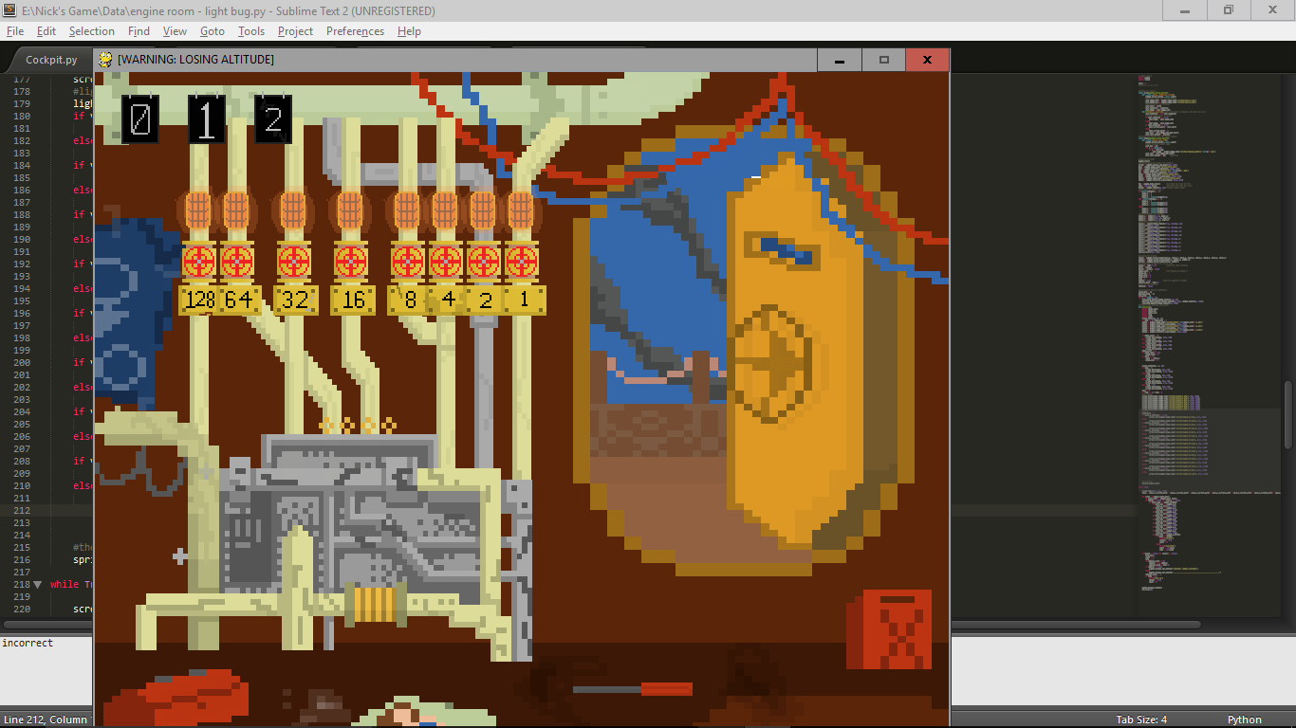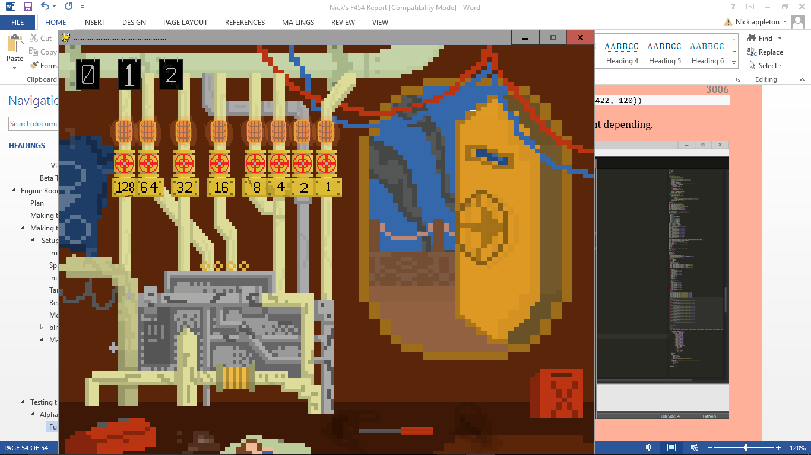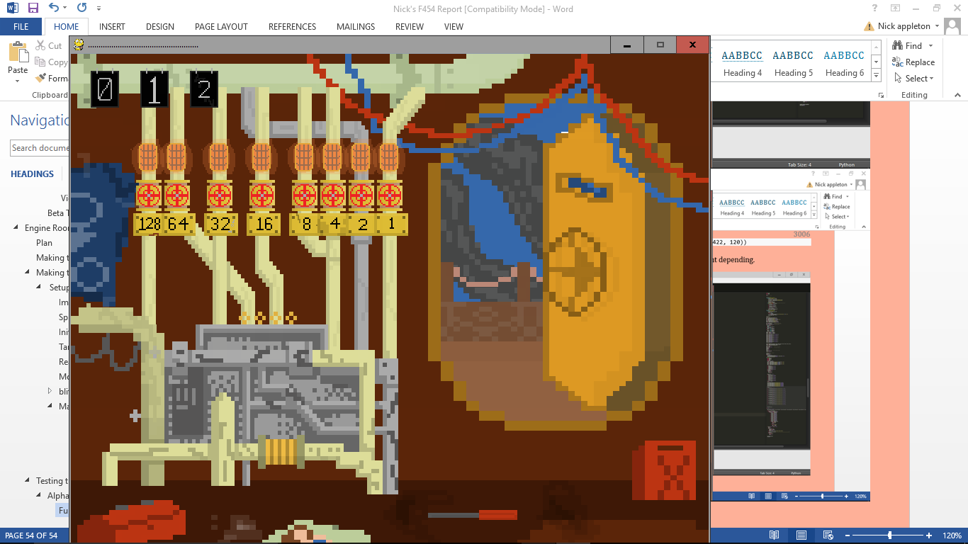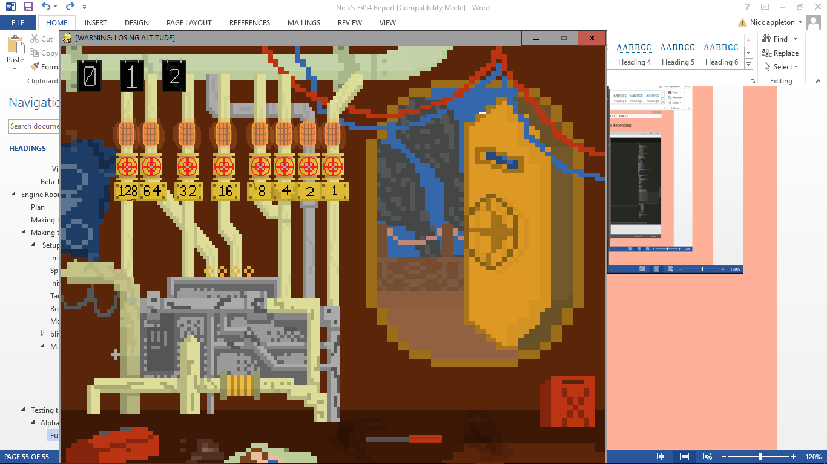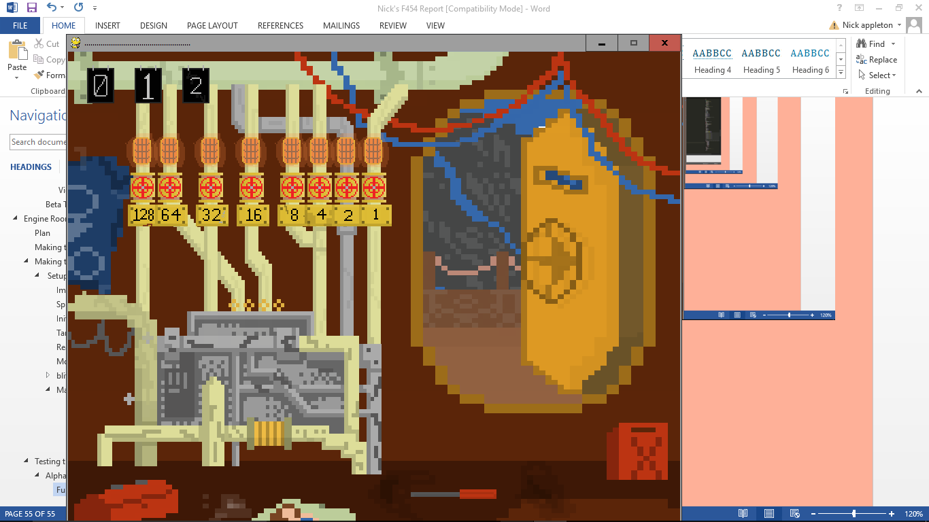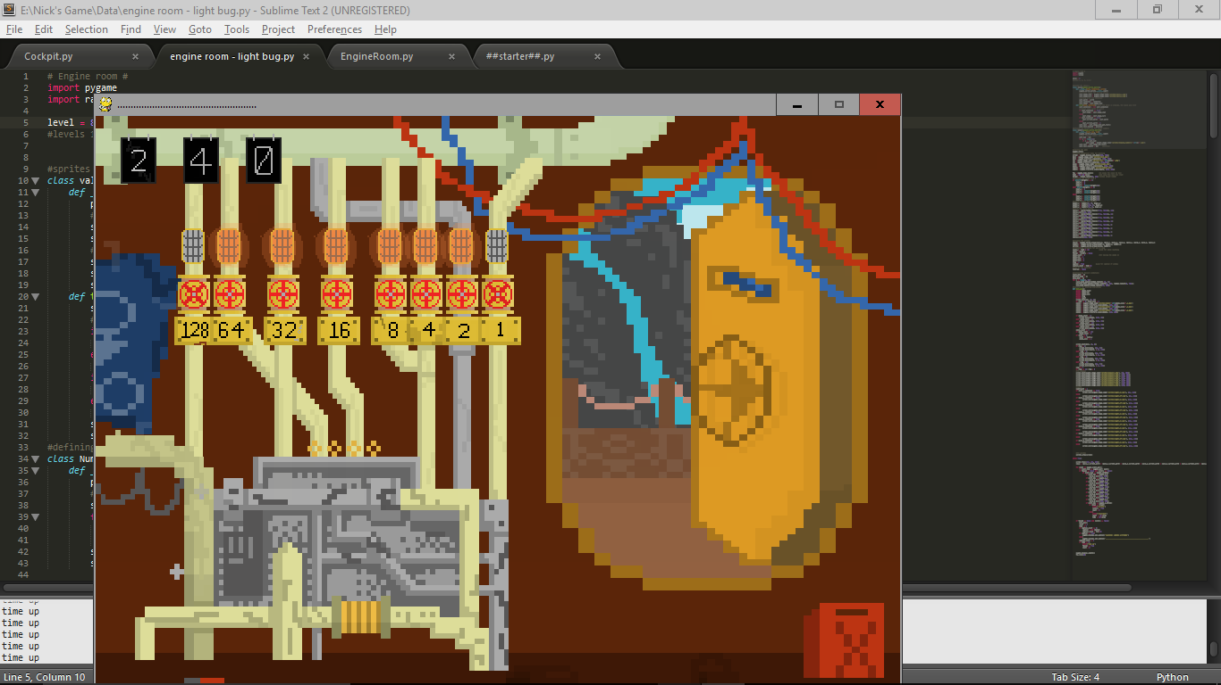

All of the smoke seems to work very well, as do all of the functions I’ve added from the previous quiz like the valve turning adding the value, and the timer running down properly.

After more testing, I’ve found that everything else works correctly, too.

### Beta Testing

This time I did a much less extensive Beta test, a handful of students had the game for a few minutes, they said that it was all alright, apart from it is hard to tell how much time you have left. This is because I haven’t yet implemented my altimeter idea yet. This will definitely come in the next version of the Engine Room quiz.

# Final Program

I am jumping to the finished product because that way I can develop the overarching program as well as sorting out the global variables that I will need across all of the programs. It’ll be easier to sort all of these things out in one go rather than having to adapt my code to fit them in later.

## Planning

I am going to have one main program that you run, and from that it will run the sidescroller, which in turn will run the cockpit quiz and the engine room quiz if needs be. I also am going to have a program that has all of the variables that I will need across the programs such as level.

## Assets

First of all I’ve got to make all of the assets for the sidescroller section of the game. Each level is going to get more and more urban, as well as descending into night. So the first level will be sunny countryside, the second will be farmland, the third suburban, the fourth urban, and the last will be very heavy urban environment. The order and number of each tile will be selected at random, so every time you play the game you’ll get a different landscape.

These are the sky images for the 5 levels.

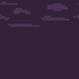

### Level 1



#### Foreground

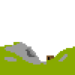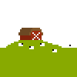

#### Background

### Level 2

#### Background



#### Foreground

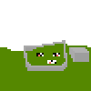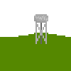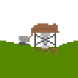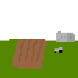

### Level 3

#### Background

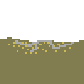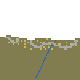

(Level 3 has the lights of faraway houses lining the hilltops in the background)

#### Foreground

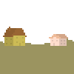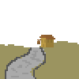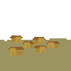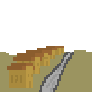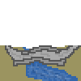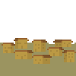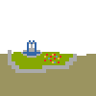

### Level 4

#### Foreground



#### Background



### Level 5

#### Background

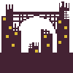

#### Foreground

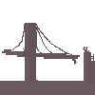

### Airships

There will be one player airship that switches between 2 sprites, as well as 2 different types of enemies, one normal and one harder, as it will take 2 shots to kill rather than 1.

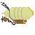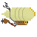Players’ airship sprites: Enemy Easy sprites: Enemy Hard sprite:



There will also have to be an image for the bullets that you will fire from your airship:

### Feedback

The users said that they appreciated how many visuals there are that I have to make, which will come across during the game. They also said that because the style of these images are so like the images for the first quiz section that they think they will all work well as a game, as they weren’t so keen on the first quiz visuals until they’d seen the rest of the game.

# Development

Once I finished my first iteration of the whole thing, I couldn’t work out a good way of ending the game, so I decided that I shouldn’t. Instead, once you complete level 5, you go back to level 1 but on ‘world 2’. This means the game is technically infinite.

I’ve also added a feature that when you input the ‘Konami code’ (up, up, down, down, left, right, left, right, B, A, enter) on the pause scree, you get 150% health, as well as restoring your engine quality and making you fire your guns ridiculously fast. This effect lasts until the end of the level.

Another important part of the game is the tutorial for each section. I’ve

The final feature I added was that to fullscreen the game. If you press ‘1’, the game will enter fullscreen mode. This doesn’t affect gameplay, it just makes it fill the screen.

## VAR.py

This is the program that will contain all of the variables that I’ll need to use across all of the programs. I’ve thought through each of the variables I will need and compiled them into the program.

1. level = 1
2. world = 1
3. EngineRoomRun = False
4. CockpitRun = False
5. engineQual = 100
6. run = False
7. k = 0
8. fullscreen = False

I have the level and world, as this’ll affect the difficulty of all of the different parts of the game. The 2 running Boolean values are to stop the games running as soon as I import them. The engine quality because this’ll have to be used over the levels of the sidescroller, however health will regenerate when you finish the level. Run is the same as the other 2 run variables but for the sidescroller part. K is a counting variable for inputting the Konomi code, and fullscreen will be persistent when it loads the next program in the game.

## Airships.py

This is the overarching program that you will run when you start the program, It’ll increment the level and world as well as displaying the world you are on at the beginning of the game and whenever you reach a new world. This section of code and annotation is of the development of the system rather than the components.

1. **import** pygame
2. **import** imp
3. **from** Data **import** var
4. **from** Data **import** sidescroller

7. airship = pygame.image.load('data/sidescrollerAssets/enemies/norm1.png')
8. airship = pygame.transform.scale(airship, (207, 108))
9. **if** var.fullscreen == True:
10. screen = pygame.display.set_mode((900, 700), pygame.FULLSCREEN)
11. **else**:
12. screen = pygame.display.set_mode((900, 700))

This first imports pygame, and the ‘imp’ library, this means I can reload programs I’ve already imported. It then imports var, so it can access all of the variables, then loads the sidescroller program. After this, it loads and resizes the enemy airship model, then sets the screen size, (and sets it fullscreen if the variable fullscreen is true)

1. var.run = True
2. pygame.init()
4. **while** True:
5. x = 600
6. y = 100

It then sets the running for the sidescroller to True, so that the next time it is imported it’ll run through it properly. It initiates pygame before starting the min game loop, then setting two coordinate values.

1. count = 1
2. screen.fill((0, 0, 0))
3. **for** i **in** range(0, var.world):
4. **if** y > 500:
5. x -= 270
6. y = 100
7. screen.blit(airship, (x, y))
8. y += 200
9. pygame.display.update()

This sets up the screen, then loops through the next part as many times as there are worlds. So when this first runs, you’ll be on world 1, so it’ll loop through it once. What the loop does is display the airship image to the coordinate values we defined earlier. It also changes the value of the coordinates so that the next airship it loads isn’t on top of the other, and if it’s too far down, it’ll set it to a new column. It then updates the display.

1. **while** count < 20:
2. count += 1
3. **for** event **in** pygame.event.get():
4. #for quitting pygame
5. **if** event.type == pygame.QUIT: exit()
6. **if** event.type == pygame.KEYDOWN:
7. **if** event.key == pygame.K_1:
8. **if** var.fullscreen == True:
9. screen = pygame.display.set_mode((900, 700), pygame.FULLSCREEN)
10. **else**:
11. screen = pygame.display.set_mode((900, 700))
12. var.fullscreen = **not** var.fullscreen
13. pygame.time.Clock().tick(10)

The count variable is used here as a timer. Once it reaches 20, it’ll stop looping. This part just lets you quit the game, and if you press 1, it toggles the fullscreen mode, either turning it o nor off.

1. **while** var.level <= 5:
2. imp.reload(sidescroller)
3. var.level += 1
5. var.world += 1
6. var.level = 1

This is the important part that loads the sidescroller part. If the level is less than or equal to 5, it loads the sidescroller (which will be at that level), it then adds one to the level and does it again, until you finish level 5, then it breaks this loop and increments the world by one and resets the level to 1, and starts the main loop all over again.

## Sidescroller

### Setup

#### Imports

1. **from** Data **import** var
2. **import** pygame
3. **import** random
4. **import** imp
5. **from** Data **import** EngineRoom
6. **from** Data **import** Cockpit
8. var.EngineRoomRun = True
9. var.CockpitRun = True
10. level = var.level
11. k = var.k
12. fullscreen = var.fullscreen

In the sidescroller program, it imports var, pygame, random, imp, EngineRoom and Cockpit, which are the two quiz programs. It then allows those to run next time they’re loaded. It then sets ‘level’ to the level, to make it easier to refer to later in the code, then does the same to k, and fullscreen.

1. **if** var.run == True:
2. pygame.init()   #initiating pygame
3. **if** fullscreen == True:
4. screen = pygame.display.set_mode((900, 700), pygame.FULLSCREEN)
5. **else**:
6. screen = pygame.display.set_mode((900, 700))
8. sky = pygame.image.load('Data/sprites/sky/'+str(level)+'.png')
9. sky = pygame.transform.scale(sky, (900, 700))
10. fps = pygame.time.Clock()

Now, the variable var.run is true, we changed it to true in airships.py. This starts the initiating of the variables I’ll need later. It initiates pygame, sets the screen (if it’s fullscreen or not).

#### Procedures

##### Making the Background

1. #defining the arrays for the scrolling backgrounds
2. islands = [[1], [1]]
3. x = [[0], [0], [0]]
4. back = False
5. **for** i **in** range(1, ((level)*5)):
6. back = **not** back
7. islands[0].append(random.randint(1, 10))
8. **if** back == True:
9. islands[1].append(random.randint(1, 5))
10. **for** f **in** x:
11. f.append(f[i-1]+900)

The array islands is a two dimensional array, the first index will be a list of which tiles have been chosen for the foreground in what order, and the second will be a list of the tiles and order of the background. The array x is the positions these tiles will be when the game starts, each will be 900 further to the right than the one before, as that’s the width of the screen. There are three arrays within x, because once the background starts scrolling, each layer will be going different speeds, so the x values will be different. Each index is representative of a layer.

Inside the loop, which loops as many times as the number of which level you are on times 5, adds the tiles randomly to the list islands. It adds a background tile half the number of times it adds a foreground one. It then also sets up the values for x.

##### Scroll

1. #defining the scrolling function
2. **def** scroll():
3. **for** i **in** range(0, len(x)):
4. **for** f **in** x[i]:
5. x[i] = x[i]-1/(i+1)

This procedure is the one that scrolls the backgrounds to make it feel like the airship is moving. It loops the length of x so that it gets to every layer to scroll it, then loops through each of the lists within x. It does the old value minus 1 over which of the sub-lists of x it’s in. This means the foreground will move much faster than the background, which in turn will move faster than the sky.

After reviewing this code, I noticed that if I use len(x) as the upper bound of the loop, then it’ll be working out what the length of x is every time it loops. Rather than making it do this, it would be much more efficient to make it work out the length of x first, then use this value, as it won’t change for the duration of the loop:

1. #defining the scrolling function
2. **def** scroll():
3. lenx = len(x)
4. **for** i **in** range(0, lenx):
5. leni = len(x[i])
6. **for** f **in** range(0, leni):
7. x[i][f] -= (1/(i+1)*10)

##### Foreground

1. **def** foregroundblit():
2. leni = len(islands[0])
3. **for** i **in** range(0, leni):
4. foreground = pygame.image.load('Data/sidescrollerAssets/level'+str(level)+'/foreground/'+str(islands[0][i])+'.png')
5. foreground = pygame.transform.scale(foreground, (900, 900))
6. screen.blit(foreground, (x[0][i], 50))

Loops through as many islands as there are in the foreground, loading each one, then blitting it to the screen in the place it tells it to in the x array.

##### Background

1. **def** backgroundblit():
2. leni = len(islands[1])
3. **for** i **in** range(0, leni):
4. background = pygame.image.load('Data/sidescrollerAssets/level'+str(level)+'/background/'+str(islands[1][i])+'.png')
5. background = pygame.transform.scale(background, (900, 900))
6. screen.blit(background, (x[1][i], 0))

The same as foreground, but it uses the different part of the islands array, as well as loads them from a different location.

##### Sky

1. **def** skyblit():
2. leni = len(x[2])
3. **for** i **in** range(0, leni):
4. screen.blit(sky, (x[2][i], 0))

The same as the other two, but it uses the same image every time, which has already been loaded into the variable ‘sky’.

##### Stats

1. **def** stats():
2. heart = pygame.image.load('Data/sidescrollerAssets/heart.png')
3. heart = pygame.transform.scale(heart, (24, 24))
4. screen.blit(heart, (600, 10))
5. engine = pygame.image.load('Data/sidescrollerAssets/gear.png')
6. engine = pygame.transform.scale(engine, (24, 24))
7. screen.blit(engine, (600, 45))
8. #healthbar and engine bar backdrop
9. pygame.draw.rect(screen, (200, 200, 200), (630, 10, 204, 24))
10. pygame.draw.rect(screen, (200, 200, 200), (630, 45, 204, 24))
11. #actual bars
12. **if** health > 0:
13. pygame.draw.rect(screen, (255, 0, 0), (632, 12, health*2, 20))
14. **if** var.engineQual > 0:
15. pygame.draw.rect(screen, (50, 80, 50), (632, 47, var.engineQual*2, 20))

This is for the status bars in the top left of the screen. It first of all loads and blits the heart and gear icons to the top left of the screen, then it makes two grey bars next to them, these will be the backdrop to the bars themselves. It then draws the two bars, using your statuses as the width of each bar. It only does this when they’re greater than 0 to stop the bar going negative when your health does.

##### Draw

1. **def** draw():
2. skyblit()
3. backgroundblit()
4. **for** i **in** boom:
5. i.boom()
6. boom.draw(screen)
7. bullets.update()
8. bullets.draw(screen)
10. ships.draw(screen)
11. ships.update()
12. foregroundblit()
13. stats()

Brings together all of the other procedures. Blits the sky, then the background, then any explosions that need to happen to the enemies, then draws the bullets, then all of the airships, the foreground, and finally, the status bars.

#### Sprites

##### Player

1. **class** player(pygame.sprite.Sprite):
2. **def** __init__(self, x, y, imgs):
3. self.count = 4
4. pygame.sprite.Sprite.__init__(self)
5. self.imgs = imgs
6. self.pic = True
7. self.image = self.imgs[0]
8. self.x = x
9. self.y = y
10. self.position = (x, y)
11. self.rect = self.image.get_rect()
12. self.rect.topleft = (self.x, self.y)

This does all of the normal sprite stuff. Arguments are given for its starting position, and the images it’ll use and switch between. It sets everything it’ll need to self so that it can be called back later.

1. **def** update(self):
2. self.count -= 1
3. **if** self.count <= 0:
4. self.pic = **not** self.pic
5. self.count = 4
6. **if** self.pic == True:
7. self.image = self.imgs[0]
8. **else**:
9. self.image = self.imgs[1]
10. self.rect = self.image.get_rect()
12. key = pygame.key.get_pressed()
13. **if** key[pygame.K_w] **and** self.y > 20:
14. self.y -= 10
15. **if** key[pygame.K_a] **and** self.x > 20:
16. self.x -= 10
17. **if** key[pygame.K_s] **and** self.y < 500:
18. self.y += 10
19. **if** key[pygame.K_d] **and** self.x < 600:
20. self.x += 10
22. **if** self.x <= 20:
23. self.x += 10
24. self.rect.topleft = (self.x, self.y)

The first part of this is the piece of code that lets it switch between the two images. Following this is the movement code. If you press W, A, S or D, it’ll change the x and y values of the airship accordingly, then reset the position. It only changes the x y values when the button is pressed if the airship is within certain bounds on the screen.

##### Enemy

1. **class** enemy(pygame.sprite.Sprite):
2. **def** __init__(self, start, y, imgs):
3. pygame.sprite.Sprite.__init__(self)
4. self.count = 4
5. self.imgs = imgs
6. self.pic = True
7. self.start = int(start)
8. self.x = 950
9. self.y = int(y)
10. self.image = pygame.image.load(self.imgs[0])
11. self.rect = self.image.get_rect()
12. self.rect.topleft = (self.x, self.y)
13. self.tick = 1

This is very similar to the player, however, rather than being given an x and y coordinate, it’s given a y, for the height, and start, for where on the level the airship will appear. This is because on the actual screen, all of the airships will start with the same x value, which will decrease at a given rate.

1. **def** update(self):
2. self.x -= 15
3. self.count -= 1
4. **if** self.count <= 0:
5. self.pic = **not** self.pic
6. self.count = 4
7. **if** self.pic == True:
8. self.image = pygame.image.load(self.imgs[0])
9. **else**:
10. self.image = pygame.image.load(self.imgs[1])
11. self.image = pygame.transform.scale(self.image, (138, 72))
12. self.rect = self.image.get_rect()
13. self.rect.topleft = (self.x, self.y)
14. **for** i **in** bullets:
15. **if** pygame.sprite.collide_rect(i, self):
16. bullets.remove(i)
17. ships.remove(self)
18. boom.add(self)
19. self.count = 2

The beginning is just changing the image again, but now the end loops through everything in the group ‘bullets’, checking if it’s collided with the enemy. If one of them has, it will remove that bullet, remove the airship from the screen, and add it to the explosion list (now in the draw procedure it will run enemy.boom).

1. **def** boom(self):
2. self.count -= 1
3. **if** self.count <= 0:
4. self.tick += 1
5. self.count = 2
6. **if** self.tick == 8:
7. boom.remove(self)
8. self.x -= 15
9. self.image = pygame.image.load('Data/sprites/explosion/'+str(self.tick)+'.png')
10. self.image = pygame.transform.scale(self.image, (270, 270))
11. self.rect = self.image.get_rect()
12. self.rect.topleft = (self.x - 70, self.y - 70)

When the airship is shot, it runs this rather than update. It uses the same method as all of the other explosion to animate the explosion.

##### Bullet

1. **class** bullet(pygame.sprite.Sprite):
2. **def** __init__(self, x, y, img, direction):
3. pygame.sprite.Sprite.__init__(self)
4. self.image = pygame.transform.scale(pygame.image.load(img), (50, 50))
5. self.direction = direction
6. **if** self.direction == False:
7. self.image = pygame.transform.flip(self.image, True, False)
8. self.x = x
9. self.y = y
10. self.position = (x, y)
11. self.rect = self.image.get_rect()
12. self.rect.topleft = (self.x, self.y)
13. **def** update(self):
14. **if** self.direction == True:
15. self.x += 50
16. **else**:
17. self.x -= 30
18. self.rect = self.image.get_rect()
19. self.rect.topleft = (self.x, self.y)

Loads a bullet on the x y coordinates given, then checks the direction of the bullet, sets the image accordingly and moves it in the correct direction. I do not currently have enemy bullets, but in putting this in the code I’ve futureproofed myself if I do want to add them.

#### Variables and Sprites

1. imgs = [pygame.transform.scale(pygame.image.load('Data/sidescrollerAssets/player1.png'), (150, 150))]
2. imgs.append(pygame.transform.scale(pygame.image.load('Data/sidescrollerAssets/player2.png'), (150, 150)))
4. xp = -40
5. yp = 300

Sets the images and sizes, as well as the starting positon of the player

1. enemy_positions = open('Data/sidescrollerassets/enemyinfo.txt').read().splitlines()

This line sets the variable called enemy_positions to an external txt file that it opens, sets it to read, then informs it that it should load the lines individually.

1. #adding sprites
2. player = player(xp, yp, imgs)
4. #adding enemy sprites
5. enemies = pygame.sprite.Group()
6. bullets = pygame.sprite.Group()
7. boom = pygame.sprite.Group()

This realises the player sprite, using the images and coordinates defined earlier. It also sets the sprite groups.

1. **if** level > 3:
2. rng = int(((level)*2)*10)
3. **else**:
4. rng = int(((level)**2)*10)
5. **for** i **in** range(0, var.world):
6. line = 1
7. **for** l **in** range(0, rng):
8. enemies.add(enemy(enemy_positions[line+1], enemy_positions[line+2], [enemy_positions[line+3], enemy_positions[line+4]]))
9. line += 5

Firstly, this sets the value rng (this’ll be how many enemies there are in the level) depending on the level. If the level is greater than 3, its level times 20, otherwise, its level squared times ten. It then loops the enemy creation part as many times as the world you are on. This is so that when you’re on world 2, each enemy will take twice as many shots to kill, on level three, three times as many etc. In this loop it goes through as many tomes as rng was set to earlier, adding an enemy to the list every time with the arguments specified in the txt file we opened earlier. Each line represents one of the arguments, start, y, and the two images.

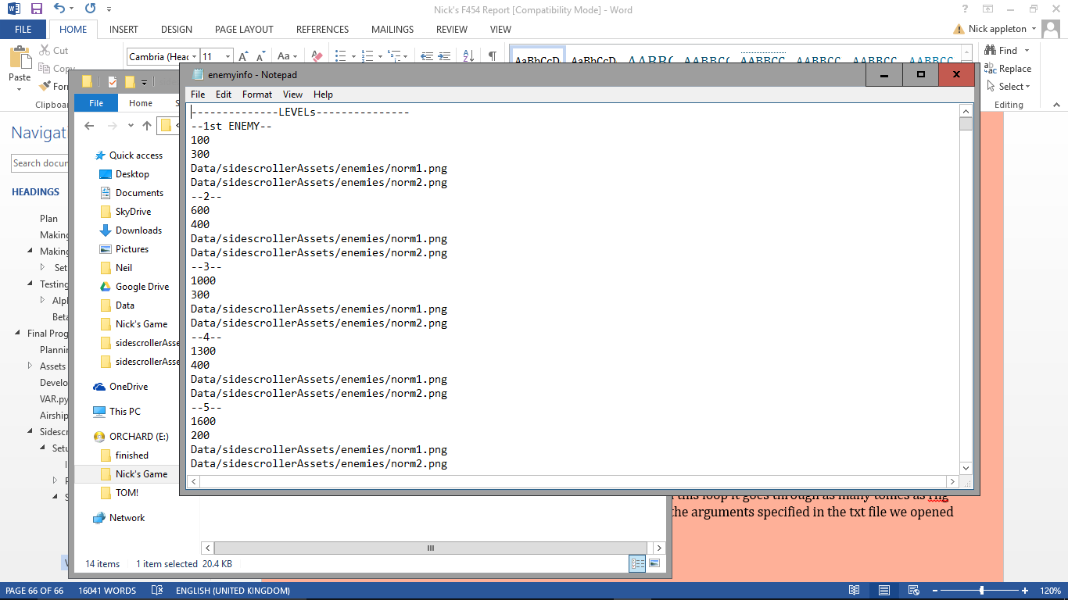

1. ships = pygame.sprite.Group(player)
3. bulletcount = 0
4. finished = False
5. dead = False
6. health = 100
7. run = True
8. paused = False
9. pausebanner = pygame.image.load('Data/sprites/paused.png')
10. tutorialImg = pygame.image.load('Data/sidescrollerAssets/tutorial.png')
11. tutorial = False
12. K_code = False
13. kpress = False

Sets more variables for various parts to the game including the tutorial, pause and Konomi code.

### Main Loop

1. pygame.display.set_caption('World: '+str(var.world)+'  Level: '+str(level))
3. **for** event **in** pygame.event.get():
4. #for quitting pygame
5. **if** event.type == pygame.QUIT: exit()
6. **if** event.type == pygame.KEYDOWN:
7. **if** event.key == pygame.K_1:
8. var.fullscreen = **not** var.fullscreen
9. **if** var.fullscreen == True:
10. screen = pygame.display.set_mode((900, 700), pygame.FULLSCREEN)
11. **else**:
12. screen = pygame.display.set_mode((900, 700))

15. **if** event.key == pygame.K_ESCAPE:
16. paused = True
17. **if** event.key == pygame.K_SLASH:
18. tutorial = True
19. **elif** event.type == pygame.KEYUP:
20. **if** event.key == pygame.K_SLASH:
21. tutorial = False

Sets the caption to the level and world, checks if you’ve quit the game or pressed any buttons. If you press 1, it toggles the fullscreen feature, escape will make it run the paused loop in the game, and [?] will bring up the tutorial. When you release [?], the tutorial will end.

#### Paused

1. **if** finished == False **and** dead == False:
2. **while** paused == True:
3. screen.fill((0, 0, 0))
4. skyblit()
5. backgroundblit()
6. screen.blit(pausebanner, (130, 50))
7. foregroundblit()
8. **for** event **in** pygame.event.get():
9. **if** event.type == pygame.QUIT: exit()
10. **if** event.type == pygame.KEYDOWN:
11. **if** event.key == pygame.K_ESCAPE:
12. paused = False
13. k = 0

If paused is true, the game will enter this loop within the loop that loads all of the things apart from the airships and bullets. It then checks if the game has been quit, or if escape has been pressed it will end the loop.

1. key = pygame.key.get_pressed()
2. **if** event.type == pygame.KEYDOWN **and** kpress == False:
3. kpress = True
4. **if** key[pygame.K_UP]:
5. **if** k == 0 **or** k == 1:
6. k += 1
7. **else**:
8. k = 0
10. **elif** key[pygame.K_DOWN]:
11. **if** k == 2 **or** k == 3 :
12. k += 1
13. **else**:
14. k = 0
16. **elif** key[pygame.K_LEFT]:
17. **if** k == 4 **or** k == 6:
18. k += 1
19. **else**:
20. k = 0
21. **elif** key[pygame.K_RIGHT]:
22. **if** k == 5 **or** k == 7:
23. k += 1
24. **else**:
25. k = 0
26. **elif** key[pygame.K_b]:
27. **if** k == 8:
28. k += 1
29. **else**:
30. k = 0
31. **elif** key[pygame.K_a]:
32. **if** k == 9:
33. k += 1
34. **else**:
35. k = 0
36. **elif** key[pygame.K_RETURN]:
37. **if** k == 10:
38. **print**('konamai code unlocked')
39. K_code = True
40. health = 150
41. engineQual = 150
42. **else**:
43. k = 0
44. **print**(k)
46. **if** event.type == pygame.KEYUP:
47. kpress = False

This is the screen on which you enter the Konomi code, so it needs to check if any of the relevant keys are pressed. If one of the keys is pressed, then it checks if it was its turn to be pressed. It does this by keeping track of what number you’re on using variable k. As you press them in the right order, k goes up, it knows if you’re pressing each at the right time by comparing k to when it should be pressed. If you press it in the wrong order, or press the wrong key, then it resets k to 0. Kpress has to be false when you press one of the buttons, this stops you pressing multiple at once and confusing it. If you get all the way to the end (k = 10) and press enter, it prints ‘Konomi code unlocked’ to the command window, sets the value of it to true, then sets your health and engine quality to 150.

1. pygame.display.update()
2. fps.tick(60)

Because this section is a loop in itself there is a display update and tick at the end

#### Satisfying conditions

1. screen.fill((0, 0, 0))
2. **if** x[0][len(x[0])-1] > 0:
3. scroll()
5. draw()
6. **for** i **in** enemies:
7. **if** x[0][0] == -i.start:
8. ships.add(i)
9. **elif** i.x <= -200:
10. ships.remove(i)
11. enemies.remove(i)
12. health -= level**2 * 2
13. **if** health <= 0:
14. dead = True
15. count = 0
16. boom_num = 1
17. boomx = player.x-70
18. boomy = player.y-70
20. **if** x[0][0] == -(len(x[0])-1)*900:
21. finished = True
22. count = 3
23. missile = 1

26. **if** tutorial == True:
27. screen.blit(tutorialImg, (0, 0))

If the level hasn’t finished, then it tells the game to scroll, then draws everything. It then checks if any of the enemies are at their starting points, if they are, then it realises them by adding them to a list of onscreen airships. However if they’ve gone of the other side of the screen then they are removed again, and [level squared times 2] health is lost. If you run out of health, it will start the dead piece of code, and it sets the variables it needs for that here. If you get to the end of the level, it sets finished to true. It also checks if the tutorial is needed.

#### Tutorial

1. **if** x[0][0] == -300 **and** level == 1 **and** var.world == 1:
2. tutorial = True
3. screen.blit(tutorialImg, (0, 0))
4. pygame.display.update()
5. **while** tutorial == True:
6. **for** event **in** pygame.event.get():
7. #for quitting pygame
8. **if** event.type == pygame.QUIT: exit()
9. **if** event.type == pygame.KEYDOWN:
10. **if** event.key == pygame.K_RETURN:
11. tutorial = False

If you are on level 1 world 1, and you have moved a certain distance, it runs another loop to pause the game, blits the tutorial and updates the display so that this takes effect immediately. In the loop it simply checks if the game’s been quit or if the player has pressed enter to exit the tutorial.

#### Firing

1. key = pygame.key.get_pressed()
2. **if** key[pygame.K_SPACE] **and** bulletcount <= 0:
3. bullets.add(bullet(player.x+75, player.y+70, 'Data/sidescrollerAssets/bullet.png', True))
4. **if** K_code == True:
5. bulletcount = 2
6. **else**:
7. bulletcount = 5

If you press the space key, it adds a bullet to the screen at the position of your airship. To stop the bullets firing constantly, you can only do it when bulletcount equals 0, if the Konomi code has been unlocked, then this cooldown time is reduced.

#### Finished

1. **elif** finished == True:
2. bullets.update()
3. player.x += 5
4. ships.update()
5. **if** missile < 8:
6. screen.fill((0, 0, 0))
7. skyblit()
8. backgroundblit()
9. ships.draw(screen)
10. missile_img = 'Data/sprites/missile/'+ str(missile) +'.png'
11. load_missile = pygame.image.load(missile_img)
12. load_missile = pygame.transform.scale(load_missile, (400, 400))
13. screen.blit(load_missile, (600, 250))
14. foregroundblit()
15. count -= 1
16. **if** count == 0:
17. count = 3
18. missile += 1
19. **else**:
20. imp.reload(Cockpit)
21. var.CockpitRun = True
22. run = False

It keeps blitting everything, but the background is no longer moving, so the player moved instead. There is now an animation using exactly the same technique as in the first quiz of the missile launching. Once the animation is finished, the cockpit quiz is loaded.

#### Dead

1. **elif** dead == True:
3. count += 1
4. draw()
5. player.y += (count*3)^2
6. player.x += 25
7. **if** var.engineQual <= 0:
8. ships.remove(player)
9. faliure_banner = pygame.image.load('Data/sprites/FAILED.png')
10. screen.blit(faliure_banner, (135, 50))
11. missile = pygame.image.load('Data/sprites/explosion/'+str(boom_num)+'.png')
12. missile = pygame.transform.scale(missile, (270, 270))
13. screen.blit(missile, (boomx, boomy))
14. **if** count == 5:
15. boom_num += 1
16. count = 1
17. **if** boom_num == 8:
18. **break**
19. **elif** player.y >= 800:
20. var.engineQual -= 20
21. imp.reload(EngineRoom)
22. **for** i **in** ships:
23. ships.remove(i)
24. ships.add(player)
25. var.EngineRoomRun = True
26. dead = False
27. player.x = xp
28. player.y = yp
29. health = 100

The y value of the player is changed at an increasing rate downwards (count, which is increasing every tick, times 3, squared). If the player has no engine quality left, then the airship explodes. Otherwise, when the player is off the screen it loads the engine room quiz, removes all the ships from the list so that you aren’t immediately swamped upon returning to the game. It also resets the players’ position and health.

1. bulletcount -= 1
3. pygame.display.update()
4. fps.tick(60)

To end the game loop is this.

## Cockpit

Amendments to the first quiz.

Now imports var, and sets the value of world and level to that within var.

1. # Cockpit #
2. **from** Data **import** var
3. **import** pygame
4. **import** random
6. level = var.level

Now needs permission to run

1. world = var.world
3. **if** var.CockpitRun == True:
4. #sprites for switches
5. **class** switch(pygame.sprite.Sprite):
6. **def** __init__(self, img_on, img_off, condition, worth):

Any of the functionality that was both in __init__ and flick is now only in flick, and I flick the switches when I make them

1. pygame.sprite.Sprite.__init__(self)
2. #defining images on and off to easily call later
3. self.image_on = img_on
4. self.image_off  = img_off
5. #setting the worth for that sprite and condition and position
6. self.worth = worth
7. self.condition = condition
8. **def** flick(self, position):  #whenever the button is pressed to flick tswitchhe
9. self.condition = **not** self.condition
10. #setting image and worth of switch
11. **if** self.condition == True:
12. self.image = pygame.image.load(self.image_on)
13. self.current_worth = self.worth
14. **else**:
15. self.image = pygame.image.load(self.image_off)
16. self.current_worth = 0
17. self.rect = self.image.get_rect()
18. self.rect.topleft = position
19. #defining the sprites for nixies
20. **class** nixie(pygame.sprite.Sprite):
21. **def** __init__(self, pos, num):
22. pygame.sprite.Sprite.__init__(self)
23. #loads relevant number image
24. self.num = num
25. **for** x **in** range(10):
26. **if** x == self.num:
27. self.image = pygame.image.load('Data/sprites/nixie/nixie_'+str(x)+'.png')
28. self.rect = self.image.get_rect()
29. self.rect.topleft = pos         #position

New fullscreen feature.

2. #starting the game
3. pygame.init()
4. #defining backgrounds ready for blitting
5. **if** var.fullscreen == True:
6. screen = pygame.display.set_mode((900, 700), pygame.FULLSCREEN)
7. **else**:
8. screen = pygame.display.set_mode((900, 700))
9. background = pygame.image.load('Data/sprites/cockpit.png')
10. sky = pygame.image.load('Data/sprites/sky/'+str(level)+'.png')
11. sky = pygame.transform.scale(sky, (910, 300))
13. fps = pygame.time.Clock()           #to allow theclock to tick
14. time = 500*(10/level)/world             #how long they have to diffuse the bomb
15. target = random.randint(0, 255)     #random target number to reach with switches
16. #splitting the target into 3 and putting into sprites
17. **if** len(str(target)) == 1:
18. digit_1 = 0
19. digit_2 = 0
20. digit_3 = int(str(target)[0])
21. **elif** len(str(target)) == 2:
22. digit_1 = 0
23. digit_2 = int(str(target)[0])
24. digit_3 = int(str(target)[1])
25. **else**:
26. digit_1 = int(str(target)[0])
27. digit_2 = int(str(target)[1])
28. digit_3 = int(str(target)[2])
29. #putting target into sprites
30. nixie_1 = nixie((720, 400), digit_1)

Switches now flicked after creation

1. nixie_2 = nixie((745, 400), digit_2)
2. nixie_3 = nixie((770, 400), digit_3)
3. #flippers
4. flipper_1 = flipper_2 = flipper_3 = pygame.image.load('Data/sprites/flipper/None.png')
5. flipping = True
6. #button
7. button = pygame.image.load('Data/sprites/button_up.png')
8. #making the 8 switch sprites
9. switch_1 = switch( 'Data/sprites/switches/switch-1-on.png', 'Data/sprites/switches/switch-1-off.png', random.choice((True, False)), 128)
10. switch_1.flick((35, 400))
11. switch_2 = switch( 'Data/sprites/switches/switch-2-on.png', 'Data/sprites/switches/switch-2-off.png', random.choice((True, False)), 64)
12. switch_2.flick((105, 400))
13. switch_3 = switch( 'Data/sprites/switches/switch-3-on.png', 'Data/sprites/switches/switch-3-off.png', random.choice((True, False)), 32)
14. switch_3.flick((175, 400))
15. switch_4 = switch( 'Data/sprites/switches/switch-4-on.png', 'Data/sprites/switches/switch-4-off.png', random.choice((True, False)), 16)
16. switch_4.flick((245, 400))
17. switch_5 = switch( 'Data/sprites/switches/switch-5-on.png', 'Data/sprites/switches/switch-5-off.png', random.choice((True, False)), 8)
18. switch_5.flick((321, 400))
19. switch_6 = switch( 'Data/sprites/switches/switch-6-on.png', 'Data/sprites/switches/switch-6-off.png', random.choice((True, False)), 4)
20. switch_6.flick((400, 400))
21. switch_7 = switch( 'Data/sprites/switches/switch-7-on.png', 'Data/sprites/switches/switch-7-off.png', random.choice((True, False)), 2)
22. switch_7.flick((470, 400))
23. switch_8 = switch( 'Data/sprites/switches/switch-8-on.png', 'Data/sprites/switches/switch-8-off.png', random.choice((True, False)), 1)
24. switch_8.flick((540, 400))
26. #grouping sprites
27. switches = pygame.sprite.Group(switch_8, switch_7, switch_6,switch_5, switch_4, switch_3, switch_2, switch_1)
28. nixies = pygame.sprite.Group(nixie_1, nixie_2, nixie_3)
29. sprites = pygame.sprite.Group(switches, nixies)
30. #various variables for use during loop
31. get_value = False       #for when enter is pressed
32. count_s = time/21       #to determine the length of each missile frame
33. count = count_s         #when it = 0, it resets and the missile moves on a frame
34. missile = 1             #which missile frame it's on
35. failed = victory = False    #have they succeeded or failed yet?
36. boom_num = 1            #explosion frame number
37. skycount = 0            #used for sky movement
38. caption = True                  #used for flipping the caption
39. caption_count = time/30
40. #used for the tutorial
41. Tutorial = False
42. tutorial_cockpit = pygame.image.load('Data/sprites/tutorial_cockpit.png')
43. #initialising failure conditions
44. count_boom = []
45. position_boom = []
46. size_boom = []
47. **for** x **in** range(0, 10):
48. count_boom.append(random.randint(-15, 1))
49. position_boom.append((random.randint(0, 900), random.randint(0, 700)))
50. size_boom.append(random.randint(75, 300))
51. boom_tick = 1
52. #function for blitting everything to the screen
53. **def** blit_all():
54. screen.blit(background, (0, 0)) #blits the cockpit

New procedure for blitting everything in one.

1. **global** button
2. button = pygame.transform.scale(button, (150, 150))
3. screen.blit(button, (190, 485))
4. #flipper blitting

New button image

1. screen.blit(flipper_1, (480, 500))
2. screen.blit(flipper_2, (550, 500))
3. screen.blit(flipper_3, (620, 500))
5. #adding plaques
6. **if** world == 1:
7. plax = 35
8. **for** num **in** range(1,9):
9. screen.blit(pygame.image.load('Data/sprites/plaque/'+str(num)+'.png'), (plax, 335))
10. plax += 72
11. sprites.draw(screen) #draws ALL sprites

Tutorial

1. #overlays Tutorial
2. **if** Tutorial == True **or** level == 1 **and** time > 4500:
3. screen.blit(tutorial_cockpit, (0, 0))
4. #event loop
5. **while** var.CockpitRun == True:
6. screen.fill((255, 255, 255))    #fills the screen with black
8. #moves sky back and forth
9. **if** skycount < 30:
10. screen.blit(sky, (-5, 10))
11. **elif** skycount < 60:
12. screen.blit(sky, (-2, 10))
13. **elif** skycount < 90:
14. screen.blit(sky, (0, 10))
15. **elif** skycount < 120:
16. screen.blit(sky, (-2, 10))
17. skycount += 1
18. **if** skycount == 120: #resets sky animation
19. skycount = 0
20. value = switch_1.current_worth + switch_2.current_worth + switch_3.current_worth + switch_4.current_worth + switch_5.current_worth + switch_6.current_worth + switch_7.current_worth + switch_8.current_worth
21. #checking all events
22. **for** event **in** pygame.event.get():
23. #for quitting pygame
24. **if** event.type == pygame.QUIT: exit()
25. **if** failed == False **and** victory == False:
26. #run switch.flick to flick the switch when key pressed
27. **if** event.type == pygame.KEYDOWN:
28. **if** event.key == pygame.K_1:
29. **if** var.fullscreen == True:
30. screen = pygame.display.set_mode((900, 700), pygame.FULLSCREEN)
31. **else**:
32. screen = pygame.display.set_mode((900, 700))
33. var.fullscreen = **not** var.fullscreen
34. **if** event.key == pygame.K_a:
35. switch_1.flick((35, 400))
36. **if** event.key == pygame.K_s:

Now only needs to be given their position.

1. switch_2.flick((105, 400))
2. **if** event.key == pygame.K_d:
3. switch_3.flick((175, 400))
4. **if** event.key == pygame.K_f:
5. switch_4.flick((245, 400))
6. **if** event.key == pygame.K_g:
7. switch_5.flick((321, 400))
8. **if** event.key == pygame.K_h:
9. switch_6.flick((400, 400))
10. **if** event.key == pygame.K_j:
11. switch_7.flick((470, 400))
12. **if** event.key == pygame.K_k:
13. switch_8.flick((540, 400))

You are now required to press enter to check your answer, and if you press [?] brings up the tutorial

1. **if** event.key == pygame.K_SLASH:
2. Tutorial = True
3. **if** event.key == pygame.K_SPACE:
4. get_value = True
5. flip_count = 1
6. value_temp = value
7. **if** event.key == pygame.K_RETURN:
8. button = pygame.image.load('Data/sprites/button_down.png')
9. **if** value == target:
10. victory = True
11. count = 0
12. **else**:
13. count -= 50*level
14. time -= 50*level
15. **elif** event.type == pygame.KEYUP:
16. **if** event.key == pygame.K_RETURN:
17. button = pygame.image.load('Data/sprites/button_up.png')
18. **if** event.key == pygame.K_SLASH:
19. Tutorial = False
20. **if** failed == False **and** victory == False:        #main game loop
21. blit_all()
22. #moving on missile animation
23. **if** count <= 0:
24. count += count_s
25. missile += 1
26. #adding the timer and victory and faliure connditions
27. time -= 1
28. #flipping the flippers when space is pressed
29. **if** get_value == True:
30. **if** len(str(value_temp)) == 1:
31. flip_num_1 = '0'
32. flip_num_2 = '0'
33. flip_num_3 = str(value_temp)[0]
34. **elif** len(str(value_temp)) == 2:
35. flip_num_1 = '0'
36. flip_num_2 = str(value_temp)[0]
37. flip_num_3 = str(value_temp)[1]
38. **else**:
39. flip_num_1 = str(value_temp)[0]
40. flip_num_2 = str(value_temp)[1]
41. flip_num_3 = str(value_temp)[2]
42. **if** flip_count < (10*level)*world:
43. flipper_1 = pygame.image.load('Data/sprites/flipper/'+str(flipping)+'.png')
44. **else**:
45. flipper_1 = pygame.image.load('Data/sprites/flipper/'+flip_num_1+'.png')
46. **if** flip_count < (20*level)*world:
47. flipper_2 = pygame.image.load('Data/sprites/flipper/'+str(flipping)+'.png')
48. **else**:
49. flipper_2 = pygame.image.load('Data/sprites/flipper/'+flip_num_2+'.png')
50. **if** flip_count < (30*level)*world:
51. flipper_3 = pygame.image.load('Data/sprites/flipper/'+str(flipping)+'.png')
52. **else**:
53. flipper_3 = pygame.image.load('Data/sprites/flipper/'+flip_num_3+'.png')
54. get_value = False
55. flip_count = 0
56. flip_count += 1
57. flipping = **not** flipping
58. #flipping the caption to blink
59. **if** caption_count <= 0:

New blinking caption

1. caption = **not** caption
2. caption_count = time/30         #slowly gets faster as missile nears
3. **if** caption == True:
4. pygame.display.set_caption('[WARNING: INCOMING MISSILE]')
5. **else**:
6. pygame.display.set_caption('....................................................')
7. caption_count -= 1
8. **if** time <= 0:           #running out of time
9. failed = True
10. count = 0
11. load_missile = pygame.image.load('Data/sprites/missile/'+ str(missile) +'.png')      #loading the missile
12. screen.blit(load_missile, (350, 100))
13. count -= 1
14. #when they win the game
15. **if** victory == True:
16. count += 1
17. **if** missile < 13:
18. **if** boom_num < 3:
19. screen.blit(load_missile, (350, 100))
20. explosion = pygame.image.load('Data/sprites/explosion/'+str(boom_num)+'.png')
21. screen.blit(explosion, (400, 230 - missile*8))
22. **elif** boom_num < 9:
23. explosion = pygame.image.load('Data/sprites/explosion/'+str(boom_num)+'.png')
24. screen.blit(explosion, (400, 230 - missile*8))
25. **elif** missile < 18:
26. **if** boom_num < 3:
27. screen.blit(load_missile, (350, 100))
28. explosion = pygame.image.load('Data/sprites/explosion/'+str(boom_num)+'.png')
29. explosion = pygame.transform.scale(explosion, (10*missile, 10*missile))
30. screen.blit(explosion, (377, 100))
31. **elif** boom_num < 9:
32. explosion = pygame.transform.scale(explosion, (10*missile, 10*missile))
33. screen.blit(explosion, (377, 100))
34. **elif** missile < 21:
35. **if** boom_num < 3:
36. screen.blit(load_missile, (350, 100))
37. explosion = pygame.image.load('Data/sprites/explosion/'+str(boom_num)+'.png')
38. explosion = pygame.transform.scale(explosion, (15*missile, 15*missile))
39. screen.blit(explosion, (323, 35))
40. **elif** boom_num < 9:
41. explosion = pygame.image.load('Data/sprites/explosion/'+str(boom_num)+'.png')
42. explosion = pygame.transform.scale(explosion, (15*missile, 15*missile))
43. screen.blit(explosion, (323, 35))
44. **elif** missile < 23:
45. **if** boom_num < 3:
46. screen.blit(load_missile, (350, 100))
47. explosion = pygame.image.load('Data/sprites/explosion/'+str(boom_num)+'.png')
48. explosion = pygame.transform.scale(explosion, (15*missile, 15*missile))
49. screen.blit(explosion, (300, 35))
50. **elif** boom_num < 9:
51. explosion = pygame.image.load('Data/sprites/explosion/'+str(boom_num)+'.png')
52. explosion = pygame.transform.scale(explosion, (15*missile, 15*missile))
53. screen.blit(explosion, (300, 35))
54. **if** count == 3:          #moving on the animation
55. count = 0
56. boom_num += 1
57. blit_all()
58. victory_banner = pygame.image.load('Data/sprites/VICTORY.png')
59. screen.blit(victory_banner, (75, 300))
60. **if** boom_num == 8:
61. var.CockpitRun = False

No longer a loop to make it more efficient.

1. **if** failed == True:
2. blit_all()
3. #all small random explosions
4. **for** num **in** range(0, 10):
5. #making sure they don't overlap the large explosion
6. **if** count_boom[num] < 9 **and** count_boom[num] > 0:
7. explosion = pygame.image.load('Data/sprites/explosion/'+str(count_boom[num])+'.png')
8. explosion = pygame.transform.scale(explosion, (size_boom[num], size_boom[num]))
9. screen.blit(explosion, position_boom[num])
10. **elif** count_boom[num] > 9:
11. count_boom[num] = random.randint(-5, 0)
12. position_boom[num] = (random.randint(0, 900), random.randint(0, 700))
13. size_boom[num]=(random.randint(75, 300))
14. count_boom[num] += 1
15. #blitting the large explosion
16. lrg_explosion = pygame.image.load('Data/sprites/explosion/'+str(boom_tick)+'.png')
17. lrg_explosion = pygame.transform.scale(lrg_explosion, (600, 600))
18. screen.blit(lrg_explosion, (160, -30))
19. **if** count == 5:              #ticking the large explosion
20. boom_tick += 1
21. count = 0
22. **if** boom_tick == 7:          #ends the game after a cetain amount of time
23. exit()
24. count += 1
25. faliure_banner = pygame.image.load('Data/sprites/FAILED.png')
26. screen.blit(faliure_banner, (135, 50))
28. pygame.display.update()
29. fps.tick(60)

## Engine Room

Amendments to the engine room quiz.

1. # Engine room #

Now imports globals from var.

1. **from** Data **import** var
2. **import** pygame
3. **import** random
5. level = var.level
6. world = var.level

Now needs permission to run.

1. fullscreen = var.fullscreen
3. **if** var.EngineRoomRun == True:
4. #sprites for valve_s
5. **class** valve(pygame.sprite.Sprite):
6. **def** __init__(self, condition, worth):
7. pygame.sprite.Sprite.__init__(self)
8. #defining images for turning valves
9. self.image_stat = pygame.image.load('Data/sprites/valve_1.png')
10. self.image_turn = pygame.image.load('Data/sprites/valve_2.png')
11. #setting worth and condition
12. self.worth = worth
13. self.condition = condition
14. self.image = self.image_stat
15. **def** turn(self, position): #when the buton is pressed, the valve will turn
16. self.condition = **not** self.condition
17. #setting image worth of switch
18. **if** self.condition == 1:
19. self.image = self.image_stat
20. **else**:
21. self.image = self.image_turn
22. **if** self.condition == True:
23. self.current_worth = self.worth
24. **else**:
25. self.current_worth = 0
26. self.rect = self.image_stat.get_rect()
27. self.rect.topleft = position
28. #defining the sprites for the target numbers
29. **class** Number(pygame.sprite.Sprite):
30. **def** __init__(self, pos, num):
31. pygame.sprite.Sprite.__init__(self)
32. #loads relevant number image
33. self.num = num
34. self.image = pygame.image.load('Data/sprites/hanging_numbers/'+str(self.num)+'.png')
35. self.rect = self.image.get_rect()
36. self.rect.topleft = pos     #position
38. #function for blitting everything
39. **def** blit_all():
40. **global** smoke_count
41. **global** smoke_num

Now uses one smoke variable that changes depending on the smoke, rather than having three that it alternates between

1. **global** smoke_size
2. **global** chug
3. **global** count
4. screen.blit(sky, (0, 0))
5. **if** time <= 0: smoke_size = 3
6. **if** victory == True: smoke_size = 1
7. smoke = pygame.image.load('Data/sprites/smoke/'+str(smoke_size)+'_'+str(smoke_num)+'.png')
8. smoke = pygame.transform.scale(smoke, (400, 400))
9. screen.blit(smoke, (450, 50))
10. smoke_count += 1
11. **if** smoke_count == 16:
12. **if** smoke_num == 3:
13. smoke_num = 1
14. **else**:
15. smoke_num += 1
16. smoke_count = 0
17. **if** count <= 0:
18. count += count_s
19. smoke_size += 1
20. **if** victory == True:
21. count = 1000
23. screen.blit(deck, (0, 0))
24. **if** chug < 1:
25. screen.blit(pipes, (60, 46))
26. screen.blit(engine, (-10, 250))
27. **elif** chug < 6:
28. screen.blit(pipes, (60, 47))
29. screen.blit(engine, (-11, 250))
30. **elif** chug < 9:
31. screen.blit(pipes, (60, 48))
32. screen.blit(engine, (-12, 250))
33. **elif** chug < 12:
34. screen.blit(pipes, (60, 47))
35. screen.blit(engine, (-11, 250))
36. chug += 1
37. **if** chug == 12: chug = 0
38. #the plaques
39. **if** world == 1:
40. screen.blit(pygame.image.load('Data/sprites/plaque/1.png'), (60, 205))
41. screen.blit(pygame.image.load('Data/sprites/plaque/2.png'), (100, 205))
42. screen.blit(pygame.image.load('Data/sprites/plaque/3.png'), (160, 205))
43. screen.blit(pygame.image.load('Data/sprites/plaque/4.png'), (220, 205))
44. screen.blit(pygame.image.load('Data/sprites/plaque/5.png'), (280, 205))
45. screen.blit(pygame.image.load('Data/sprites/plaque/6.png'), (320, 205))
46. screen.blit(pygame.image.load('Data/sprites/plaque/7.png'), (360, 205))
47. screen.blit(pygame.image.load('Data/sprites/plaque/8.png'), (400, 205))
48. #blitting the lights
49. x = 42
50. lightcount = 1
51. **if** valve_1.condition == True:
52. screen.blit(pygame.image.load('Data/sprites/light_on.png'), (82, 120))
53. **else**:
54. screen.blit(pygame.image.load('Data/sprites/light_off.png'), (82, 120))
55. **if** valve_2.condition == True:
56. screen.blit(pygame.image.load('Data/sprites/light_on.png'), (122, 120))
57. **else**:
58. screen.blit(pygame.image.load('Data/sprites/light_off.png'), (122, 120))
59. **if** valve_3.condition == True:
60. screen.blit(pygame.image.load('Data/sprites/light_on.png'), (182, 120))
61. **else**:
62. screen.blit(pygame.image.load('Data/sprites/light_off.png'), (182, 120))
63. **if** valve_4.condition == True:
64. screen.blit(pygame.image.load('Data/sprites/light_on.png'), (242, 120))
65. **else**:
66. screen.blit(pygame.image.load('Data/sprites/light_off.png'), (242, 120))
67. **if** valve_5.condition == True:
68. screen.blit(pygame.image.load('Data/sprites/light_on.png'), (302, 120))
69. **else**:
70. screen.blit(pygame.image.load('Data/sprites/light_off.png'), (302, 120))
71. **if** valve_6.condition == True:
72. screen.blit(pygame.image.load('Data/sprites/light_on.png'), (342, 120))
73. **else**:
74. screen.blit(pygame.image.load('Data/sprites/light_off.png'), (342, 120))
75. **if** valve_7.condition == True:
76. screen.blit(pygame.image.load('Data/sprites/light_on.png'), (382, 120))
77. **else**:
78. screen.blit(pygame.image.load('Data/sprites/light_off.png'), (382, 120))
79. **if** valve_8.condition == True:
80. screen.blit(pygame.image.load('Data/sprites/light_on.png'), (422, 120))
81. **else**:
82. screen.blit(pygame.image.load('Data/sprites/light_off.png'), (422, 120))
83. **if** altcount < 9:
84. alt = pygame.image.load('Data/sprites/altimeter/'+str(altcount)+'.png')

Altimeter now added and is blitted here.

1. screen.blit(alt, (400, 280))

4. #the sprites
5. sprites.draw(screen)

New fullscreen feature

1. #starting the game
2. pygame.init()
3. #defining background ready for blitting
4. **if** fullscreen == True:
5. screen = pygame.display.set_mode((900, 700), pygame.FULLSCREEN)
6. **else**:
7. screen = pygame.display.set_mode((900, 700))
8. deck = pygame.image.load('Data/sprites/deck.png')
9. deck = pygame.transform.scale(deck, (900, 700))
10. sky = pygame.image.load('Data/sprites/sky/'+str(level)+'.png')
11. sky = pygame.transform.scale(sky, (910,500))
12. pipes = pygame.image.load('Data/sprites/pipes.png')
13. pipes = pygame.transform.scale(pipes, (500, 600))
14. engine = pygame.image.load('Data/sprites/engine.png')
15. engine = pygame.transform.scale(engine, (550, 600))
17. fps = pygame.time.Clock()       #to allow the clock to tick
18. time = 500*(10/level)/world         #hoe long they have til crash
19. target = random.randint(0, 255) #random target number
20. #splitting the target into 3
21. **if** len(str(target)) == 1:
22. digit_1 = 0
23. digit_2 = 0
24. digit_3 = int(str(target)[0])
25. **elif** len(str(target)) == 2:
26. digit_1 = 0
27. digit_2 = int(str(target)[0])
28. digit_3 = int(str(target)[1])
29. **else**:
30. digit_1 = int(str(target)[0])
31. digit_2 = int(str(target)[1])
32. digit_3 = int(str(target)[2])
33. #putting targets into sprites
34. Number_1 = Number((0, 0), digit_1)
35. Number_2 = Number((70, 0), digit_2)
36. Number_3 = Number((140, 0), digit_3)
37. #making the valve sprites
38. valve_1 = valve(random.choice((True, False)), 128)
39. valve_1.turn((60, 150))
40. valve_2 = valve(random.choice((True, False)), 64)
41. valve_2.turn((100, 150))
42. valve_3 = valve(random.choice((True, False)), 32)
43. valve_3.turn((160, 150))
44. valve_4 = valve(random.choice((True, False)), 16)
45. valve_4.turn((220, 150))
46. valve_5 = valve(random.choice((True, False)), 8)
47. valve_5.turn((280, 150))
48. valve_6 = valve(random.choice((True, False)), 4)
49. valve_6.turn((320, 150))
50. valve_7 = valve(random.choice((True, False)), 2)
51. valve_7.turn((360, 150))
52. valve_8 = valve(random.choice((True, False)), 1)
53. valve_8.turn((400, 150))
55. #grouping the sprites
56. valves = pygame.sprite.Group(valve_8, valve_7, valve_6, valve_5, valve_4, valve_3, valve_2, valve_1)
57. numbers = pygame.sprite.Group(Number_1, Number_2, Number_3)
58. sprites = pygame.sprite.Group(valves, numbers)
59. #initialising variables for use in loop
60. count_s = time/3 +10            #used for smoke counting
61. count = count_s
62. alttime = time/8
63. alttemp = alttime
64. altcount = 1
65. failed = victory = False
66. smoke_count = 1                 #for moving the smoke on
67. smoke_num = 1
68. smoke_size = 1
69. smoke_tick = 1
70. chug = 1
71. caption = True              #used for caption of window
72. caption_count = time/30
73. #used for the tutorial
74. Tutorial = False
75. valve_turns = [False, False, False, False, False, False, False, False]
76. Turn_count = 0
78. #initialising failure conditions
79. count_boom = []
80. position_boom = []
81. size_boom = []
82. **for** x **in** range(0, 10):
83. count_boom.append(random.randint(-15, 1))
84. position_boom.append((random.randint(-200, 500), random.randint(-200, 400)))
85. size_boom.append(random.randint(400, 700))
86. boom_tick = 1

Needs permission to run here, too

3. **while** var.EngineRoomRun == True:
5. screen.fill((255, 255, 255))
6. value = valve_1.current_worth + valve_2.current_worth + valve_3.current_worth + valve_4.current_worth + valve_5.current_worth + valve_6.current_worth + valve_7.current_worth + valve_8.current_worth
8. **for** event **in** pygame.event.get():
9. **if** event.type == pygame.QUIT: exit()
10. **if** failed == False **and** victory == False:
11. **if** event.type == pygame.KEYDOWN:

New fullscreen feature

1. **if** event.key == pygame.K_1:
2. **if** var.fullscreen == True:
3. screen = pygame.display.set_mode((900, 700), pygame.FULLSCREEN)
4. **else**:
5. screen = pygame.display.set_mode((900, 700))
6. var.fullscreen = **not** var.fullscreen
7. **if** event.key == pygame.K_a:
8. valve_1.turn((60, 150))
9. **if** event.key == pygame.K_s:
10. valve_2.turn((100, 150))
11. **if** event.key == pygame.K_d:
12. valve_3.turn((160, 150))
13. **if** event.key == pygame.K_f:
14. valve_4.turn((220, 150))
15. **if** event.key == pygame.K_g:
16. valve_5.turn((280, 150))
17. **if** event.key == pygame.K_h:
18. valve_6.turn((320, 150))
19. **if** event.key == pygame.K_j:
20. valve_7.turn((360, 150))
21. **if** event.key == pygame.K_k:
22. valve_8.turn((400, 150))
23. **if** event.key == pygame.K_RETURN:
24. **if** value == target:
25. **print**('correct')
26. victory = True
27. count = 20
28. **else**:
29. **print**('incorrect')
30. count -= 50*level
31. alttemp -= 50*level
32. time -= 50*level
34. **if** failed == False **and** victory == False:
35. blit_all()
36. count -= 1
37. time -= 1
38. **if** caption_count <= 0:
39. caption = **not** caption
40. caption_count = time/30
41. **if** caption == True:
42. pygame.display.set_caption('[WARNING: LOSING ALTITUDE]')
43. **else**:
44. pygame.display.set_caption('....................................................')
45. caption_count -= 1
46. **if** time <= 0:
47. **print**('time up')
48. failed = True
49. count = 0

52. alttemp -= 1

Altimeter has now been added and correctly represents the time left

1. **if** alttemp <= 0:
2. alttemp = alttime
3. altcount += 1
5. #when they win the game
6. **if** victory == True:
7. **if** count != 1000:

When you win, the altimeter counts back up to full (you’re regaining altitude.

1. count -= 1
2. blit_all()
3. victory_banner = pygame.image.load('Data/sprites/VICTORY.png')
4. screen.blit(victory_banner, (75, 300))
5. **if** altcount > 1:
6. altcount -= 1
7. **else**:
8. var.EngineRoomRun = False
9. **if** failed == True:
10. blit_all()
11. #all small random explosions
12. **for** num **in** range(0, 10):
13. #making sure they don't overlap the large explosion
14. **if** count_boom[num] < 9 **and** count_boom[num] > 0:
15. explosion = pygame.image.load('Data/sprites/explosion/'+str(count_boom[num])+'.png')
16. explosion = pygame.transform.scale(explosion, (size_boom[num], size_boom[num]))
17. screen.blit(explosion, position_boom[num])
18. **elif** count_boom[num] > 9:
19. count_boom[num] = random.randint(-5, 0)
20. position_boom[num] = (random.randint(-200, 500), random.randint(-200, 400))
21. size_boom[num]=(random.randint(400, 700))

No longer has a large explosion as that didn’t make sense.

1. count_boom[num] += 1
2. boom_tick += 1
3. **print**(boom_tick)
4. **if** boom_tick >= 20:          #ends the game after a cetain amount of time
5. exit()
6. count += 1
7. faliure_banner = pygame.image.load('Data/sprites/FAILED.png')
8. screen.blit(faliure_banner, (135, 50))
10. pygame.display.update()
11. fps.tick(60)

# Testing

## Alpha Testing

### Airships.py

It starts correctly, displaying the world in airship form.

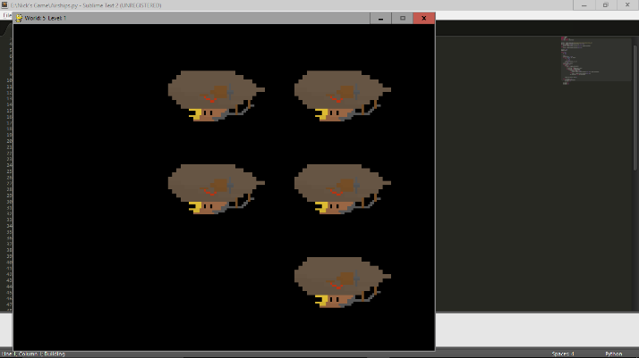I have also tested it on further worlds and they all work correctly.

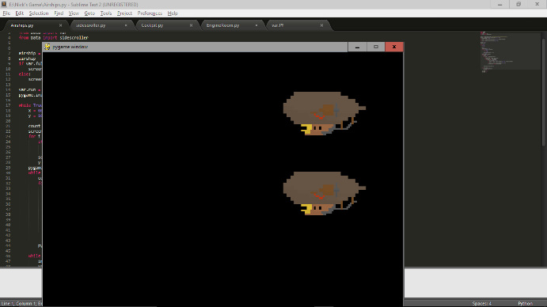It also only displays this on level 1 of each level, and the fullscreen function does work.

### Sisedscroller

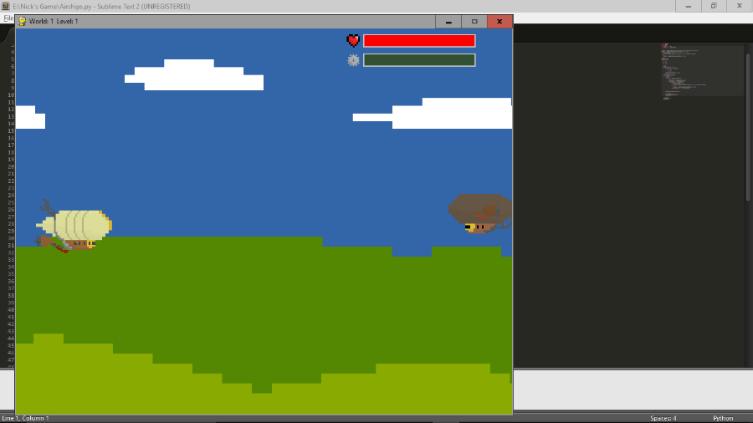When the siescroller first opens on each level, the airship moves on from the left of the screen.

Shorlty after, an enemy comes on from the right.

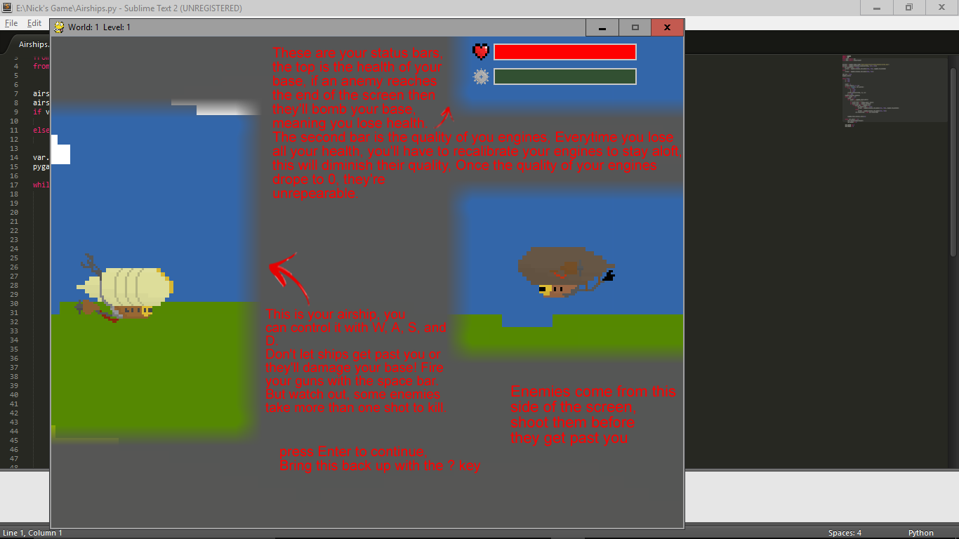

After this, the tutorial pops up and freezes the game. This is what the tutorial looks like:

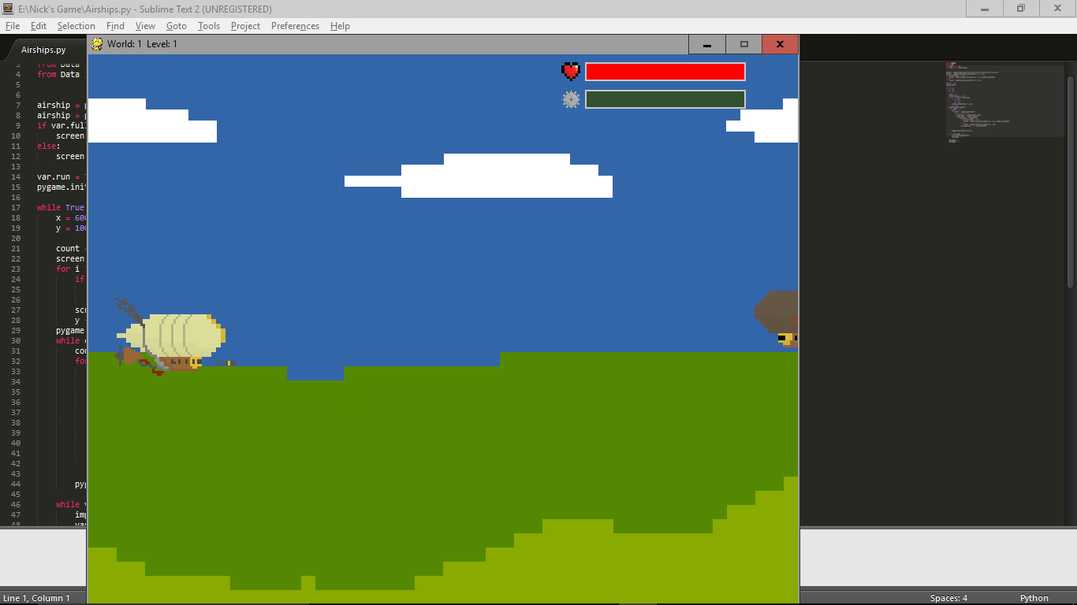When you press space bar, a bullet comes out of the front of the airship:

If space is held down, then a stream of bullets comes out:

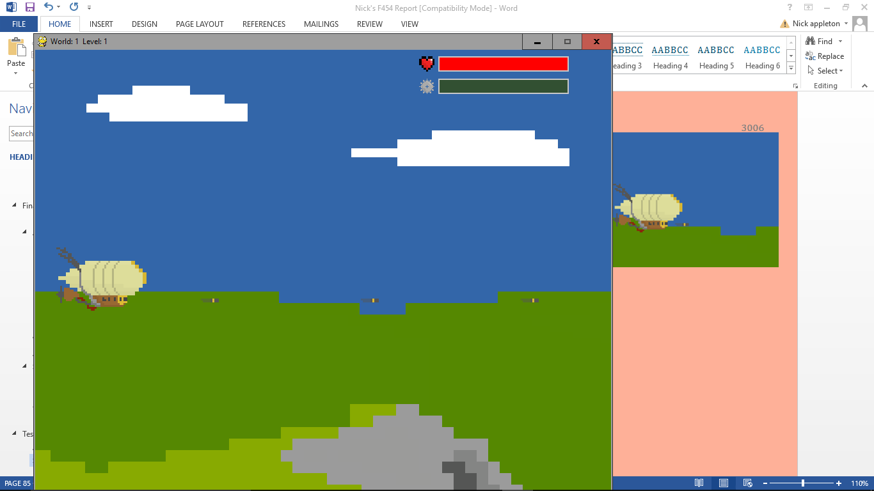

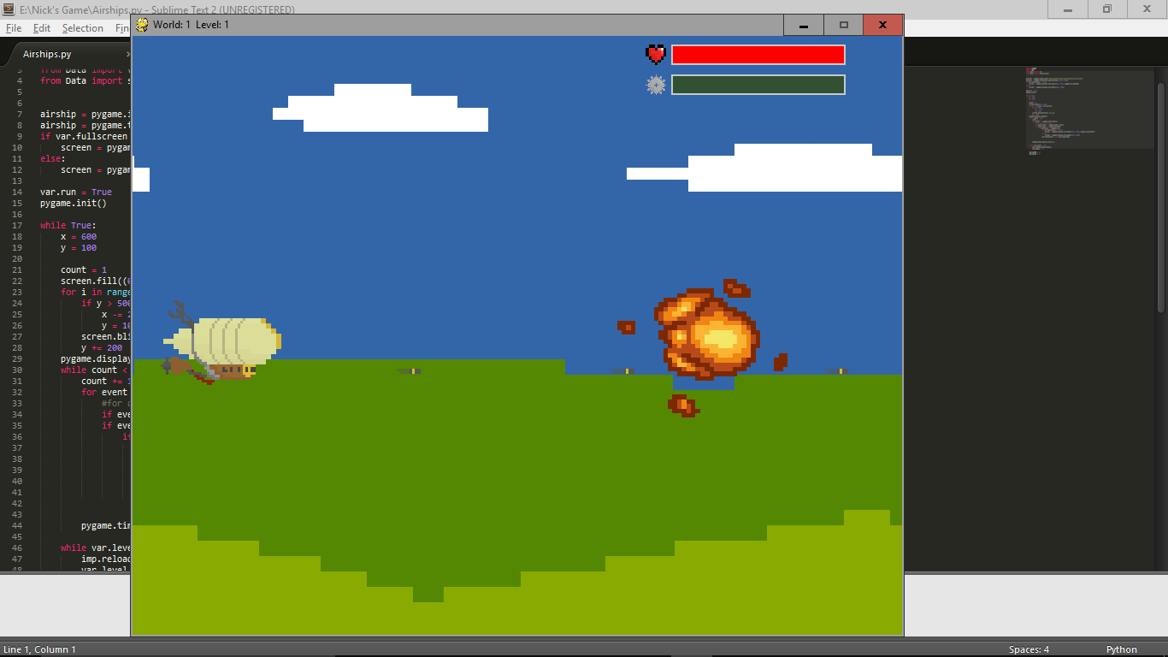If this hits one of the enemies, they do correctly explode.

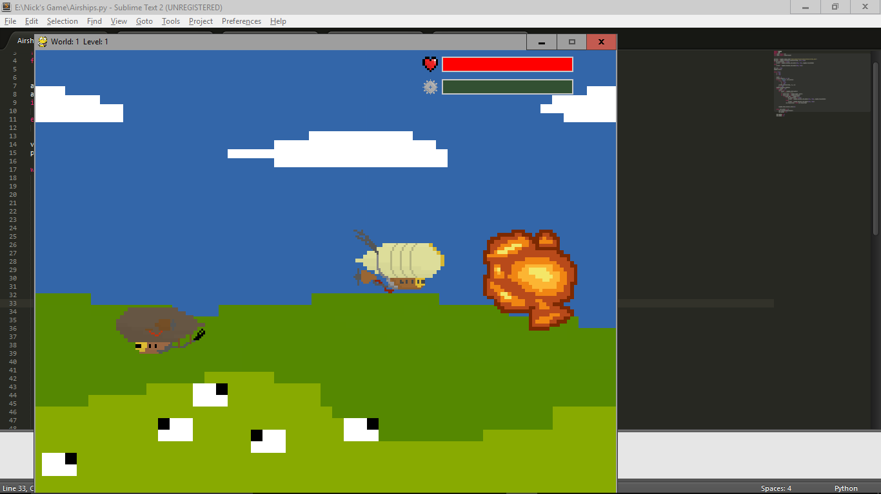The movement, and bounds of movement also work:

This is all of the basic functions working correctly, next I’ll test the pause function and Konomi code:

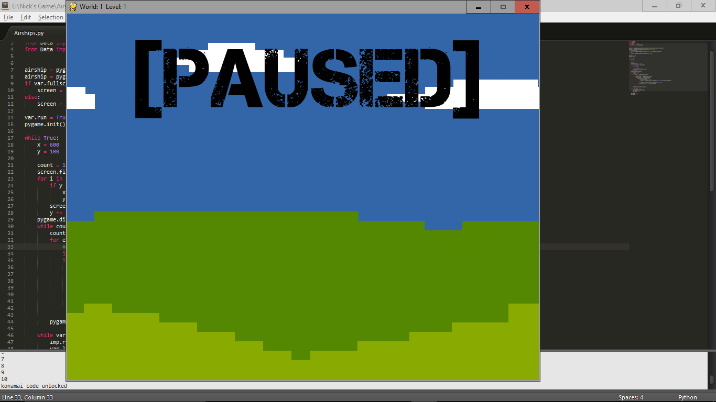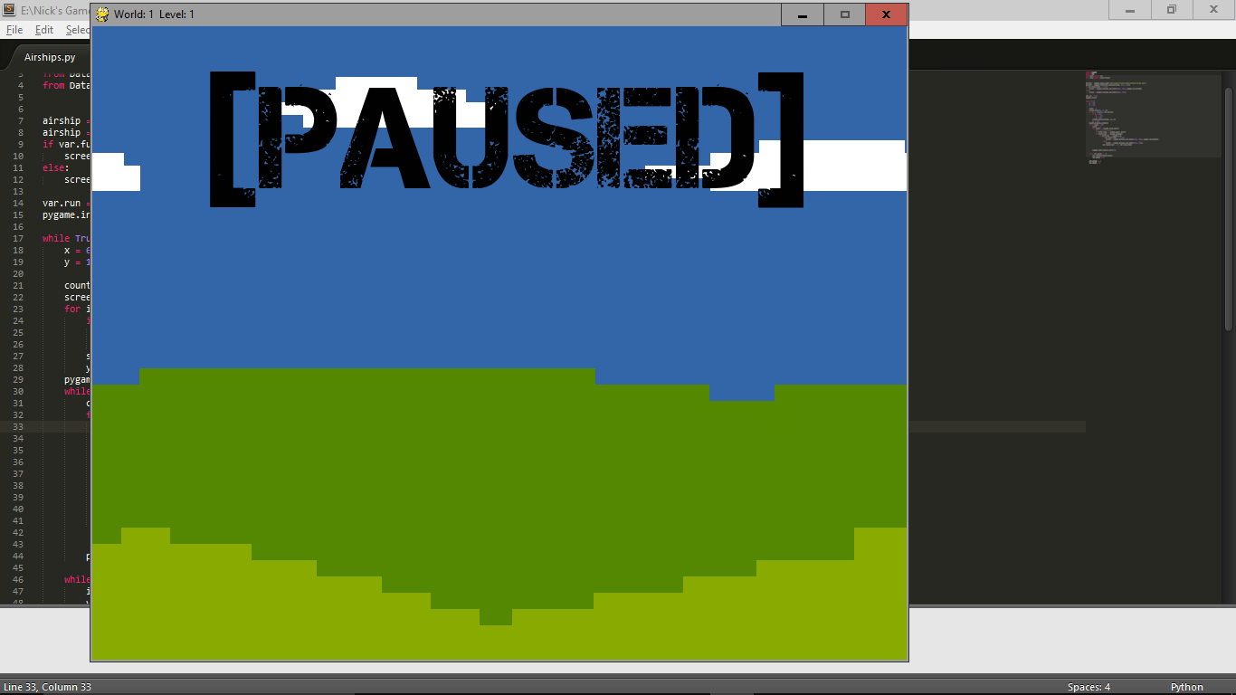The paused screen itself works, and whenthe konami code is input it counts it up properly, too.

When you exit from the paused, your heath is increased and you fire much faster.

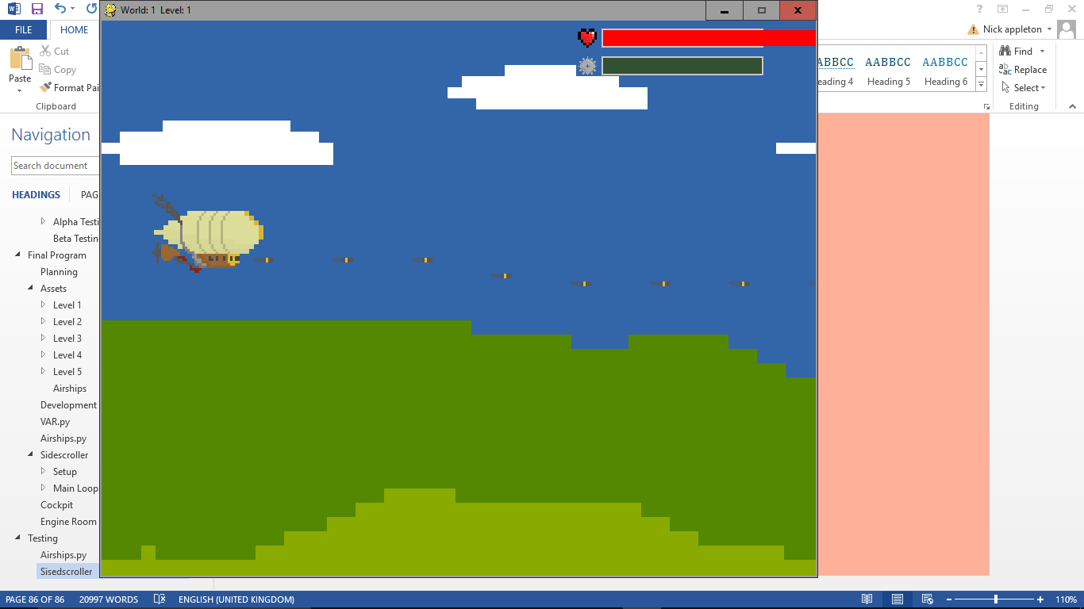

Next I’ll test each level and make sure they all work well.

Level 1:

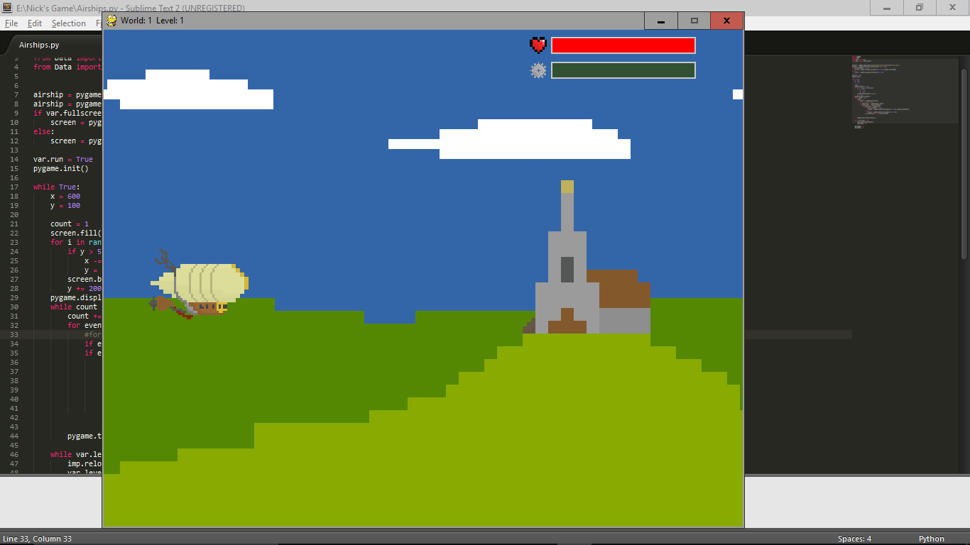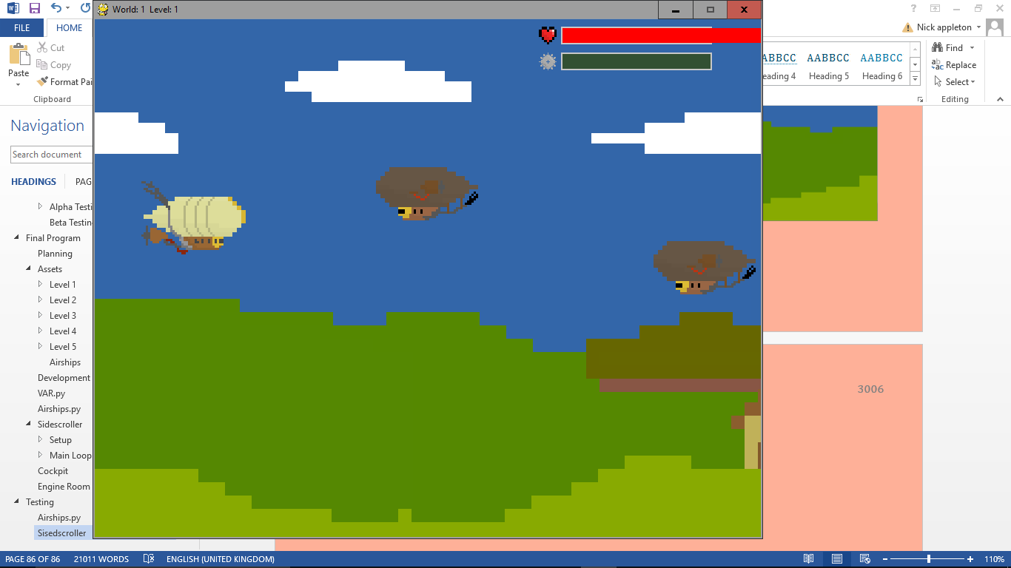

Level 2:

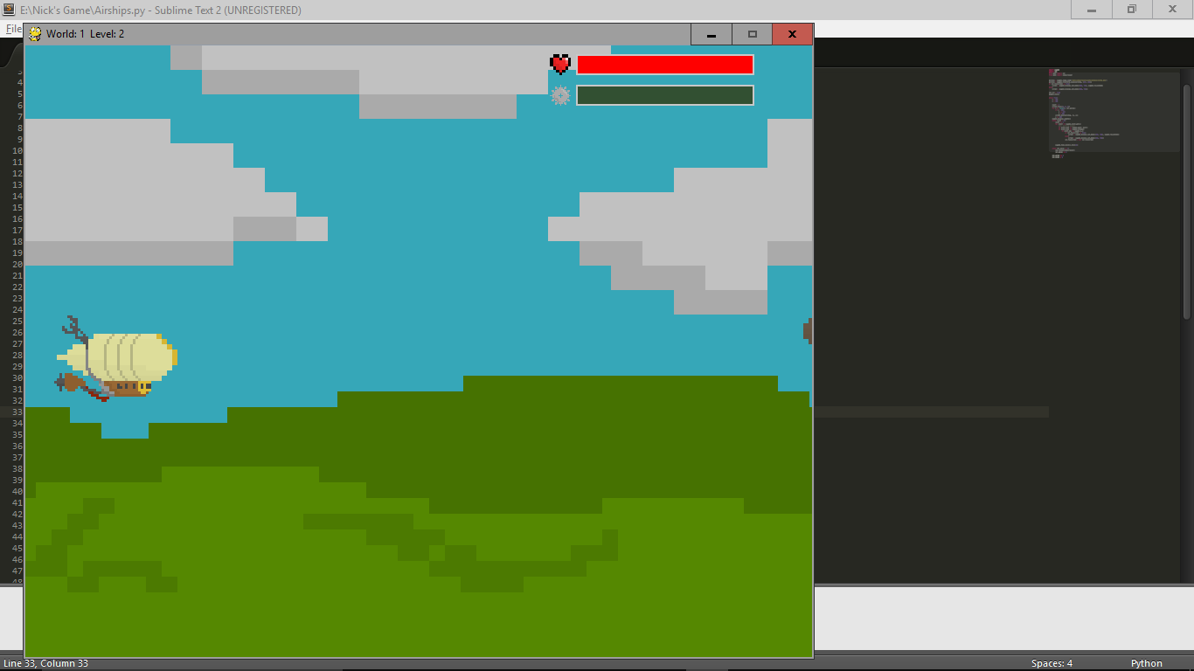 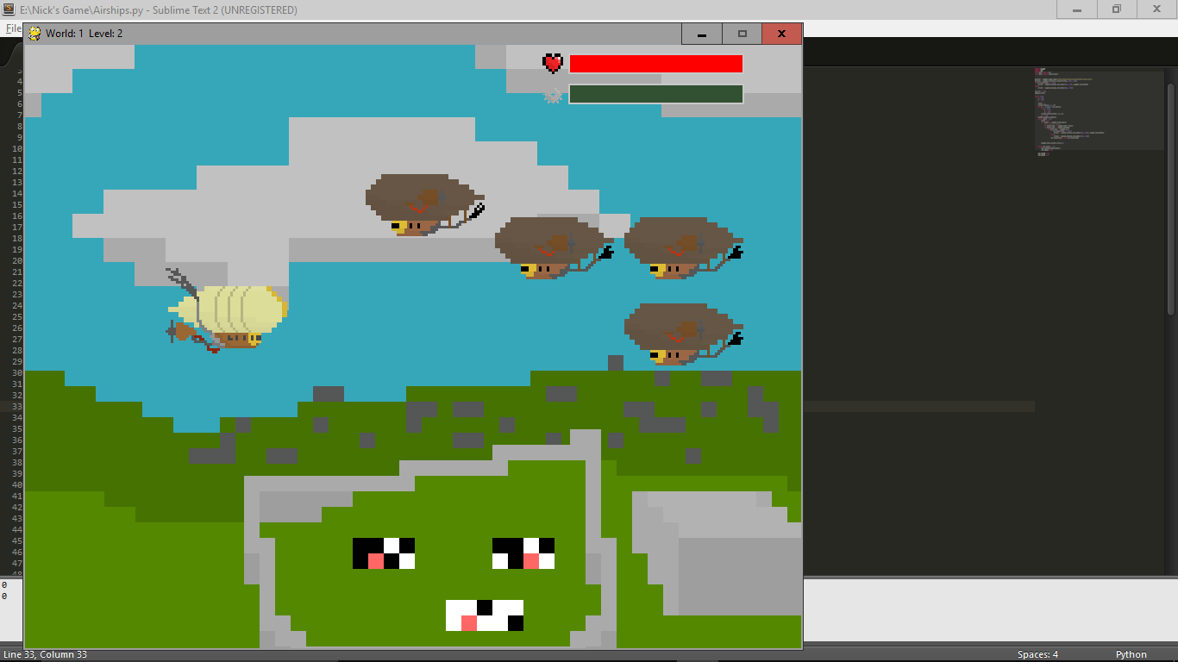

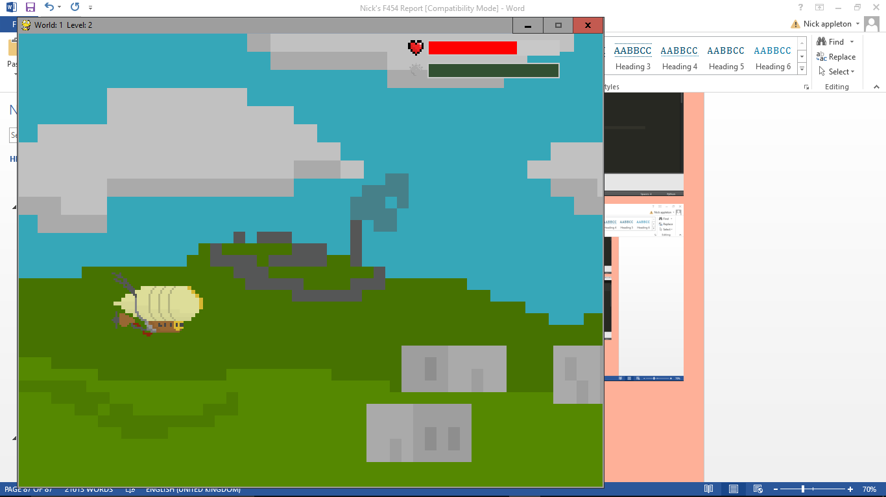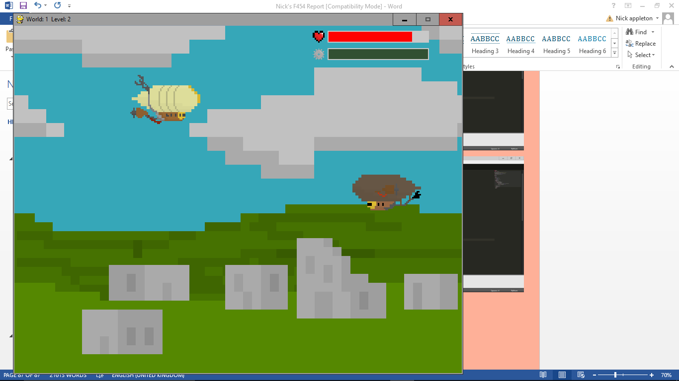 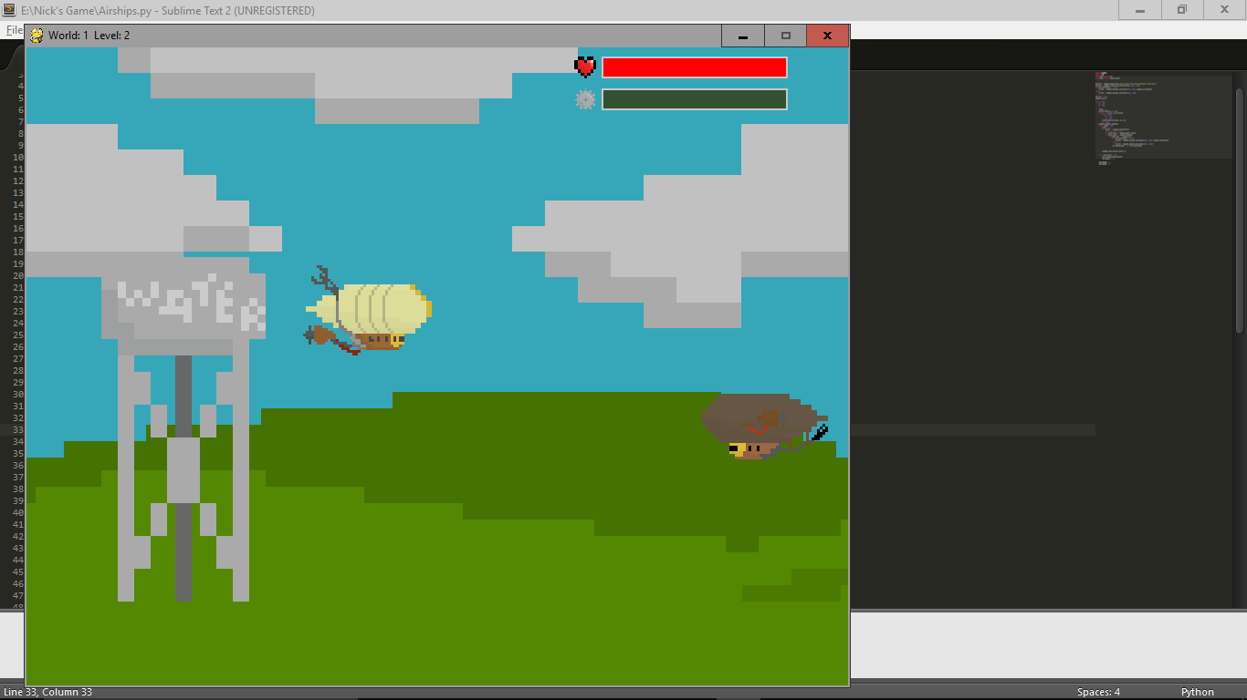

Level 3:

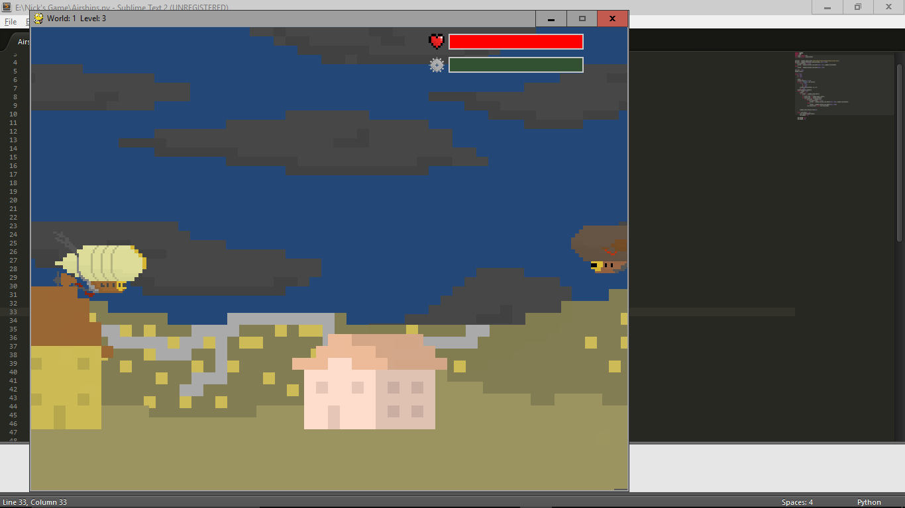 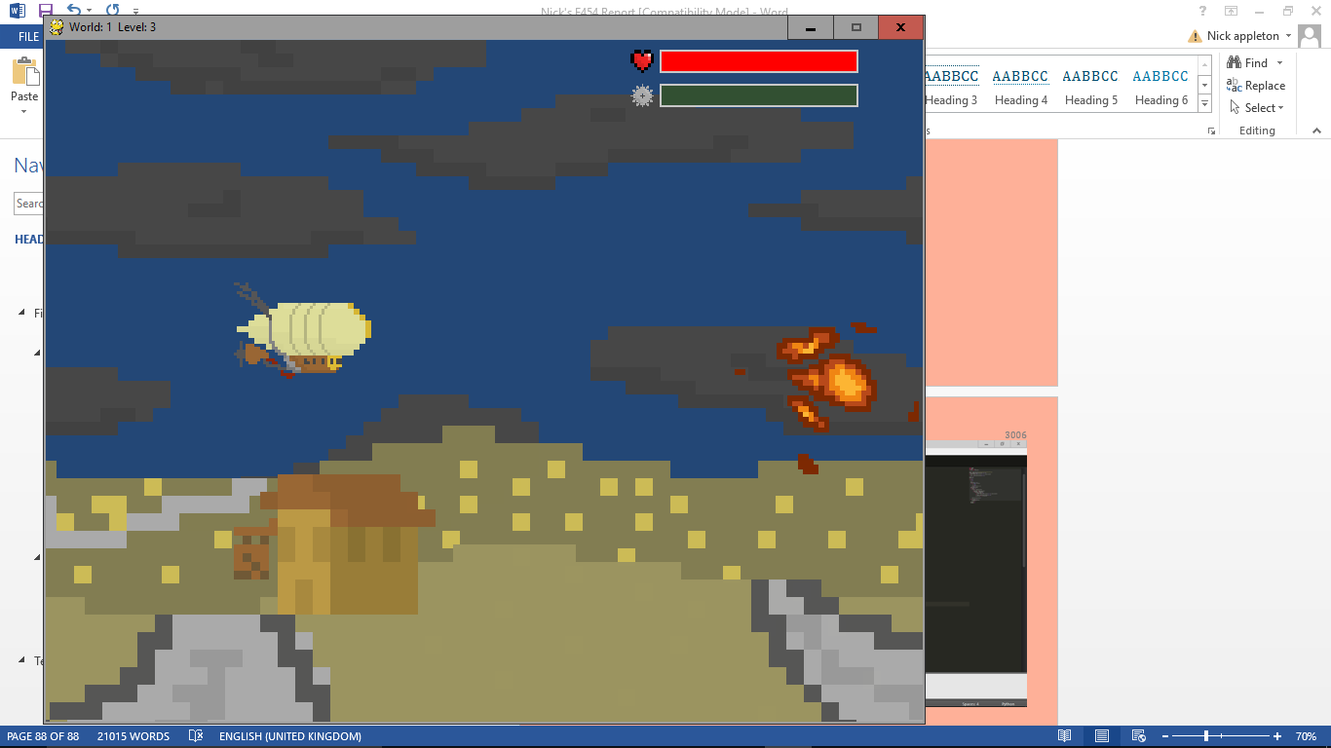

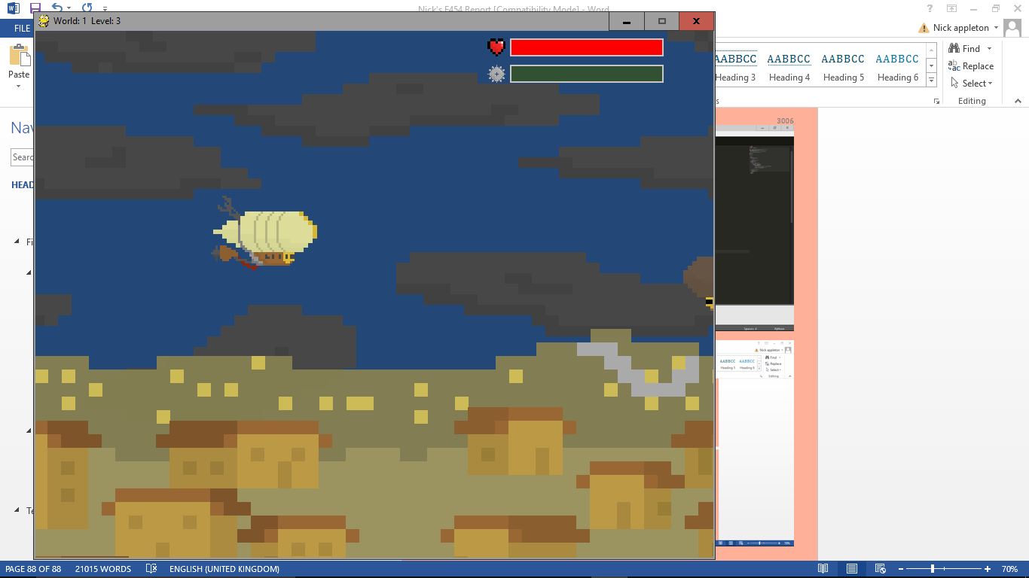 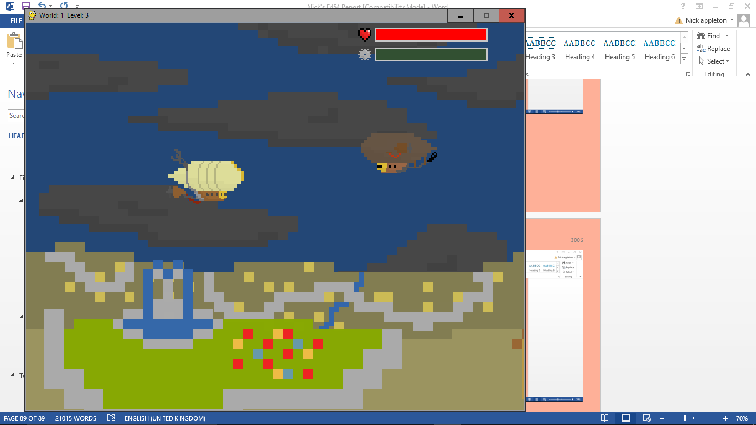

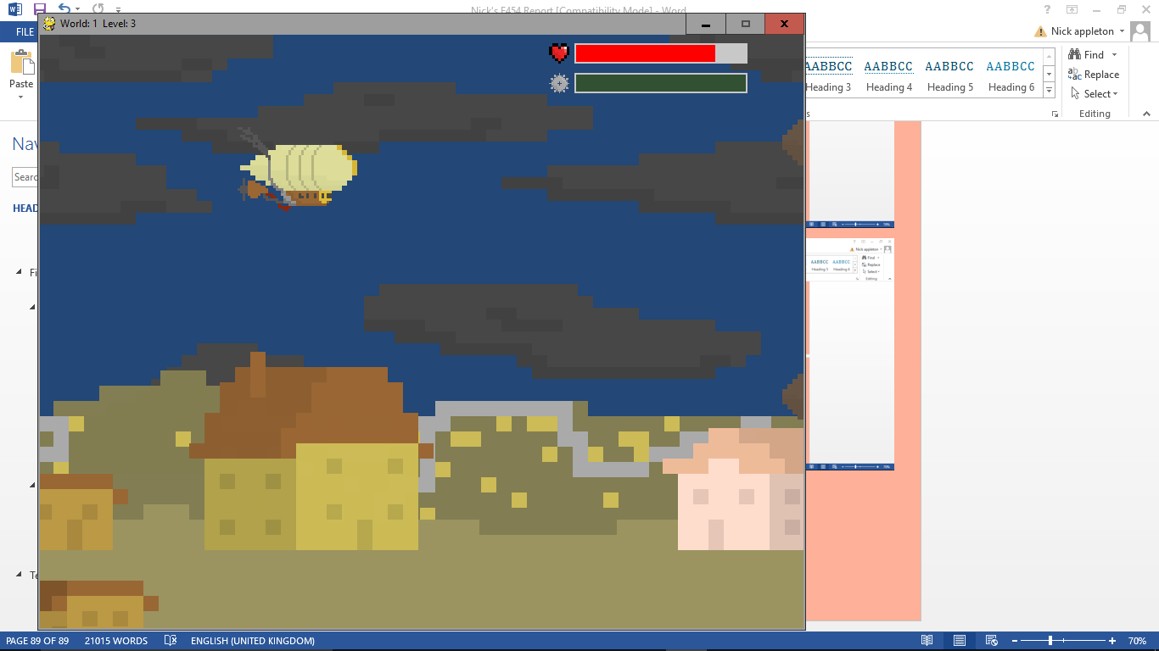 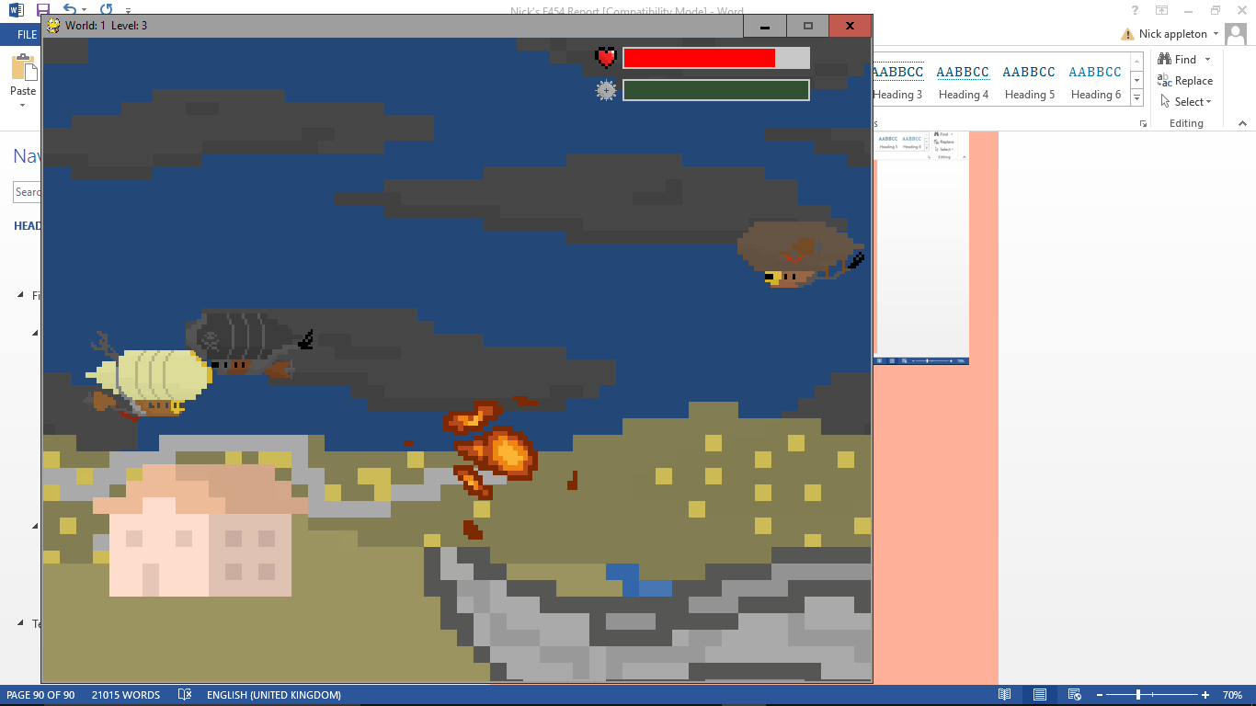

Level 4:

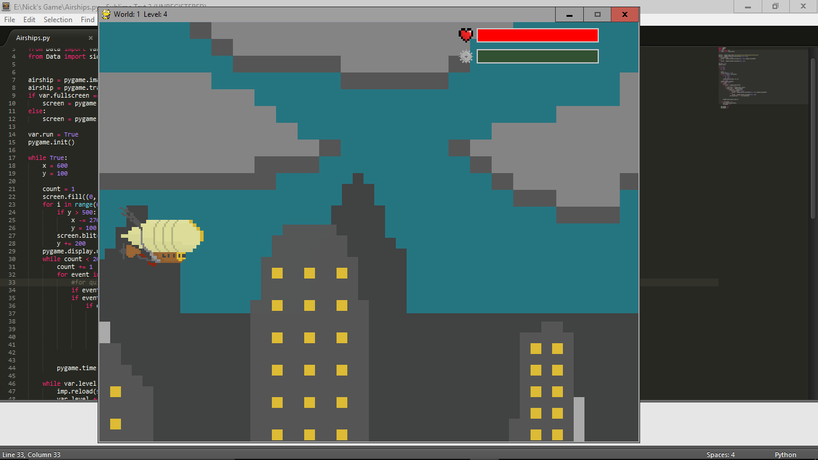 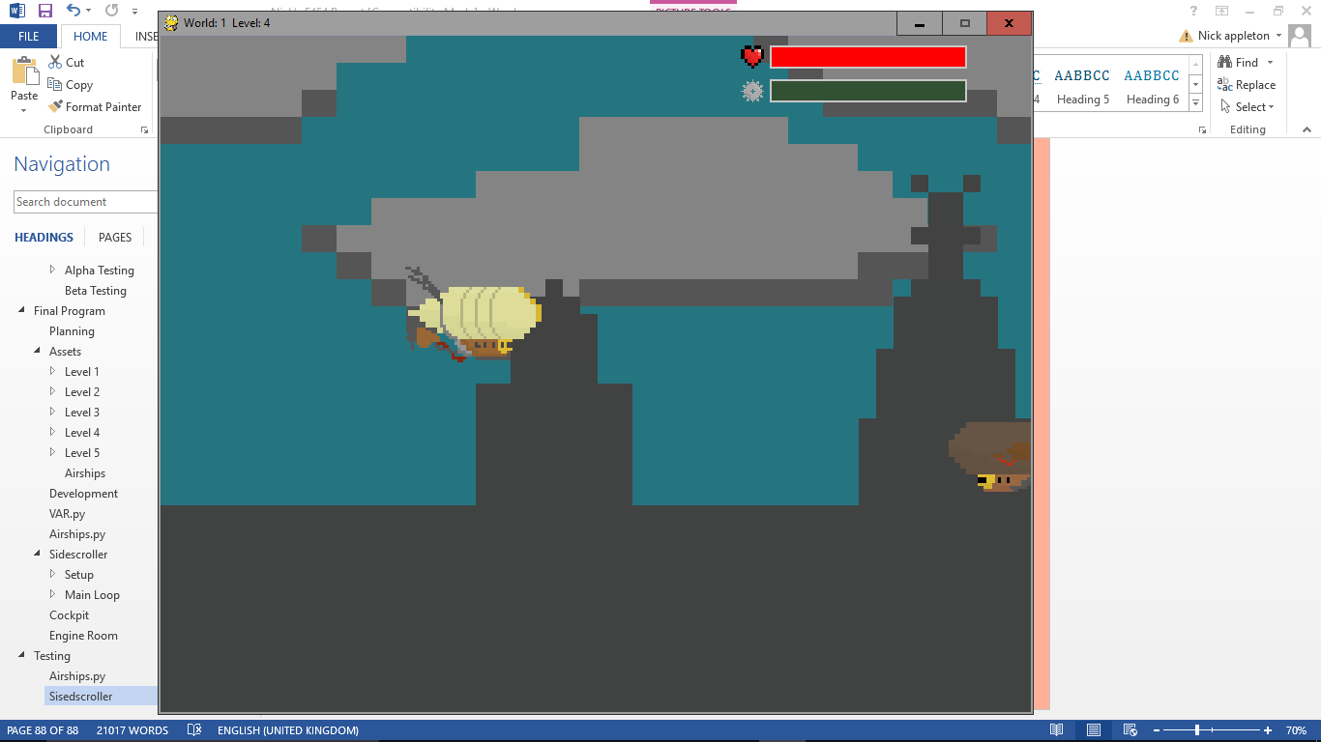

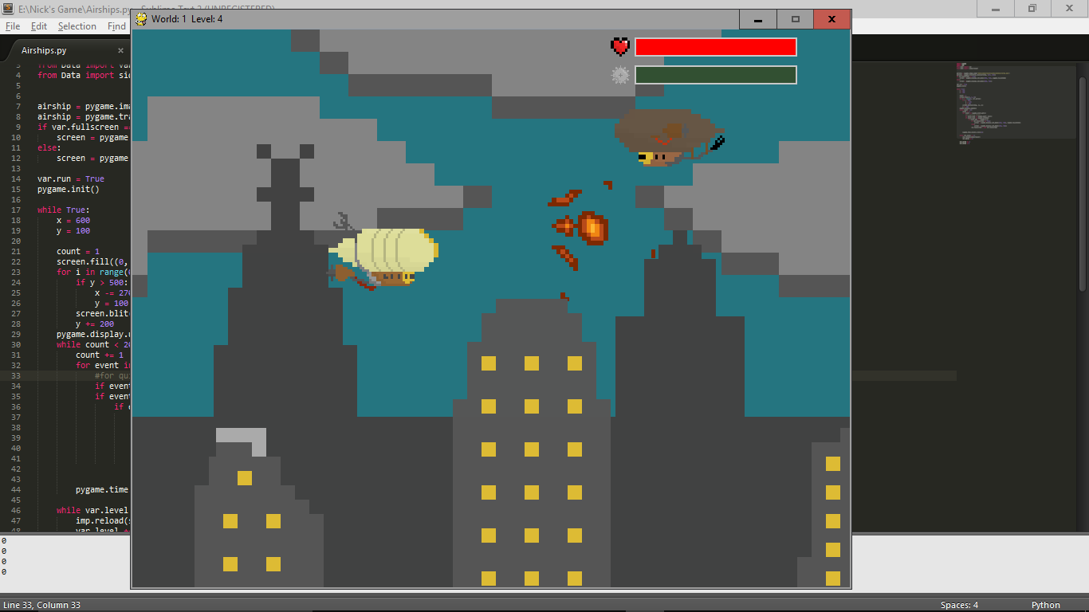 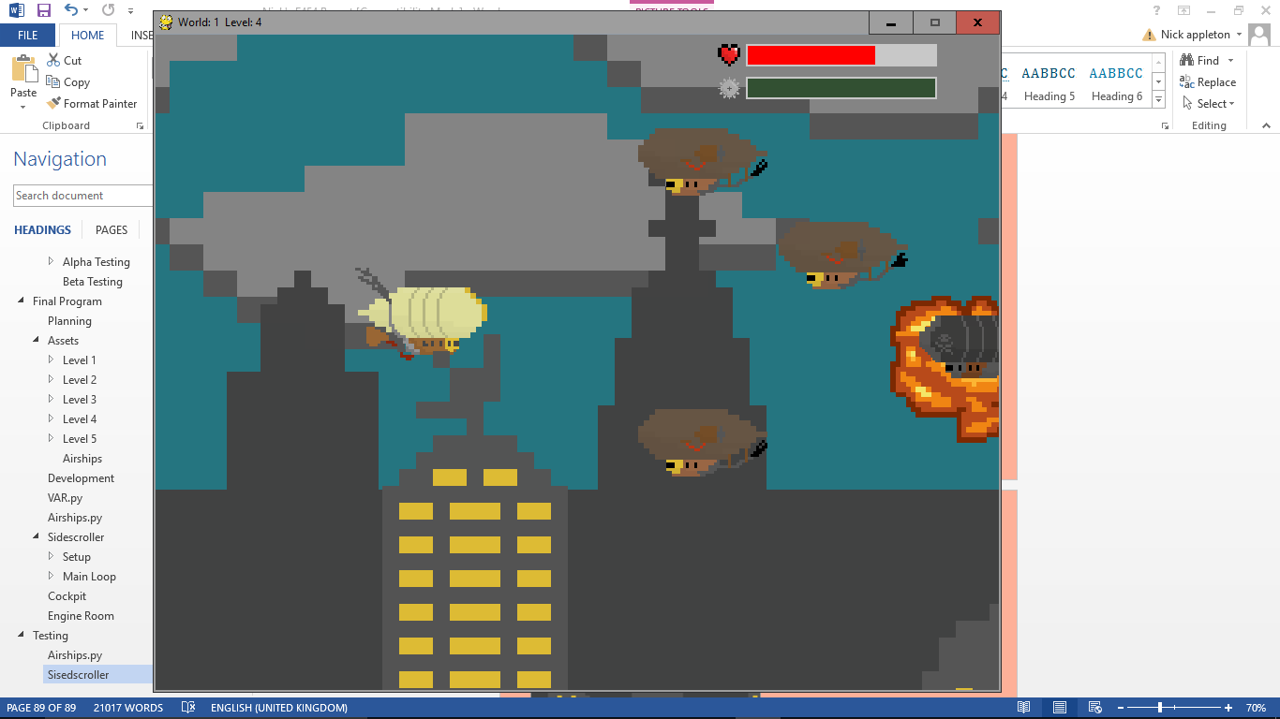

Level 5:

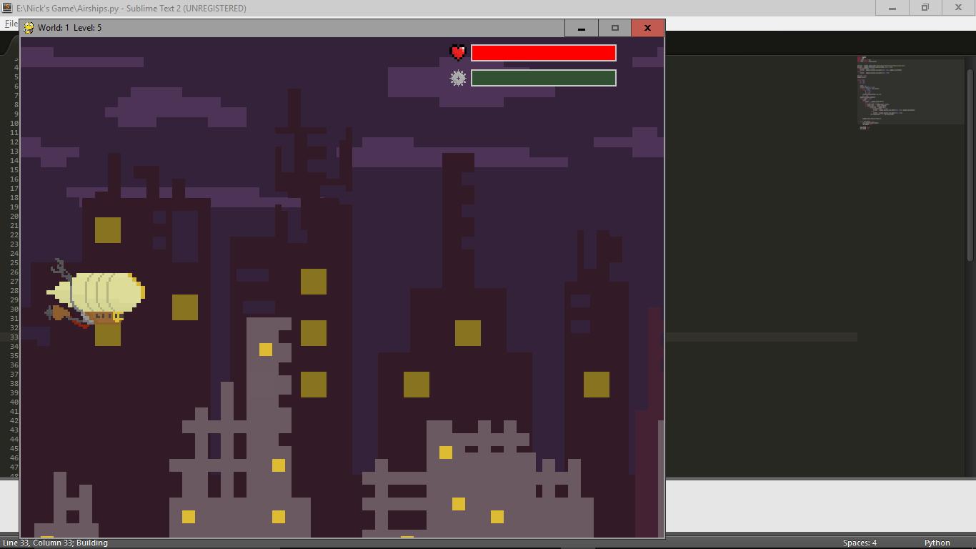 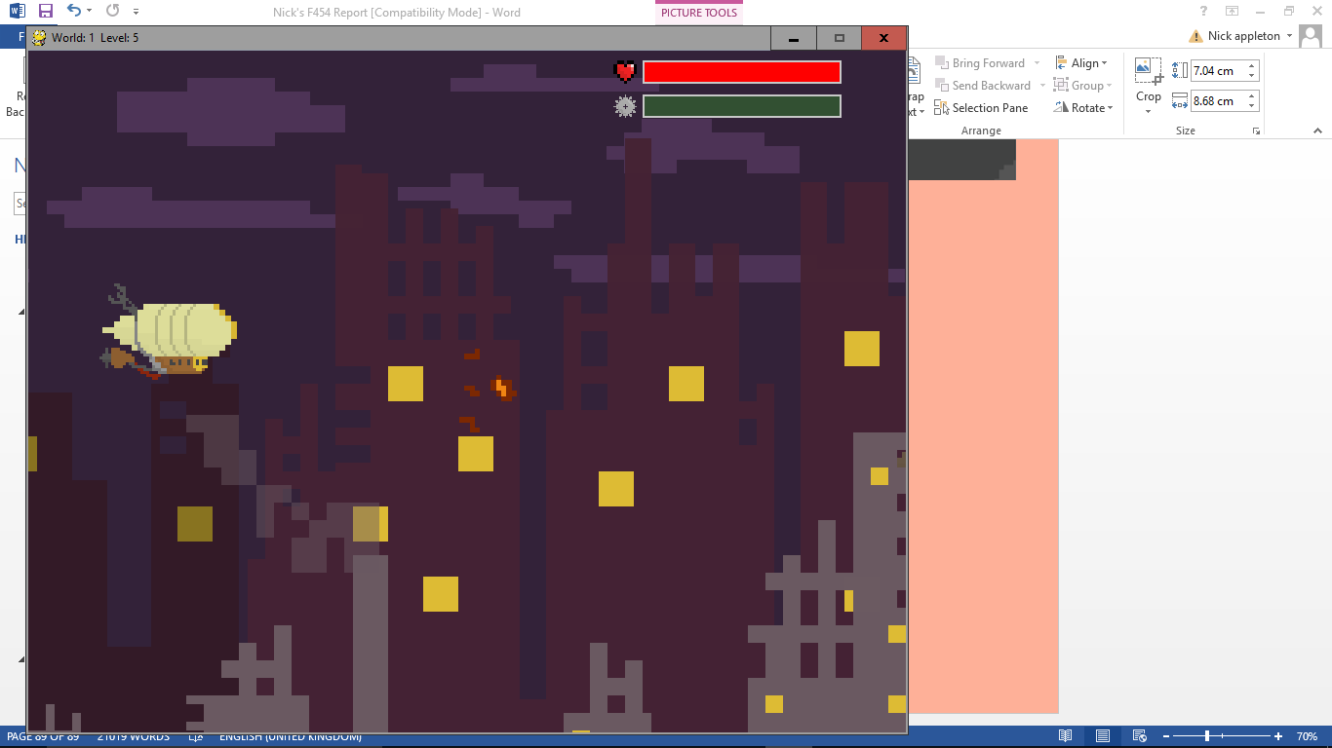

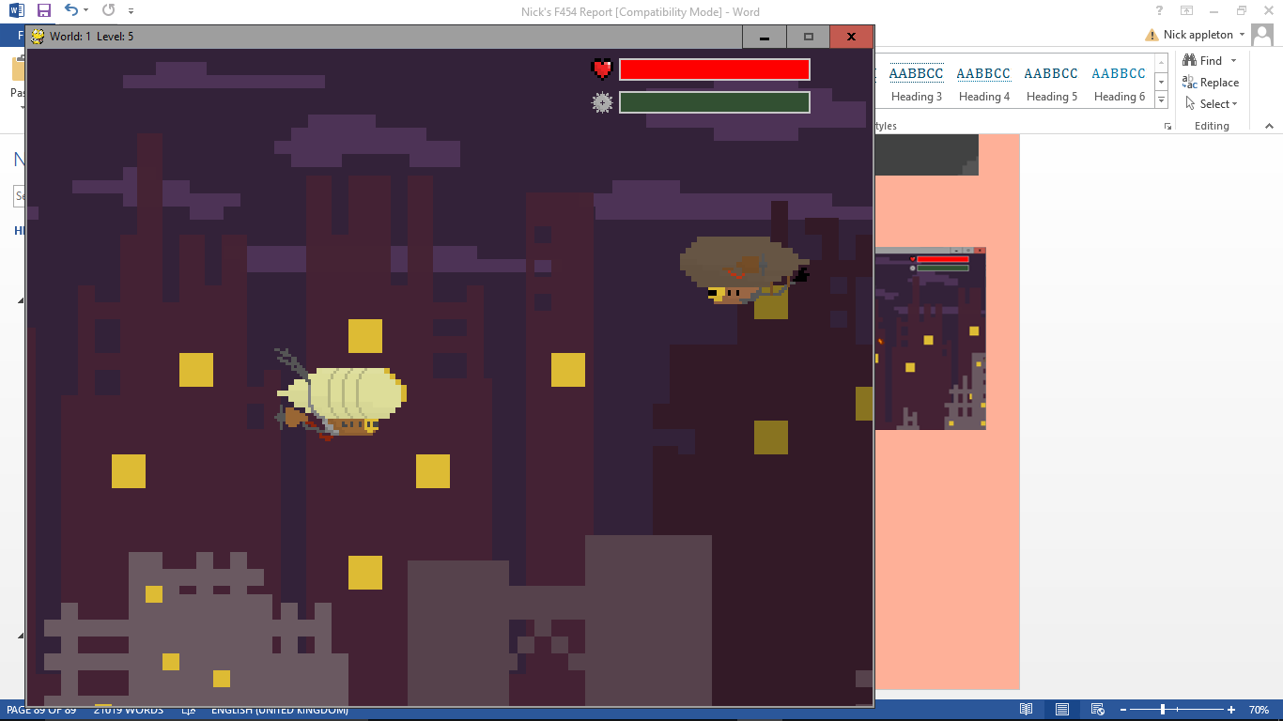 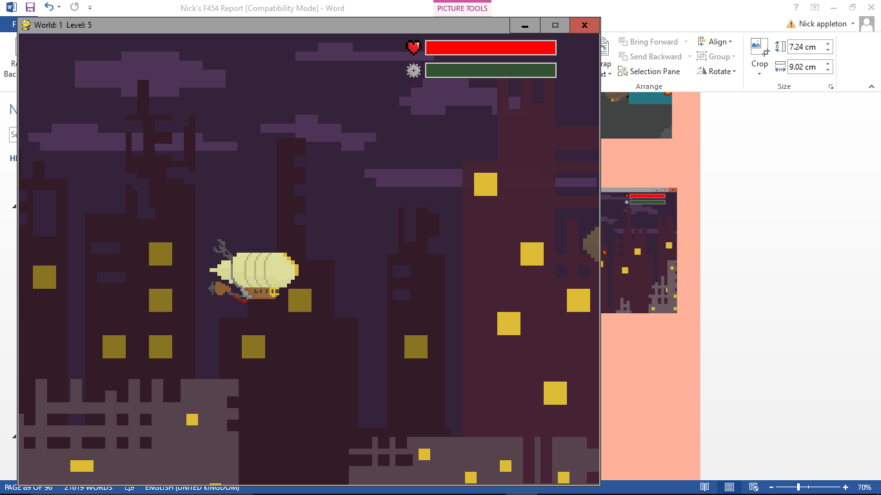

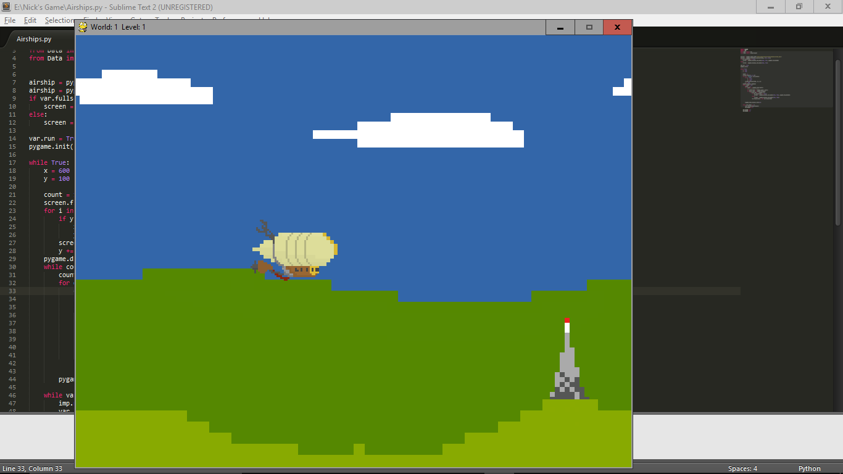All of the levels look good and work correctly. It didn’t crash when loading the levels, the enemies get more intense as the levels go on, the enemies that take two shots to kill work, too. Also the enemies do more damage on the later levels.

Next I am going to test the end of the level and the player dying.

End of level:

The background of the level stop but the airship keeps going; the missile animation works effectivly; and it loads cockpit correctly.

Dying:

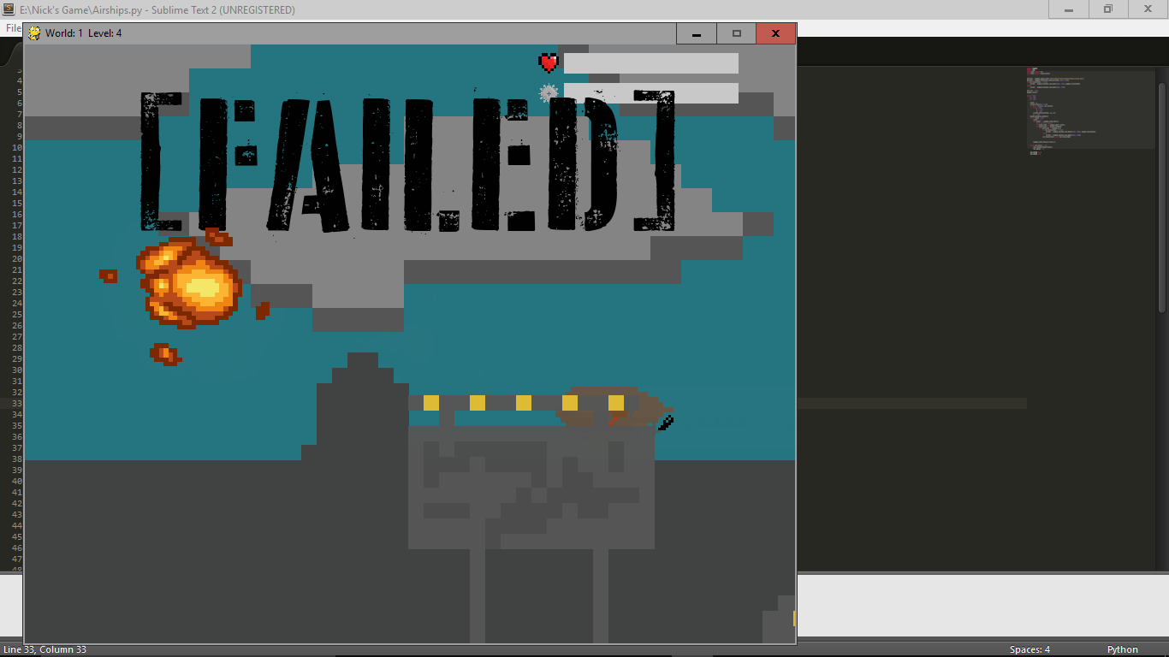When you run out of health, the airship drops at an increasing rate which looke quite natural, all of the airships are correctly removed and everything is reset properly, and the quiz is loaded correctly.

If the engine quality is 0, then the screen freezes, and your airship explodes. The explosion is slower for the player airship as it signals the end of the game.

However, when the animation ends, it simply moves you onto the next level. To fix this, in the part of the game that deals with the death on 0 engine quality, I’ve replaced break, which siply handed back control to airships.py which thought it had therefore finished the level, with exit() which completely exits the game. This has fixed the problem.

### Cockpit

When testing the cockpit I have determined that it loads correctly when the sidescroller level ends. The new controls also work, now pressing space to trigger the flippers, as well as the new button image as well as animation when the button is pressed (using the enter key). The timer and punishment are both also harsher as the levels go on, as well as the sky image changing level to level.

Also, the tutorial works on the first level, as well as when [?] is pressed.

#### Checking the Table

|  |  |  |  |
| --- | --- | --- | --- |
| No. | Test | Expected Outcome | Outcome |
| 1.a | Pressing each of the buttons that will change the switches | The corresponding switches should change to the opposite orientation and the overall value of the switches will also change. | The switches change as expected and intended. |
| 1.b | Pressing multiple switches at the same time. | This should change all of the switches that are pressed to the opposite orientation as well as changing the overall value correctly | When multiple switches are switched at once, all of the switches do work properly |
| 2.a | Flipping the flippers | The flippers should spend some time flipping then one by one should stop moving and rest on a number until the final number is made. | The flippers work properly when the button is pressed. |
| 2.b | Press some of the switches while the flippers are flipping | The flippers should continue as before, but when the buttons are pressed, the number should NOT change on the flippers. | Originally, the flipper did update to the new number while flipping, but I identified this early and managed to rectify this mistake. |
| 2.c | Press the button to flip the flippers once the flippers are already flipping. | The flippers should restart with whatever the number is now (if it’s been changed since the first time it was flipped) and flip like normal | The flipper starts again, and the number it displays is the number that the switches are on the most recent time you pressed it. |
| 3.a | Get the correct number | The missile should explode in the air, and the victory banner should display, as well as then close the game. | The Victory section works as intended |
| 3.b | Let the missile hit the cockpit | One large explosion should appear in the middle of the screen (where the missile hit), and a lot of small explosions all over the dashboard. Then the game should close. | The failure section all works properly |

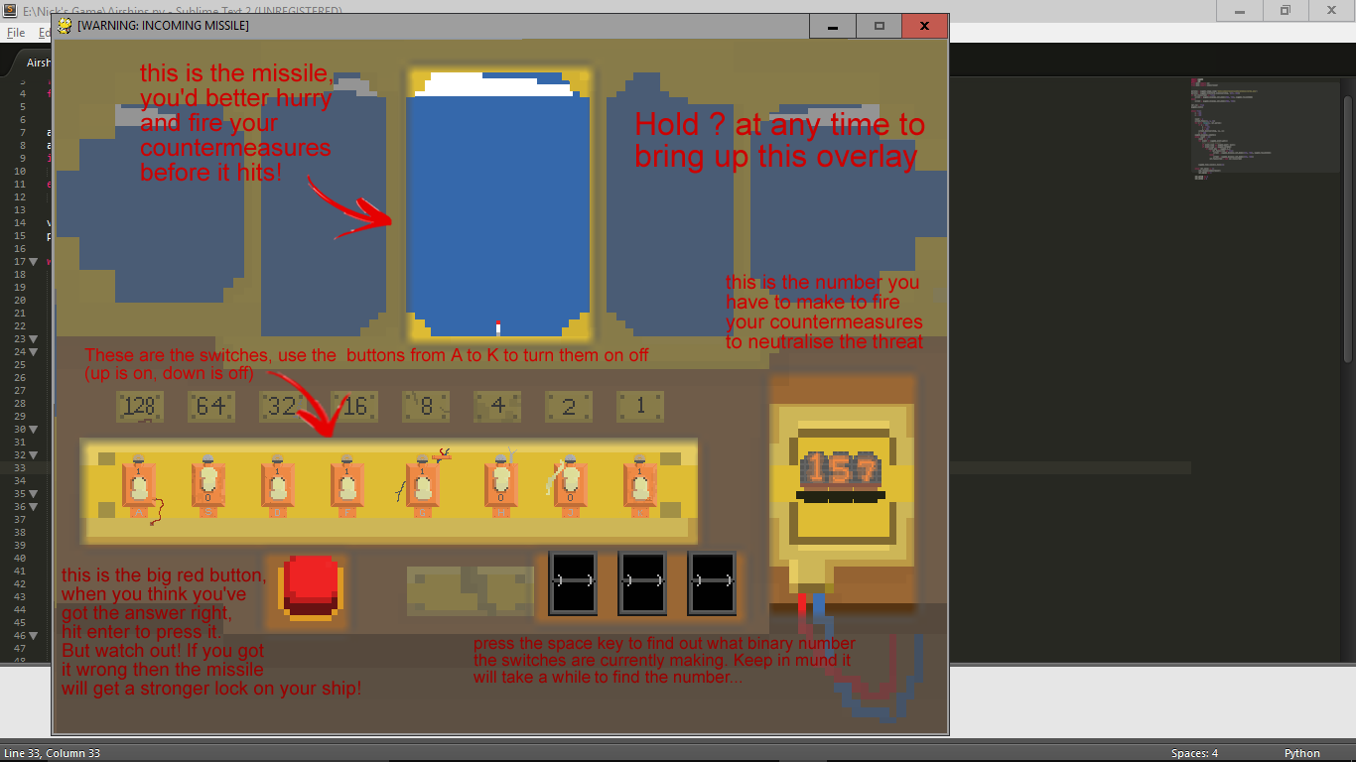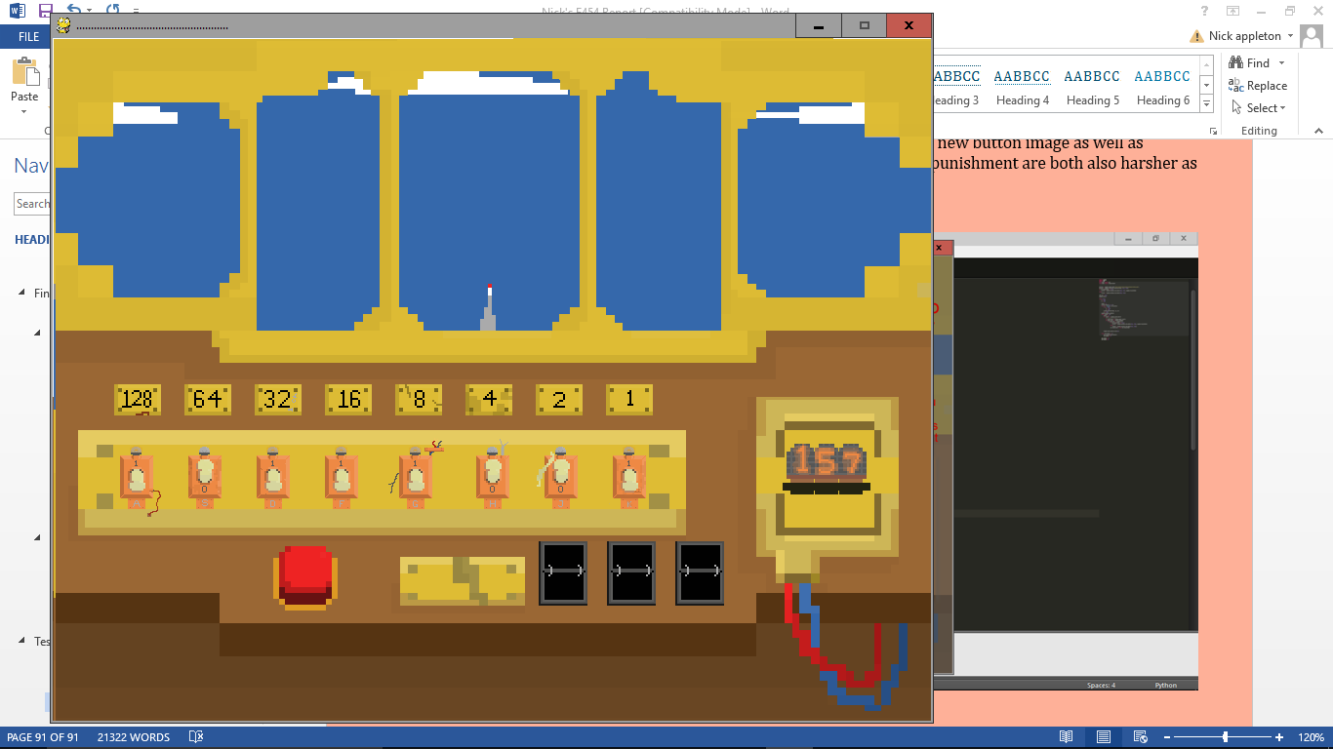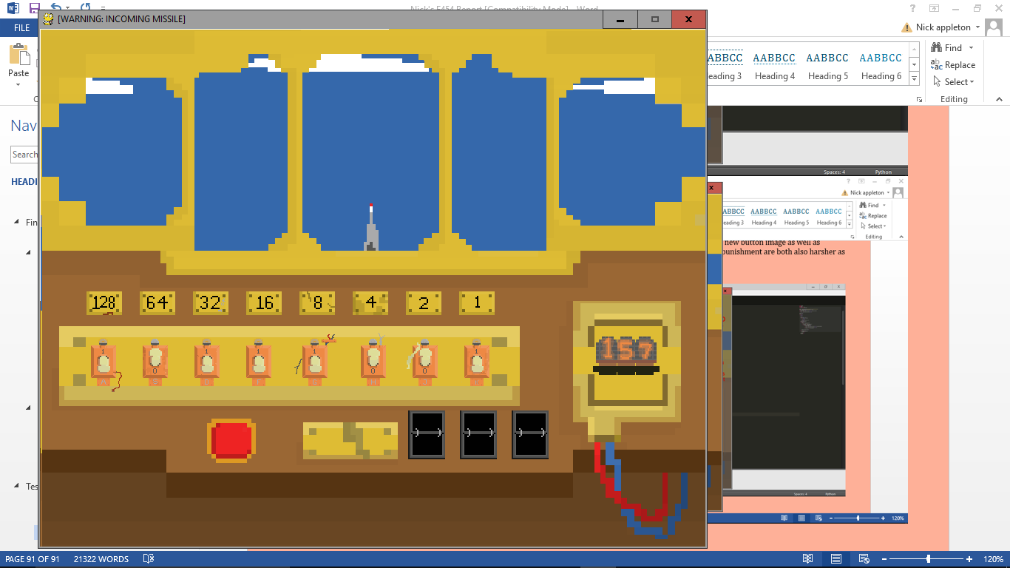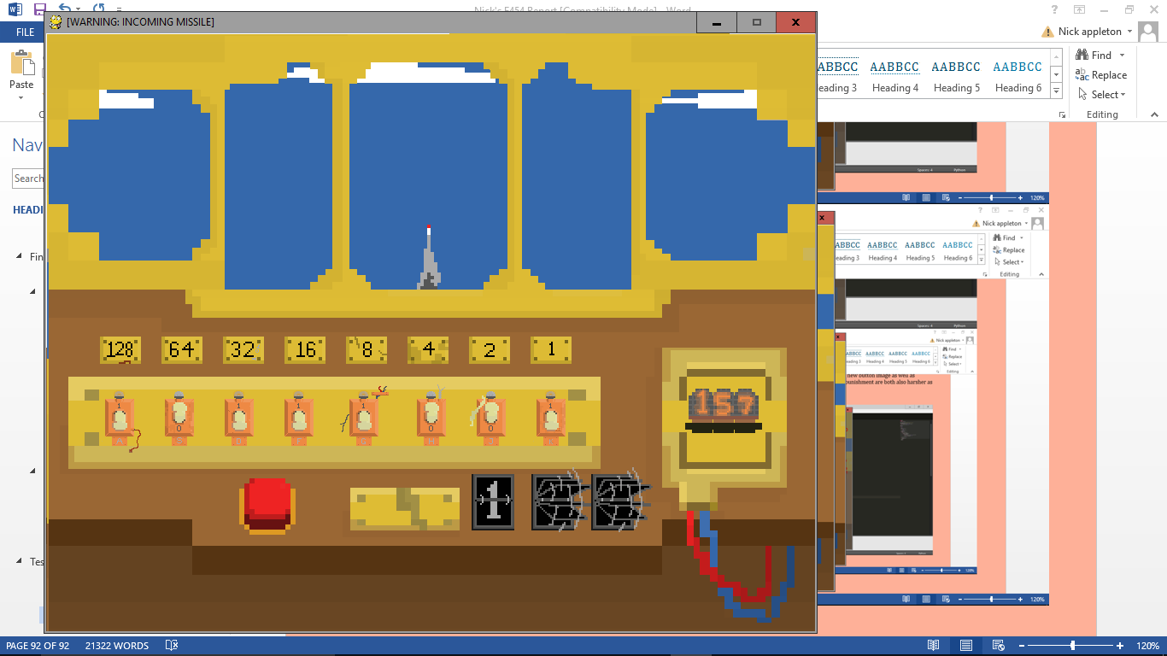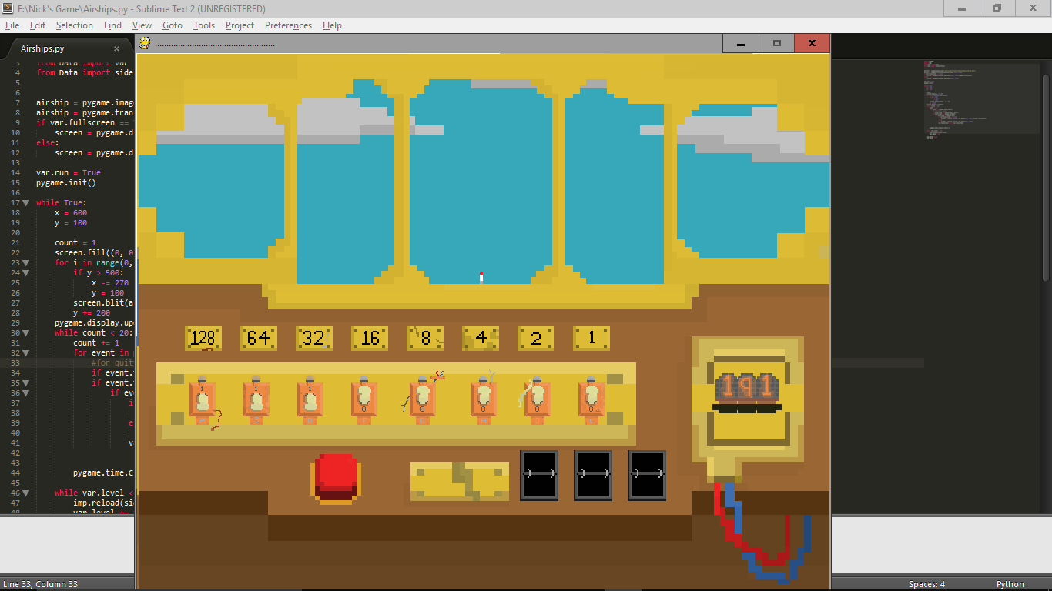 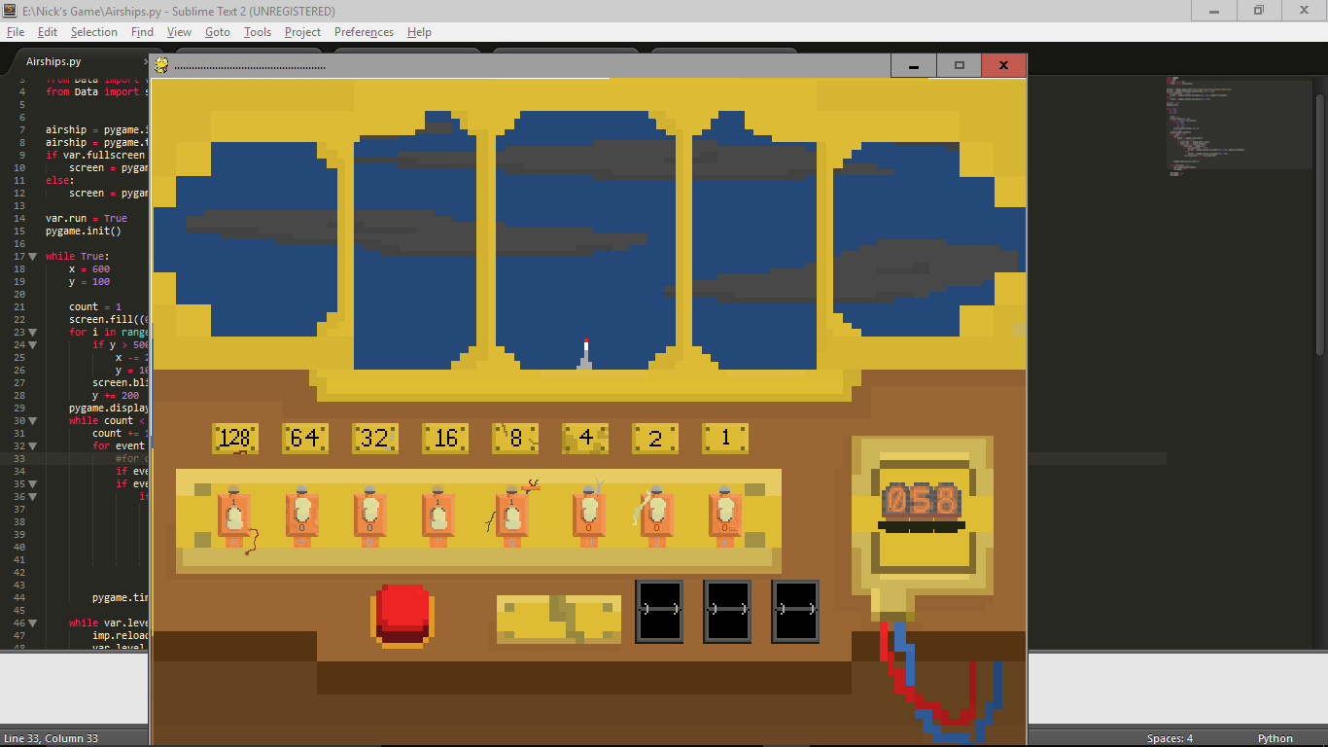

If the quiz is completed successfully, then it succsfully hands back control to the main program, this means that the level and/or world are correctly incremented and the sidescroller is run again. If you fail the quiz, the game will tell the player they lost (in very much the same way as the first version) and the game quits. This means that if the player fails, they will completely lose the game and have to start again from the beginning.

### Engine Room

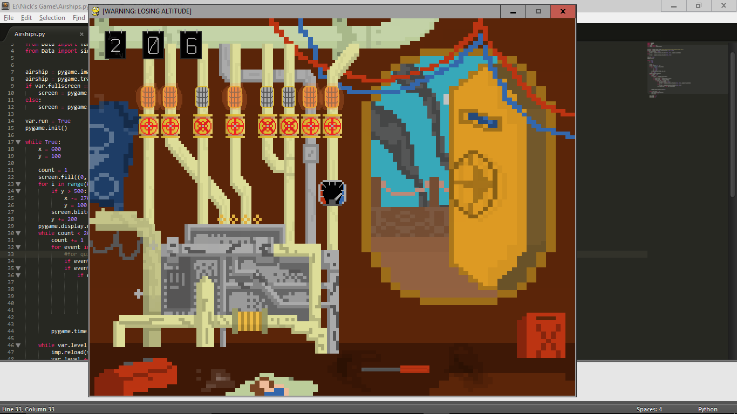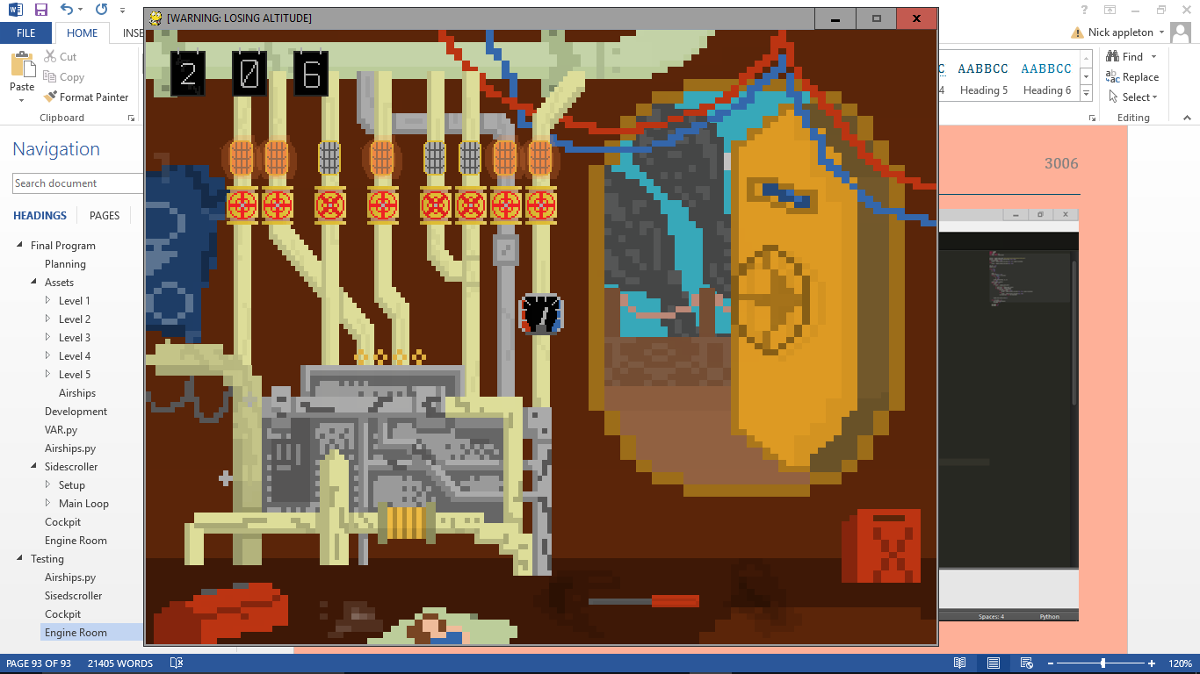

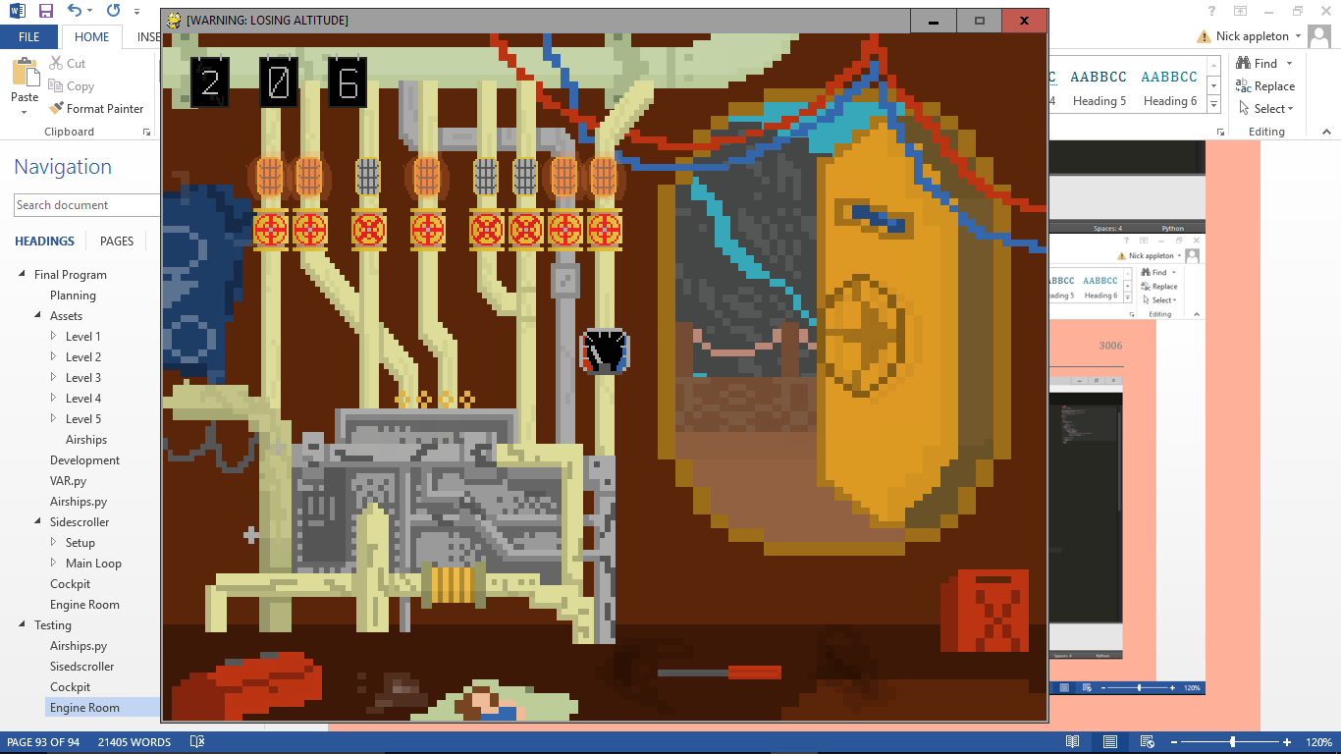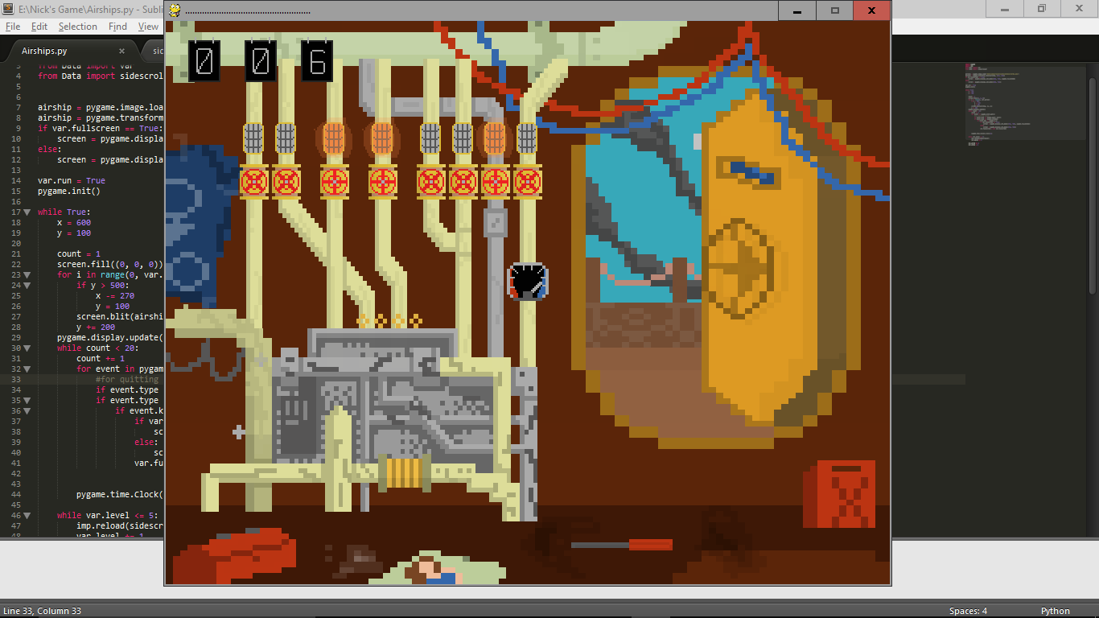

The engine room all looks good, all of the new features such as the altimeter work correctly. However, I noticed that the plaques weren’t being displayed, apart from on level 1. I noticed that the if statement that only displays them on world 1 wasn’t working, and discovered that this was because I had written

1. level = var.level
2. world = var.level

Instead of

1. level = var.level
2. world = var.world

This was very easy to fix, and doing so also fixed the problem. This was probably also why the engine room quiz never lasted very long, which now has also been fixed.

When you complete the quiz, the sidescroller continues and all of the onscreen enemies are gone, also your health is back to full but engine quality is lowered. You also enter from the left of the screen again.

If you fail, the same thing happens as in cockpit.

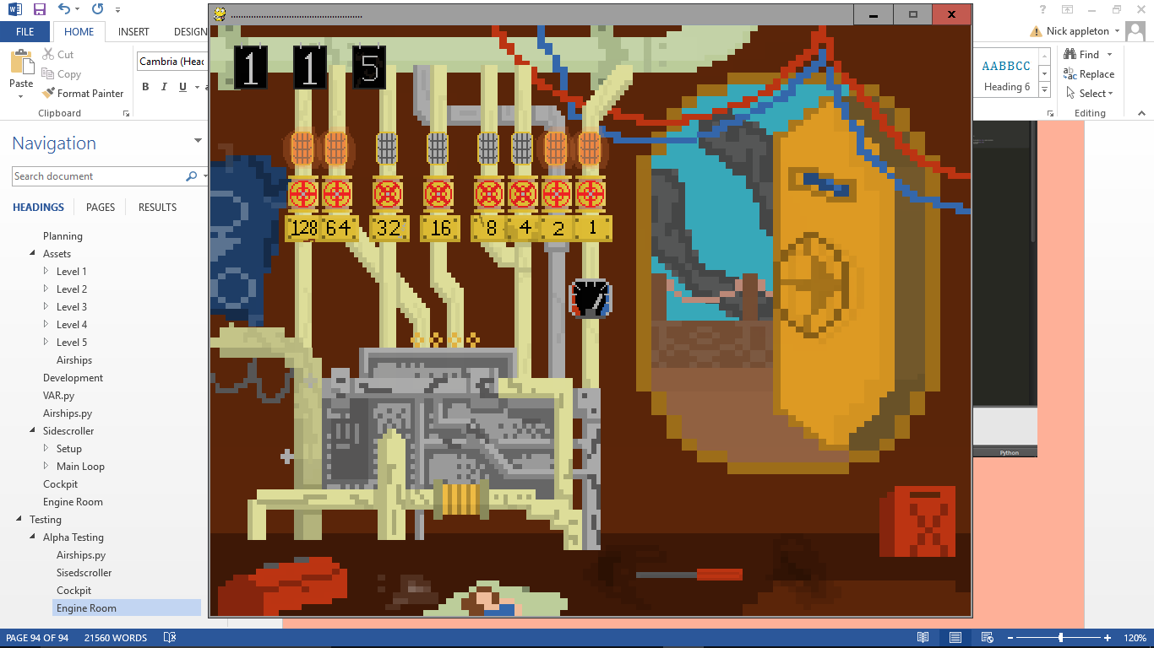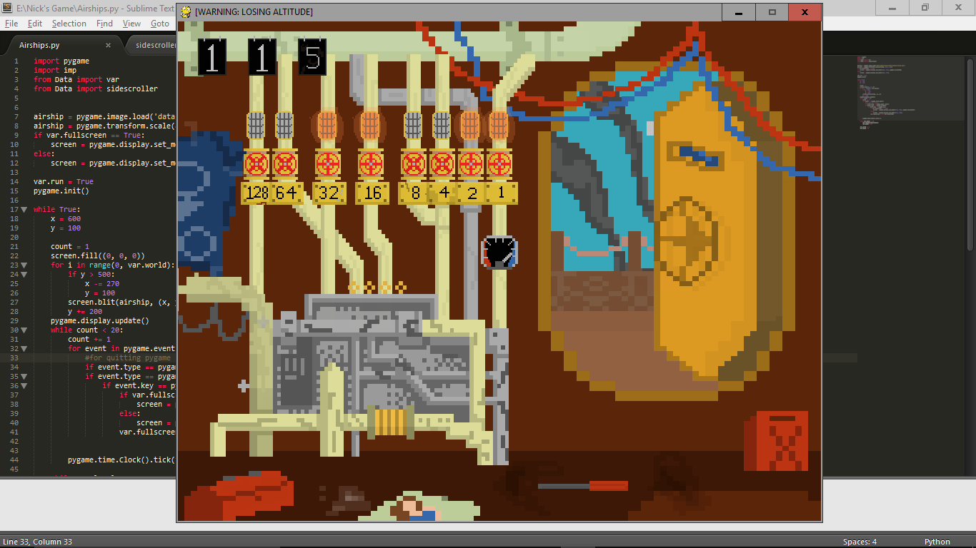

This means that all sections of the game have been successfully alpha tested, and I will now move on to beta testing.

## Beta Testing

On Monday the 29th of February, I gave my game to a group of 6 GCSE computer science students that my client had picked out for me from his class. I gave them a copy of my game, a sheet including all of the user requirements, design specifications, and design objectives. I asked each of them if they would consider these objectives and specifications while playing the game, and to feedback on the sheets whether they thought each of them had been met or not. Once I have received the feedback forms, I will sit down with them individually for a one on one interview to discuss why they thought certain specifications had or hadn’t been met, as well as qualitative testing: whether they liked the gameplay, the visuals, the style, the structure, etc.

### Design Specification

* All aspects must link into the overall theme (airships) : 6Y/0N
* Must conform loosely to steampunk style: 5Y/1N
* All displays must be creative (e.g. Nixie tubes rather than a TV screen): 6Y/0N
* Must be easy to see all the information needed by the user: 6Y/0N

It is almost unanimous that all of the design specifications are completely and correctly implemented in the game. The only reason it is not is because one of the users didn’t believe that it was a completely steampunk style as there aren’t many parts of it that define it as specifically steampunk. This is probably the least important of the design specifications in my opinion, so it doesn’t bother me too much.

I have only included the response for the design specification because it is the only of the considered documents that is qualitative, the other two are quantitative, and so I don’t need the response of the end users.

### One on One

The one on one talks with the students went quite well. The students feedback was all very positive on the game, I asked each student mainly on a different part of the game. The general responses from each are summarised below.

#### Sidescroller

One of the students I asked about the sidescroller told me that his initial thoughts while playing were that it was fun and looked very promising. Both the students I asked said that once you get to the later levels it becomes a bit tedious, and there is a lack of enemies at some points on levels 4 and 5. I have considered this and think that it would be quite simple to change this; I could make the later levels shorter by changing how many islands are generated when the level is started, as well as adding more enemies by changing the for loop that deals with such matters (how many times it iterates) and add more enemies to the list that it reads from.

Neither of the players found the Konomi code, however, once I showed it to them they both agreed that it was a good idea, giving you a different way to play the game if you’re in on it.

#### Cockpit

The first student I talked to said that while she could feel the game helping her revise, she felt that the pressure it puts you under and the fact that if you don’t succeed all of your progress will be lost all made the game enjoyable. The other student said that because the way the sidescroller finishes and transitions to the cockpit quiz, it really does feel like you’ve got to complete it to progress to the next level. One of them also told me how they liked the idea of it being in the cockpit, and the pretence of the test.

#### Engine Room

One of the students pointed out that there is no tutorial on the engine room the first time it opens. While developing the game I had considered this, however, it is not possible to die on the first level, therefore the first time you’ll encounter the engine room quiz you will have already done the cockpit quiz at least once. This means that you should already be familiar with the system, so I decided not to add a tutorial to this section.

The students also said that the lights above the valves are useful as it makes it very east to see which is on and which is off. Another thing that they picked up on was that there was no flipper system, but that is because the engine room quiz is meant to be slightly harder, because it’s giving you a second chance at life, unlike the cockpit quiz which is actually a required part of progression in the game, so it is slightly more lenient.

This means that all of the sections have now been both alpha and beta tested, and I will move on to the evaluation of the game as it seems that both my client and end user are satisfied with the game.

# Evaluation

## User requirements

### Has it Achieved Them?

Next to each user requirement is a tick if it has been met, along with a page number and heading at which to find evidence.

#### General

* Must have a level system 
* Each level should get harder than the previous 
* Must have a scoring system
* Scoring system should scale for levels

#### Quiz section

* Must effectively help students revise binary 
* Must have multiple incantations throughout the game that are played at different times
* At least one of these should have a scale depending on how well the player is doing (the better they are doing, the harder it gets) 
* Must not discourage players form playing (must be fun) 
* Must link into concept of the main game smoothly 

#### Game section

* Should change difficulty depending on level 
* Should keep players entertained 
* Should make up more of the game than the ‘quiz’ section 

### Reviewing the User Requirements

#### General

The game does have a level system that does get harder as it gets further into the game (as seen on page 67 under the “Making the Background” section: the arrays length depends on the level, as well as on page 72 when making the enemy sprites, the number that will be made is dependent on the level). The game doesn’t strictly have a scoring system however, but the users can use what world and level they got up to as there score, so this technically has been achieved.

#### Quiz section

The students I used to Beta test the game informed me that they did think that it helped them practice converting deanery into binary, but also that it helped the other way around, because you’ve got to work out what number you’re on by converting from binary to deanery. There are two versions of the game that are played, both of which are less lenient as the player progresses through the game, the cockpit especially, because not only does it give you less time and punish you more for an incorrect answer, it also makes you wait more for the flippers depending on the level (as seen in pages 32 – 42). The design of both quiz sections definitely links to the design of the sidescroller and the very loosely steampunk airship theme, and the students said that the pressure of the timed nature of the quizzes means that they are not boring and do not take away from the fun of the game, especially because if you lose, the whole game is over (page100).

#### Game Section

The main game does get harder as the levels go on: more airships; more damage for mistakes; longer levels etc. (pages 67 and 72). The users told me that the game was fun and they enjoyed progressing through the levels, this satisfies the second point, and the sidescroller definitely takes up more of the game than the quiz section.

## Encountered Problems

I encountered quite a few problems when making my game. Some of which were simple logic errors that I’d made when coding the game, but some were more complex errors in the algorithms, like the light bug error that remains unsolved. Almost all of the errors were solvable, they just required some thinking around what the problem actually was and then how to sort it out, however a couple of the problems I couldn’t solve, so I had to think up a new solution to the problem and implement that where the old, broken code was.

### Limitations

One of the requirements that I did not fully meet was the scoring system. I did not implement the scoring system in the end because, while perfectly doable, it wouldn’t add much to the game and would’ve taken a while to work out a good scale and scores for each goal met. For these reasons I decided that the players progression through the game was a score enough, so any leaderboard someone were to theoretically draw up would have the world and level that the players got to before they lost. It would also have been nice to add more features and continue developing the game further, however due to time restrictions I cannot.

## End User Feedback

When I gave the game to the end users for the final phase of testing, I also asked them to write up a small paragraph detailing their experience with the game and asking them to compare it against the specifications as well as highlighting any limitations of the program. Here is what they wrote.

“We thought the game was a fun and interactive way to get revision done on binary number conversion, it doesn’t feel like you’re revising at all but it makes you more confident and more responsive around Binary number related questions. We felt that the main level part was fun and was the main thing that stopped it feeling like revision, however it was quite samey and easy. It did get more difficult as the game went on and the later levels did get quite hard. The last couple of levels could get quite laggy and stuttery but this could just be the computer we were playing on. The two quiz sections were very good and really helped us becoming more apt at converting binary and decimal numbers. We all agree that the flippers are an extremely useful asset, but it’s also good how it takes them longer on each level, because it slowly makes you rely on them less and less.”

It’s reassuring to hear that the students felt that the game was both fun and helped them revise, and I’m glad they enjoyed playing each aspect of the game. They said that the sidescroller got a bit ‘samey’, which is understandable as there are only 2 types of enemy in the game at this stage, neither of which do particularly much, however they did still say that the game did get more difficult as it went on, which I think slightly makes up for the lack of diversity.

One of the most prominent things they said was that the later levels could get ‘laggy’. After some research on different machines I’ve found that this is probably to do with the length of the levels, as it loads all of the backgrounds, foregrounds and sky at the very beginning of the level, then simply scrolls through it. I think I could quite easily fix this by using a similar method to the one I used for realising the enemies: when the screen is in the right place for the next tile to be just off screen, it would load that tile, then when the tile has passed the whole screen and is off the other side it can remove it again. If I were to continue developing then game this is the first change I’d make, to make the game run as smoothly as possible on as many different machines as possible. I have tested the lag problem further and find that on most laptops there is a slight problem, however desktops with 4GB of RAM barely lag at all. Because of this I have updated the Hardware specifications in the documentation to include “Recommended Hardware”.

## Desirable Extensions

Having looked through the evaluation of the system, and taking into account the alpha and beta testing, I have compiled a list of good and bad points of the system.

### Good Points

* All of the visual objectives have been met
* The levels get harder as you go on
* The levels visuals change as the game progresses
* Game is infinite, and keeps getting harder as it goes
* The game is completely bug free
* All inputs work correctly

### Bad Points

* On levels 4 and 5 the game can slow down if being run on a lower end machine
* The number of levels is limited to 5, you play the same 5 levels every world

### Possible Extensions

I felt that the system definitely met and exceeded the minimum requirements that both my client and I set myself. I’m very glad I did several iterations of the game, as this means that the game is a lot more refined and a lot of the initial problems have been sorted out and the games have become a lot more efficient. There are a few ideas that I would’ve liked to add had time permitted. For example, I’d have liked to add two player functionality, as well as having more types of enemies, especially enemies that fire bullets back at you that you have to avoid as well as enemies that move up and down while moving across the screen.

I’ve already got some of the resources to implement some of these. Namely the bullets have the capacity to move the other direction on the screen, so they could come from enemy airships. I could quite easily add this using a simple timer and a very similar method to the one I used for the normal firing of the bullets. I feel that these improvements would add some more diversity to the levels and make the game more unpredictable.

While I was developing the player sprites I tried adding the buttons as variables rather than just adding them as the default W, A, S and D buttons but decided it wasn’t worth it if I’m not going to make a two player version. This would make it very easy to implement a second player that uses the arrow keys to control. I could also add a simple button or shortcut to turn on two player mode. This could simply add another player sprite to the screen with a different set of controls. The health could be a combined health of both ships. The only problem is the quiz section: there isn’t an obvious way to adapt it for more people aside from just making them collaborate to find the correct number.

Another thing that I would add if I were to make the game again is game sounds. I feel that this would be another thing to add to the depth and relatability of the game. It would engage players more and could even add more diversity to playing if I were to use different sounds for different parts of the game. I believe there to be a library routine within Python or Pygame that would allow me to add sound files to trigger, however I do not know what it is, this would require some research to find out.